Project

**Analysis**

Proposal

Problem

In recent years there haven’t been many good 2D top down video games created, especially ones which provide an educational element. My client has requested me to create them a video game which is a top down RPG which goes back to the basics which lets them play the role of a knight. They also requested the game to include educational parts on the history of the time. They would like the game to include, simple but effective combat, different enemy types, items/consumables, a reasonably sized map, scrolls with historical/educational information.

Client

My client is a history teacher, they currently have a number of students who enjoy video games but also struggle to learn. They like RPGs, especially old games, such as The Legend of Zelda and Mario. The teacher would like this video game made for their students as they are interested in top down games and would like a game with educational value for people who don’t know much about the time. They want the game to be set in medieval times due to the era the students are studying. I will be able to communicate with my client by meeting with them and asking them questions on what I can do to improve the project.

Target Audience

The target audience for my game will fit a wide age range, with it bring back old fans of the style and also introduce new people to this style. The game will mainly target people who are 14 - 18 and people interested in medieval times and enjoy the RPG style, which is slow but shows a clear level of progression. As the game also includes educational value this will bring students from my client’s class and also those who wish to know about the time.

Approach

I will use the programming language C# to make my game due to the freedom it allows when writing code. I will use Visual Studios and the Unity engine to produce the game as it will allow me to edit my C# code and it allows me to put lots of creations together to make them into a full game (eg. character models, the map). I have some experience programming with C# and using Unity, creating a basic 3D game with a player and consumable objects. I will use the agile model when programming my project as it lets me go back and amend mistakes, meaning the game will be more and more refined as time goes on.

Difficulties

When I program my game, I expect to run into a number of problems. One of the problems I expect to face is creating a map, this is because I believe that the map should be split into parts, however I will first have to find a way of creating multiple rooms. I will also expect to face lots of syntax errors where I will have mistyped something and have to search through my code to correct it. I will record any problems I face in a table.

Success

I will know that I have been successful when my client can say that they are satisfied with the final product and I have a working game that includes all the requirements I have set. These requirements may change throughout the development of the project and will be recorded in a table when altered.

Computational methods

This project is creating a fun and educational game. I am able to teach people about the history of knights using computational methods by including books within the game which the player can read. I can also include real events inside of the game which took place during the time. Using computational methods of educating people about the history of knights is better than using traditional teaching methods as it allows people to learn what they want whilst also having fun. This means the player won’t be retaught things they know as they can ignore the book they pick up.

Abstraction

When I create my game, I will have to consider abstraction. This is the process of deciding what is and what isn’t important to include when developing a program. In my game I am going to have different historical events take place, therefore I’m going to use abstraction and not include every little thing that took place during the time, instead I will find out what the most important events were and include a scaled down version of the event in the game. I also won’t include every person that existed back in the time but instead pick some of the key figures of the time and put them into the game for the play to react with.

Decomposition

The process of decomposition is where a problem is broken down into more manageable stages meaning it can be completed easier and quicker. When developing my game, I will make sure to use decomposition as that way I will be able to include more challenging elements of code without it actually being any harder. I will also be able to use this when designing different parts of the game breaking it down into different sections meaning each element can be as detailed each other.

Thinking ahead

I must make sure that I complete a number of tutorials and learn about lots of new commands to make sure that I am as prepared as I need to be when it comes to programming my game. I must also make sure I know what has to be in my game before I start to produce it as that way producing the game will be much more efficient. I can lay these requirements out in a success criteria allowing me to refer back to it later on.

Hardware and software requirements

As my game is being made through unity the requirements to run it are identical to what you would need to be able to run unity.

Software:

Windows 7 SP1+, macOS 10.12+, Ubuntu 16.04+

Hardware:

Graphics card with DX10 (shader model 4.0) capabilities

CPU: SSE2 instruction set support

Research Plan

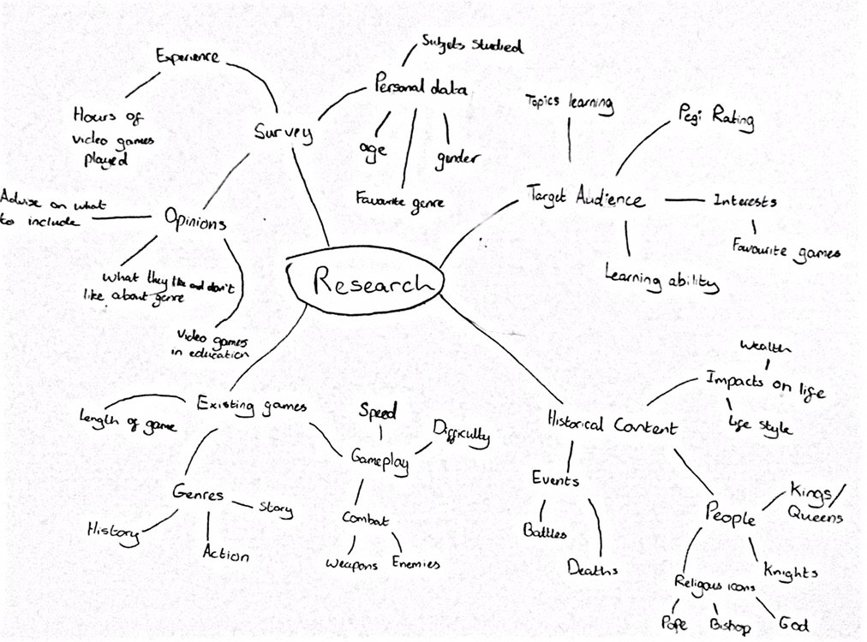

I have created a mind map to plan out what I will be researching and all the elements I will focus on. This should allow me to research my project easier meaning the end program should benefit.

Target Audience plan

When I produce target audience research, I have told myself that I must look for the specific learning ability of the students which the game is being made for. This way I will be able to change how the game teaches people and make it as engaging for each student. I will also look at the pegi rating of my game by comparing the age of my students and the requirements put in place for game age rating. As the game is being produced for students, I will have to make sure that it is actually focused around what they are studying and that it will help them pass their exams. To keep the students engaged in the game I make I will also have to make sure that I include some of their interests, this is why I will make sure that I do extensive research into what they do in their free time and what interests them.

Existing solutions plan

For this section of my research I must look at similar games that have been made to what I am creating and learn what they do and how I can implement some of these features into my own game. With each game I look at I will make sure to look at a range of different aspects including the gameplay, the difficulty and the story. Looking at the gameplay is an important element as I am able to get an understanding of how their game plays and what does and doesn’t work. This then lets me take inspiration for my own game making the gameplay as fun and fulfilling as possible. The story is also another important element of a game with it being some peoples main reason for them playing a game, this is why I need to know how much story there normally is in a top down game and how much my client would want in the game.

Historical Research plan

Before I can make my game, I need to make sure I know as much as possible for the era that my game will take place, this will therefore allow me to create my game with a lot more ease. To start with I will make sure that I found out what era it is that the students are studying and what would be the best part for me to cover. I will look into the different monarchs of the time and I will also look at the different events/battles that took place during the time. I will be able to use all this data I gather to put into my game and to create a world that the player starts to pay attention to and can watch the story unfold.

Survey plan

To further my research, I will create a survey to find out what people in my target audience age range think about my idea and what they suggest I can do to improve it. I will make sure to first ask the person some personal questions so I will be able to categorise them and see how opinions change depending on age and gender. I will then find out how reliable each answer to my survey is by asking the person how often they play video games, I will then be able to find out if this person has experience with games and how useful their response is. I will also make sure to gather as many opinions as possible with me asking them questions such as, do you believe video games should be used in education and what features would you expect to be included in a top down game.

Target Audience

I am making my game for students in my client’s history class who are aged 14 -18. This allows me to keep up to date on what my target audience like and are interested in.

History topic

I have learnt that my target audience are currently studying about the crusades. This has now given me the ability to start researching the time period and different events that took place during that time. The students are also looking at events over a number of different years however due to time restrictions I won’t be able to make my game take place over years, therefore I have used abstraction, having my game take place in one year. I will also be able to start to decide who the player is going to meet and battle during the game and what would be most educational for them.

Learning ability

My client has told me that their students are all able to learn quite well however they believe that a video game will allow them understand or refresh their memory on events that happened during the time. My client thinks it is best that the students don’t have to relearn content that they already feel confident on. This has reinforced my idea of having optional reading material, with the main basis of content being told through the story and the more complex stuff being told in optional pages to read. This also allows people who aren’t playing the game to be educated to also enjoy it as they wouldn’t be bombarded with endless facts they don’t want.

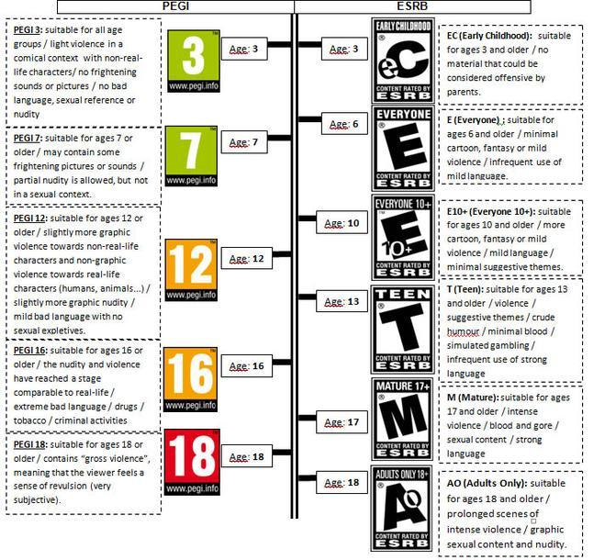

Pegi Rating

I have looked into what age rating my game should be put under. I have to consider both the kind of game that I am making and the target audience age for my game.

Pegi 3 - For my game to be a pegi 3 it would require it to include little violence and no frightening sounds. As my game is set in medieval times, I think it would be hard to get a pegi 3.

Pegi 12 - This allows me to make my game more adult with it including more violence, which allows me to make my game more realistic to the times.

Pegi 18 - This wouldn’t be suitable for my game as it would only fit the top bracket of my target audience in it, therefore meaning I wouldn’t get the most out of my game.

In conclusion my game should be a pegi 12 as it fits all of the target audience ages whilst allowing me to produce a game which can be more accurate to the medieval times, benefiting the students who play the game.

Research

The Legend of Zelda

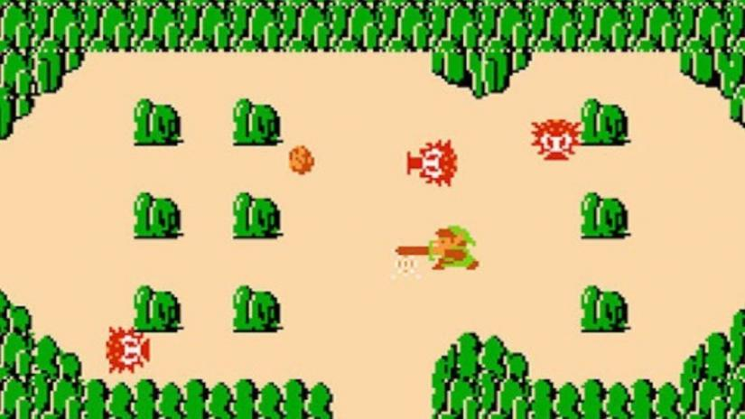

The legend of Zelda is an old game that was available on the NES. The layout of this game is simple but it also is effective, as it provides different rooms which can provide a challenge. The room system uses lots connected rooms to create the illusion of a map, making the user believe they are in an open world and not a number of rooms. This layout is similar to what I plan on doing for my game as it allows me to create an open world looking game without it having to load a huge map, this will mean there is less processing power needed to run my game. Due to time restrictions I won’t have enough time to make an open world game so I will have to make a streamlined game which has some open world features.

The gameplay in this isn’t too advanced due to it being an old game and that was the best they could do at the time. The combat in this game is very basic as it only has one attack. The enemies also move in random patterns and attempt to kill the player. The player is given 6 hit points meaning it is fair on the player.

I like the idea of using simple combat, however I believe it may become boring to the player, therefore I will talk to my client and see what they think of the idea. I don’t like the idea of having 6 hit points as I feel like this may be too easy for the player to beat the game.

Assassin’s Creed

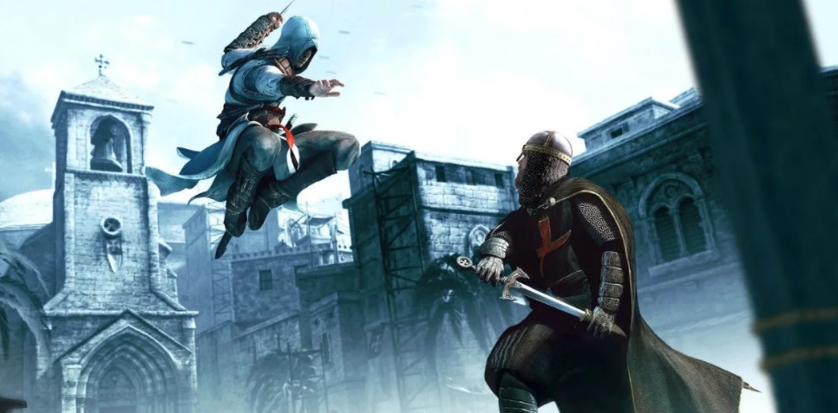

Although Assassin’s creed doesn’t fit within my pegi rating of 12 it does fit a similar theme of a historical game. The game allows the player to hunt down and kill real figures from history providing the player with a fun and educational experience, this is done by allowing the user kill the person however they like, this also adds replayability to the game. Due to time restrictions I won’t have multiple ways to kill enemies but I will be able to make some of these characters real people from history adding to the educational element of my game.

Assassin’s creed also allows the player to customise their character by applying different clothes. These clothes can sometimes alter the players abilities making them stronger or faster depending on what they wear. If I have time, I will implement a way for the player to customise their character by changing one or two colours of the clothing they’re wearing.

This game includes a third person 3D world for the player to explore. This would have been developed by many people over months with lots of resources, this means I won’t be able to produce a game nearly as big or ambitious but will still be able to take ideas from it and put them in my own game.

The Binding of Isaac: Rebirth

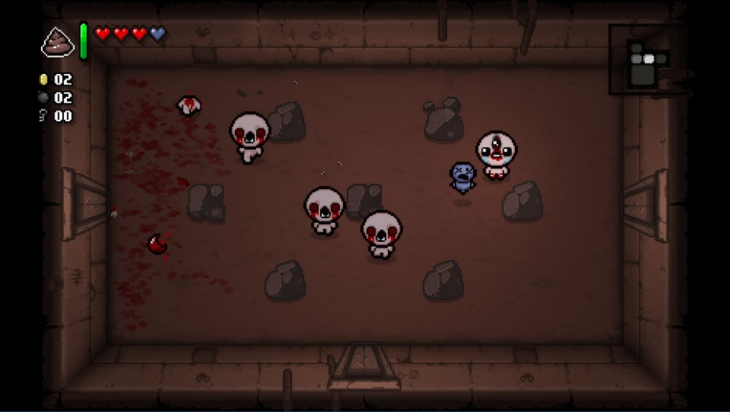

The Binding of Isaac: Rebirth is an endless dungeon crawler with waves of enemies in each room. These enemies have many varieties with each wave becoming stronger than the last, having new abilities and more health. These enemies aren’t pre decided as they are procedurally generated. The idea of an endless dungeon crawler doesn’t suit my game however having procedurally generated enemies would add replayability to my game as you would face a different challenge each time you entered a new area of the map.

The player receives power ups if they enter the correct room allowing them to defeat enemies easier. The player will get more and more power ups as the time goes on helping them defeat the stronger enemies. This gives the player a sense of achievement as they receive a reward for surviving so long. I may add different weapons for the player to use with different ones providing the player with buffs to reward them. However, I may decide against this as this might make the player too strong and make the game too easy for them.

Kingdom Come Deliverance

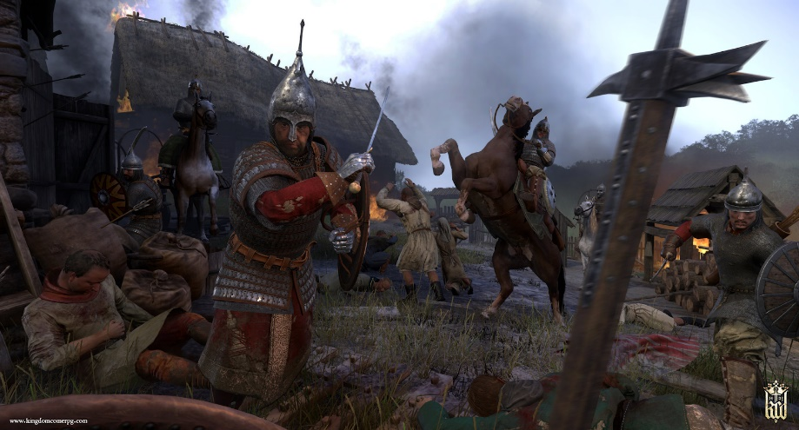

In the game Kingdom Come Deliverance the player is faced with a very realistic look into the medieval times. With very realistic gameplay that has accurate combat and learning mechanics. The ability to learn in this game starts you without the ability to read and fight and you must spend many hours learning how to do this. This concept wouldn’t work in my game as it won’t be playable for 100s of hours, therefore the player character will start with most of their abilities.

The historical element of this game is a key part of the users experience. This educates the player on the history of the time if they wish to learn it or they can just play the game and ignore the historical parts. This is similar to how I want to structure my game, allowing people to play the game with some optional elements of education and some not.

The ability to save the game in Kingdom Come Deliverance isn’t accessible to the user at all times with them having to find a save potion to save. This increases the tension in the game as the player will possibly lose hours worth of progress. This won’t suit my game as it requires my game to be playable for many hours and adds an extra layer of difficulty not needed in my game.

Conclusion - Features to be included and features to not

|  |  |
| --- | --- |
| Features to include | Features to not include |
| Simple Combat | Lots of hit points |
| Appears to be open world | Multiple ways to kill one enemy |
| Real characters from time | Endless |
| Customisation (Maybe) | Character strength progression |
| procedurally generated enemies (Maybe) | Open world |
| Buffs for player | Allies |
| Historical theme | User saving when they want |
| Checkpoints |  |

Historical Research

The First Crusades

During 1096 the christians were manipulated into thinking their holy land had been stolen and that they had to go and reclaim from the muslim people. The person who gave the original speech to go and reclaim the land was given by Pope Urban the second, where he persuaded the people that they would be wiped of sin if they were to take part in the recapture of Jerusalem (the holy land). He created the idea of the crusade which was to take place during August of 1096.

The people’s Crusade

Before the Pope had gathered his army to go and retake Jerusalem there were a number of people who believed they could help with it and form their own armies to help with the fighting.

One of the groups formed was led by Peter the Hermit who claimed to have seen the atrocities that had taken place in Jerusalem first hand and he wanted to form an army to take place in the crusade. He got thousands of untrained peasants, ranging from women and children to the elderly. He did manage to get some knights to be part of his army including Walter Sans Avoir, who became Peter’s lieutenant after leading his own army.

The second group of people were led by Walter Sans Avoir, who led an army of peasants to Jerusalem. Walter however, didn’t wait until August to make his journey and left during spring which meant his troops would find it hard to resupply on food. When he made it to Belgrade, they were unexpected and were told to wait until the local governor was able to contact Constantinople about what was going on. Due to Walter’s bad timing for the journey his people were starving, so they pillaged the countryside.

The third group was led by Count Emicho. He had heard of Peter’s teachings so he gathered an army to help with the capture of Jerusalem. Before his army even left Germany they realised it would be much easier to attack the jews as they were much closer and nowhere near as well armed. This was disliked by everyone as this wasn’t what the Pope had asked for so a number of armies tried to defend the Jews but Emicho’s army only got bigger until he overwhelmed them all.

The Princes’ Crusade

The Pope had been forming his own army which was made up of knights and warriors who would be able to take over places along the way with ease. The Pope’s army was made up of 5 armies all put together, who would meet up in Constantinople and make their way to Jerusalem from there.

The first was led by Hugh of Vermandois who was the brother of the king of France. He traveled to Constantinople by sea, but ran into a storm on the way and lost a good number of his ships. When he arrived at Constantinople, he wrote to the byzantine Emperor to come and greet him as Hugh was “king of kings”.

The second army was led by Godfrey de Bouillon who brought a large army to help with the recapture of the Holy land. He made it to Constantinople with relative ease and lost almost none of his troops.

Bohemond of Taranto led the third army which was much smaller than the others but was the most well trained. He sailed over with no problems and also had no real problems making it to Constantinople.

The fourth army, led by Raymond of Toulouse was the largest army out of the five. Raymond considered himself the leader of the crusade and wished to die in the holy land. On his way to Constantinople most of the food had been taken by other armies and groups heading there so his army decided to pillage. He lost quite a few men in this but eventually made it to Constantinople.

Robert of Flanders was leader of the fifth army and also went by sea. He faced no problems getting over however, his army had two other people leading this army, Robert of Normandy and Steven of Blois who didn’t travel at the same time and lost a ship on the way over. Also, some of his men found a Italian winter too much and went back.

Conclusion

With all of this information I have gathered I will be able to make my game a much more fulfilling experience for the player and a much more accurate one, which will be able to educate anyone who plays it. This will also save time for me when I create my game as I will have to spend less time researching what happened and what parts to include and not include.

Video Game survey

I have created a survey to let me get to know my client better and different aspects people expect in an educational video game. I have split my survey into two sections with one looking at the person answering the survey, finding out how reliable their answers are and with the second section looking at what they think about my idea and what they suggest I add.

Section 1

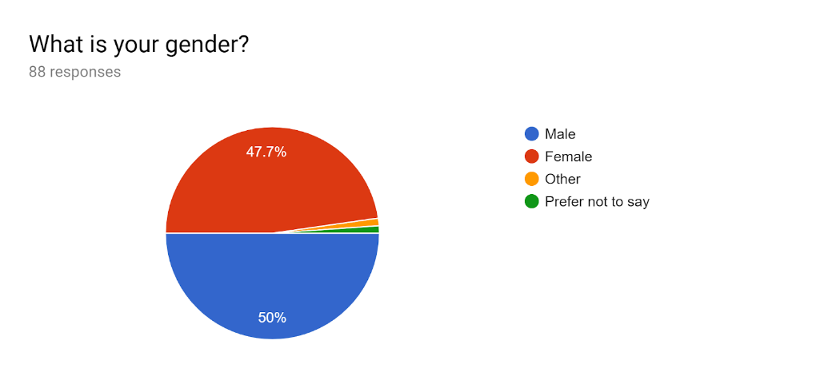

I have had around an even split of both males and females answer my survey. This is good for my research as my game doesn’t have a specific gender in mind and therefore will be for anyone in the age range.

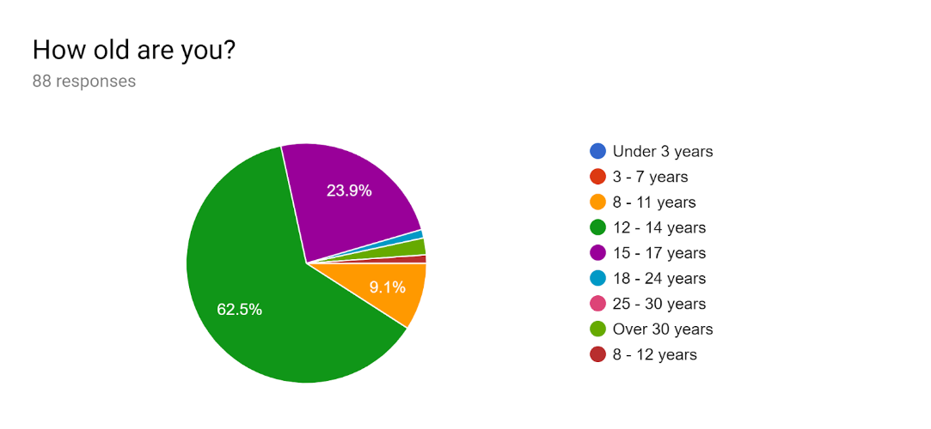

The age range I have mainly received responses is from people who are aged 12 - 14 with the second most being 15 - 17. This is exactly the age that I am directing my game towards meaning I can use lots of these responses to help me when looking at what my target audience wants.

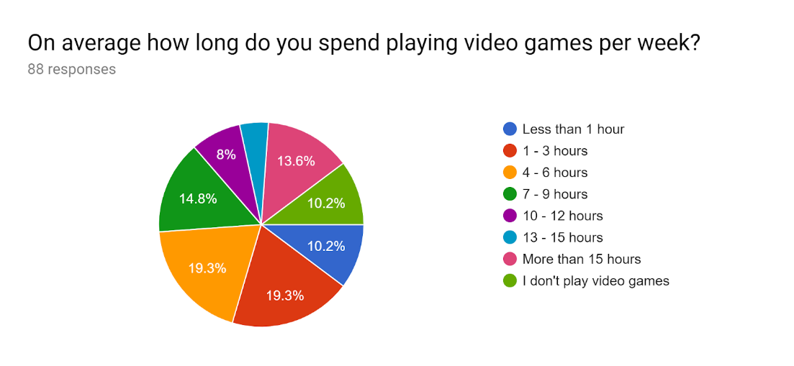

I also asked the person how long they play video games for a week. I had a very even split with lots of people spending around 1 - 6 hours per week. I can use this data to tell me how useful their response is as people who play more video games are more likely to know what is needed to make a game good. I can also mainly ignore most of the people who don’t play video games as they are unlikely to know what could improve my game.

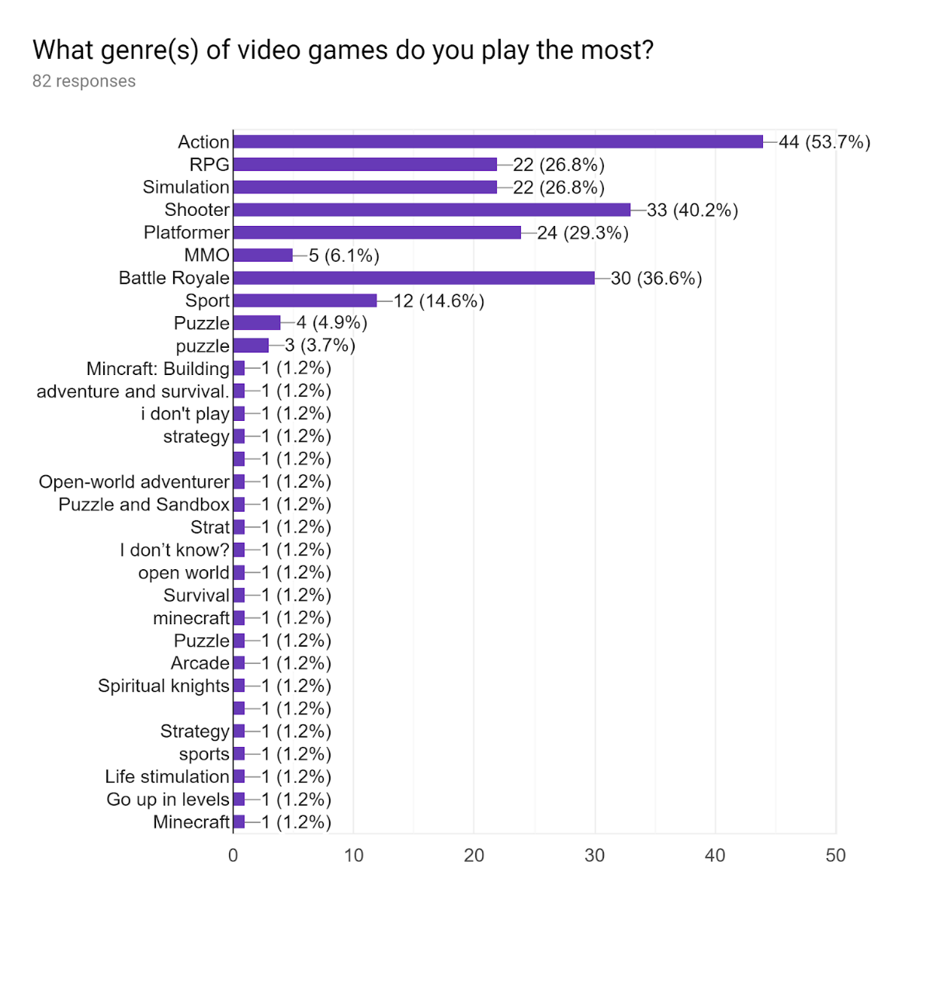

The question about what genres people prefer has told me that an RPG will still work as there is a large amount of people who enjoy them. This means I will also look at what these people say more as they have more experience with my style of game.

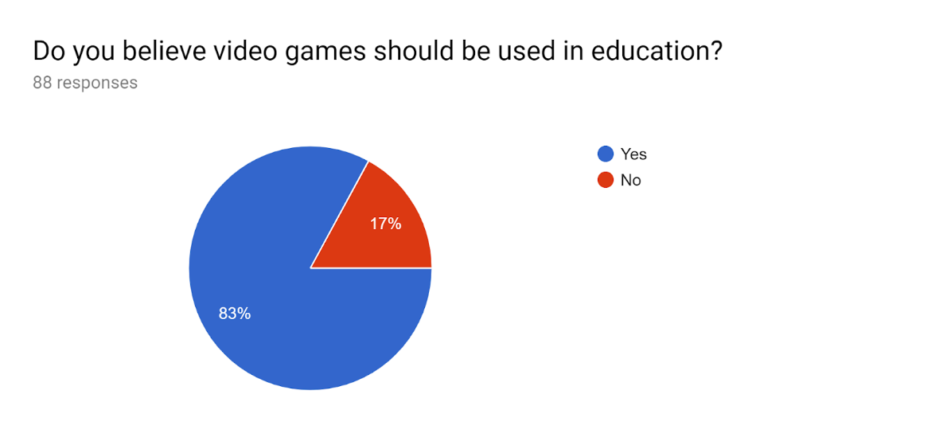

In my research I was hoping to find out that people wanted video games in education and I have had 83% of people say they should be used. This is very helpful as it tells me that people want to play video games and that an educational game would work well.

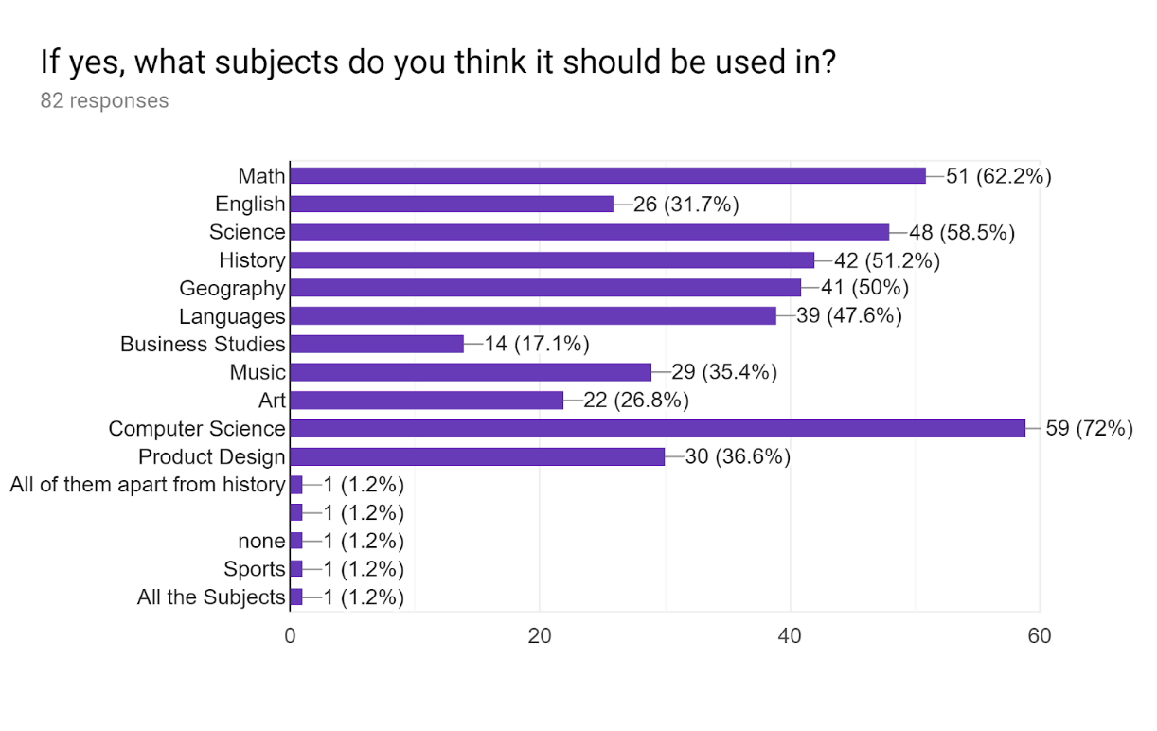

Most people believed games should be used in computer science and maths. However, I did get 51% of people saying that history should have a video game aspect. This data may be slightly biased though due to me not looking at what subjects people study. This could suggest why maths has such a high demand.

Section 2

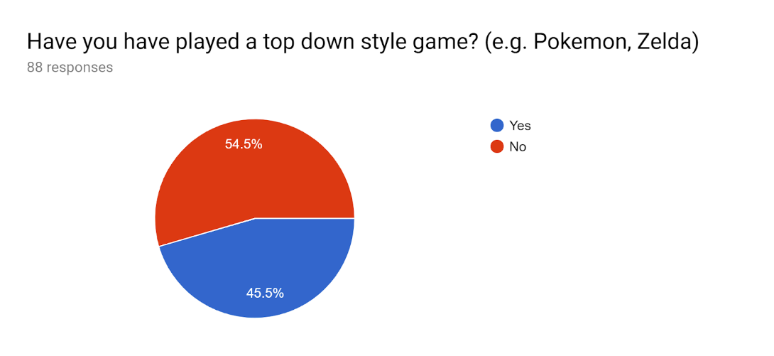

When I asked people if they had played a top down game before I was surprised to find out that only 45% of people had. This means that any suggestions for my game that come from people who haven’t played a top down game might be less useful. This also tells me that I should most likely include a simple to understand tutorial at the start of my game if I have time to ease new players into the style.

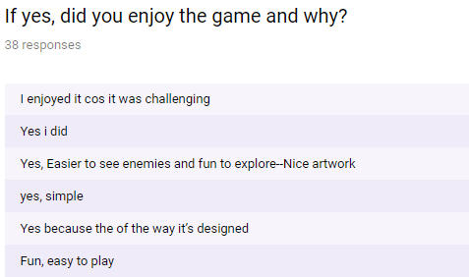

I have taken a few of the reasons why people enjoy video games and will try to implement a similar style/control to my own game. I will be able to refer to these in the designing stage of development and think about adding them then.

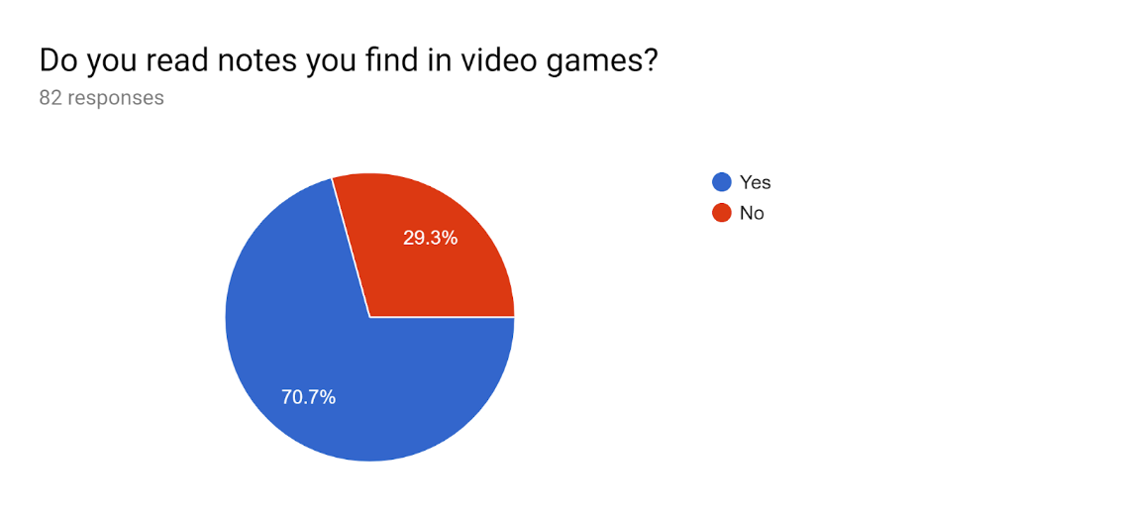

This chart tells me that my idea of adding books/scrolls with educational information would work really well as most people read them when playing other games. I will make sure reading these scrolls isn’t too inconvenient and make them a reasonable length.

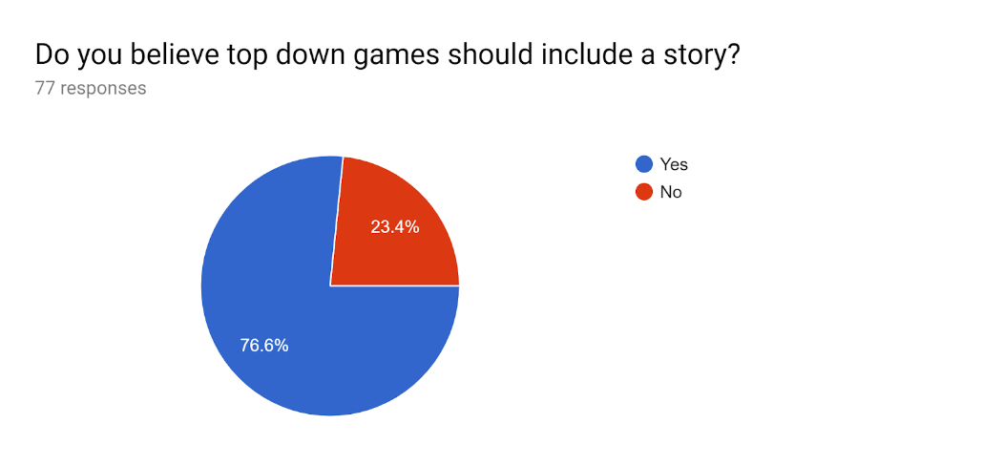

Most people also think that top down games should include a story. This lets me know that if I added historical characters and a simple narrative to my game it may be much more successful.

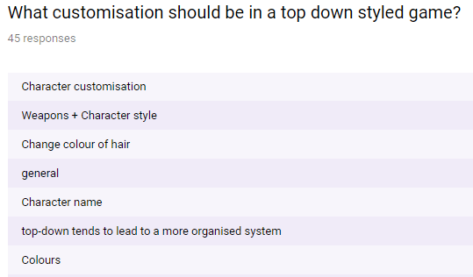

I have taken some of the best customisation responses and have looked at them for what I should and shouldn’t add. Customising the character should be quite simple by allowing players to change the colour of clothes and the name. I am unlikely to have customisable weapons as that might be too challenging for the time available.

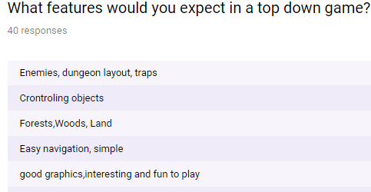

I have also looked at the different things people expect in a top down game. From my responses I can gather that people want the game to be big and simple to navigate. I am able to get around this by making my game appear to be bigger than it is.

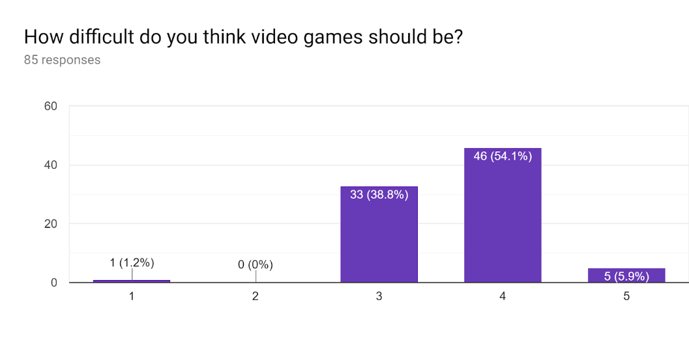

I can learn from this graph that people want my game to be challenging and for it to take time to complete. I also can learn that most people think that a video game shouldn’t be beatable by everyone, however I will have to allow most to complete the game as it is designed to educate students.

When I develop my game, I will use all of this data I have gathered to influence my decisions. Most of the responses I received matched my expectations however I was surprised with the lack of knowledge around top down games. This maybe because people don’t know the term top down game and maybe more familiar with them being called a ‘birds eye view game’. I will make sure to include a basic tutorial if I have the time, introducing new players of the genre.

Client Interview

Q: What are the most important parts of what your students are studying?

A: “My students are studying a number of topics in history however, lots of them seem to be struggling on the crusades and I believe the students would really benefit from a game to help them learn the content. I suggest including the battle of Dorylaeum, the Siege of Antioch and the Siege of Jerusalem. These battles however could go on for weeks so I believe you should make them shorter or only show parts of the battle”

From this question I wanted to learn if there were any main parts of the topic I needed to make sure I covered when producing my game. What I have learnt from this is that I need to include a number of battles that they suggested and make the battles a reasonable length for a game, making them appear shorter than they were if I have to.

Q: How much of my game should be dedicated to learning content?

A: “I believe to not overwhelm students with information and to keep them interested, to make the game about 50% educational with the other 50% being with the purpose of entertaining the students.”

What I wanted to learn from this question was the fun my game should be compared to how much learning the player would be forced to do. From my client’s response I can conclude that they would like the game to have a 50/50 split between entertainment and education. This allows me to plan out the base story and how much of it should be educationally based.

Q: Do you like my project proposal and what could I do to improve it?

A: “I like the idea of making an educational game to teach people about history which can keep people engaged and bring the subject to life. I think that your game should introduce the basic historical characters of time and allow the player to learn at their own speed, allowing them to go back and relearn some of the content.”

What I wanted to find out from this question was if there was anything wrong with my project that my client wasn’t happy with and wanted changed. What I found out is to improve my game I must allow the player to take their time with the game and allow them to look back on what they’ve done already (e.g. rereading notes found).

Q: What should I not include in an educational video game?

A: “The game shouldn’t include inaccurate content that may mislead the students and teach them content which is false. It also shouldn’t be too violence as although my students vary in age it may distract some of my students from the educational value of the game.”

What I was hoping to find out from this question was if there is anything that I have suggested that my client doesn’t like and if there is anything else they don’t want. What I did find out was that my client only wants accurate content to a degree with there being no misleading content. This means I have to be careful with my research and to double check everything I put in.

Q: Why would a video game educate your students better than the traditional way of teaching?

A: “My students can lose interest in a lesson, especially as I drone on and on about the content. I would much rather have my students physically engaging themselves with the time, immersing themselves in the time and learning on the go.”

What I wanted to find out from this question was why I was actually making this game and what my client wanted out of it. I learnt from my client’s answer that they are looking for alternative ways of teaching as for some students the traditional way doesn’t work and need a motive to learn.

Expert Interview

Q: Can my game be made and run in Unity?

A: “From what I can tell, your game will have no problem running in Unity with it being quite well suited to the engine. You will be able to create all the features that you want in your game without it seeing almost any performance issues.”

What I was hoping to find out from this question was if my game was possible to make with Unity and if it would run. What I have found out is that my game is possible to make with Unity with it facing no issues when running it. This allows me to consider the features in my game more freely, knowing I will have less holding me back.

Q: Do you think it will be feasible for me to make this game with the time restrictions?

A: “The game you are looking to make doesn’t appear to be too grand, however you may have to spend your free time working on your game if you find it being bigger than anticipated. You could also utilise the Unity asset store where you can get premade assets for your game, saving you time.”

I was looking to find out how the time restriction may affect my final game and what I could do to avoid it causing me to create a half finished game. I learned from my expert’s response that they believe I should create the game in my free time as well as at school. This was already my plan as I am not too sure how much code I am going to have to produce. I was also told about the asset store which can help me save time when it comes to designing some parts (e.g. Objects, character models).

Success Criteria

|  |  |  |
| --- | --- | --- |
| No. | My game will: | Reason |
| 1. | Have a player character | So the player is able to have something to control within my game |
| 2. | Have inputs to move the character (WASD) | So the player is able to move around the map |
| 3. | Have enemies | To give the player something to fight |
| 4. | Have a set number of hit points for enemy | So the player is able to kill the enemy |
| 5. | Have a set number of hit points for the player character | So they player has the chance of being killed |
| 6. | Include a weapon which the player can use | So the player can deal damage to the enemies |
| 7. | Have the weapons deal a set amount of damage | So the weapons have the ability to deal damage to enemies |
| 8. | Have consumables that can buff the player | So the player can make themselves stronger or heal up from damage |
| 9. | Allow player to attack the enemy | This allows the player to kill enemies |
| 10. | Have a small tutorial on how to play the game | This is so the player isn’t confused when playing the game |
| 11. | Teach at least 80% of students about the crusades and what happened during the time | This is so my game can be educational and teach people about the time |
| 12. | Include a menu page | This is what the player can use to interact with non gaming elements of the game |
| 13. | Pause game when menu button is pressed | So the player won’t die when looking at the menu |
| 14. | Allow player to quit game | This is so the player can stop playing when they want to |
| 15. | Allow play to resume game | This is so the player can continue playing the game once finished in the menu |
| 16. | Allow player to select from a number of colours/looks for character | This gives the player more options when it comes to developing their character |
| 17. | Have a map for the player to walk around | This gives the player something to explore and a place for the games story to take place |
| 18. | Include a basic story | Helps to teach the player more about the historical content |
| 19. | Load the map as the player moves across the world (move from room to room) | This is so the game can act as one map instead of lots of rooms |
| 20. | Have a top down camera | This is so it matches my top down style of game I am making |
| 21. | Have real historical figures from history | So that the player can learn what these people were like |
| 22. | Allow the player to pick up items | So the player can gather items to help/educate them |
| 23. | Have the player be able to look at items through menu | This is so the player can look back of what they have collected |
| 24. | Include readable notes | To allow the player to read about the time |
| 25. | The player can die | So the player has a challenge |
| 26. | Inform the player they’ve died | So the game doesn’t end abruptly |
| 27. | Game is saved when player gets to checkpoint | So the player can continue when they die |
| 28. | Inform player when the game is saved | So they know when they have reached a checkpoint |
| 28. | Game can be made full screen | So the player can see more |
| 29. | Enemies move towards player | So they can be close enough to attack |
| 30. | Enemies attack player | So they player can take damage |
| 31. | Control menu | So the player can remind themselves of the controls for the game |
| 32. | Save players login data in a table | This is so the player is able to continue from where they left off |
| 33. | Load next level | This is so the game will continue when they finish a level |
| 34. | The enemys can die | This is so the player is able to progress through the game, killing opponents |
| 35. | The game can be completed | This is so the game doesn’t go on forever and has a clear end |
| 36. | Make my own sprites | This is so I own all the elements of my game, without having to worry about having taken images from elsewhere. |

**Design**

Flowcharts and Pseudocode

System diagram

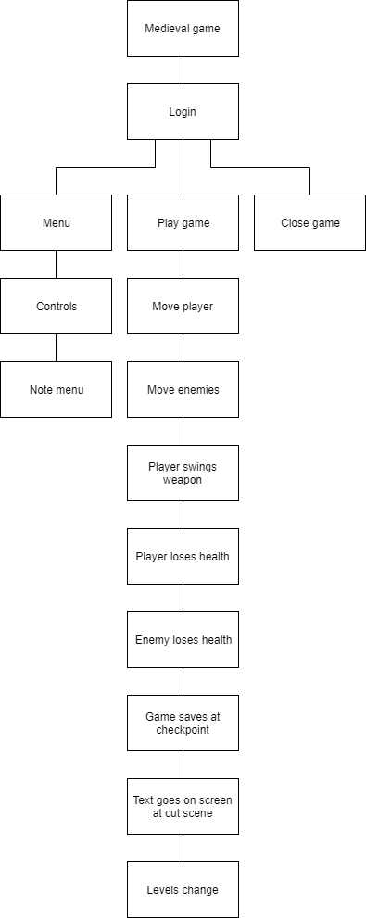

This is my plan for my flow charts, with this being a basic way to plan out each stage of my flow chart, making it easier to come up with each stage of the game. With this I will also be able to get an idea of the basic function of my game and see how likely it is to be successful. I will be able to see what does and doesn’t work within my current structure and alter my game as I learn this.

Start

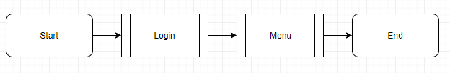

This is the first algorithm which holds both the start and the end of the game. This goes to the login page and then moves onto the main menu which the user can use to navigate the whole game.

Login menu

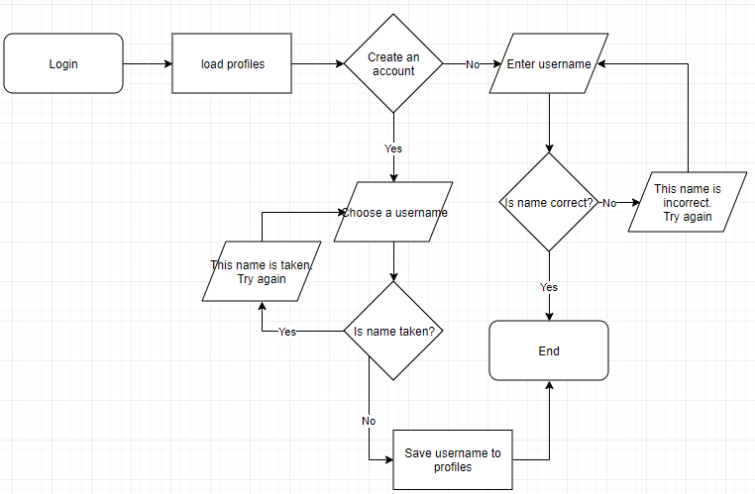

Login Screen

Load Login

Open Profiles

LOOP

INPUT “Do you want to login?”

IF Yes THEN

INPUT “Enter your username”

IF username is in ‘Profiles’ THEN

Login to account

Load Menu

ELSE

OUTPUT “That username is incorrect”

ENDIF

ELIF No THEN

INPUT “Make a username”

IF name is taken THEN

OUTPUT “The name is already taken”

ELSE

Save name

Load Menu

ENDIF

ENDLOOP

This algorithm is used for the player to save their data and come back to continue the game where they left off. This requires the user to create a username so they have a unique way of identifying each person.

Menu page

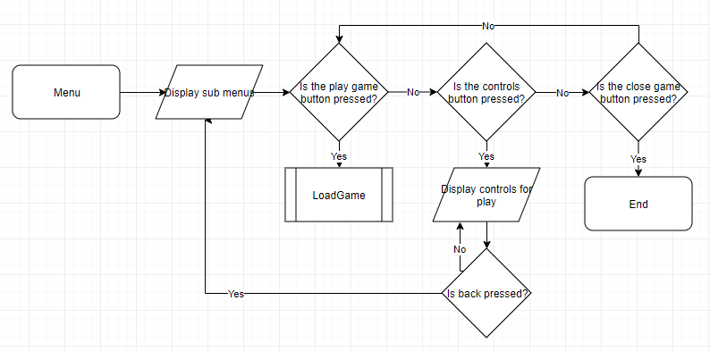

Menu Screen

Load Menu

LOOP

IF Play game is pressed THEN

Load GameSave

ELIF Controls is pressed THEN

OUTPUT Open control image overlay

LOOP

IF cross is pressed THEN

OUTPUT Close control image overlay

ELSE

Continue to display image overlay

ENDIF

ELIF Quit game pressed THEN

Close game

ENDIF

ENDLOOP

This is the main page which the user can interact with, with it being the hub of playing the game, opening the control page and quitting the game. The control menu allows the player to see how to move and attack, also allowing them to see how to open this menu mid game. The close button which completely shut down the program and play button with go to the load game algorithm.

Loading game

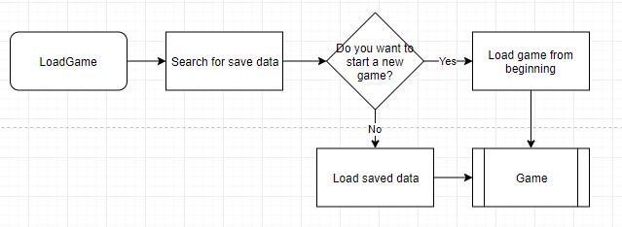

Game Save

Open Saves

Check for game save

IF game save is found THEN

Load Game from save

ELSE

Load Game

ENDIF

This looks at the user’s profile which they have signed into and sees whether they have had any game saves previously. It then asks the user whether they want to create a new game or if they would like to continue where they left off.

Main game functions

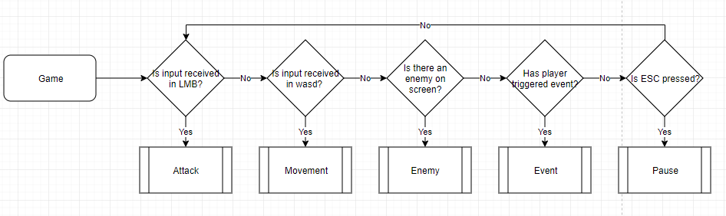

Load Game

PLayer health = 5

Enemy health = 3

LOOP

IF LMB pressed THEN

Load Attack

ELIF wasd pressed THEN

Load Movement

ELIF enemy on screen THEN

Load Enemy

ELIF player triggers event THEN

Load Event

ELIF ESC pressed THEN

Load Pause

ENDIF

ENDLOOP

This algorithm shows how the game mainly plays, with it having how the player attacks, how the player moves, how enemies react, how events are triggered and how the player brings up the pause menu and interacts with it. This loops until the player wins the game, if the player dies or if the player quits.

Attacking enemies

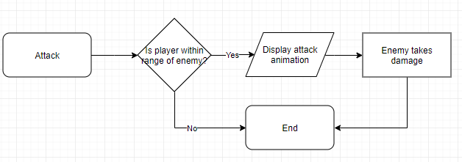

Attack

If player is close to enemy THEN

OUTPUT attack animation

Enemy health = Enemy health - 1

Load Game

ELSE

Load Game

ENDIF

The algorithm which allows the player to attack checks for an input in the LMB and then checks to see whether the player is close enough to deal damage to the enemy, if yes then the enemy takes damage.

Movement controls

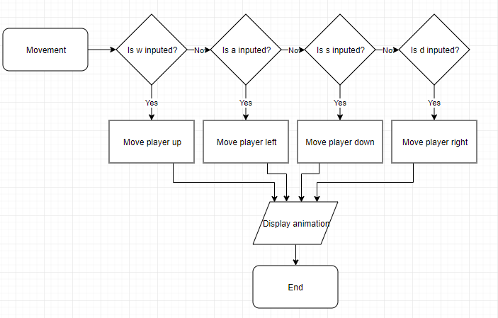

Movement

IF W is pressed THEN

Move character up

ELIF A is pressed THEN

Move character left

ELIF D is pressed THEN

Move character right

ELIF S is pressed THEN

Move character down

ELSE

Load game

ENDIF

OUTPUT Movement animation

Load game

This checks for an input in wasd, which then games to move the player either up, down, left or right. After it receives the input the animation will play for the character movement.

Enemy instructions

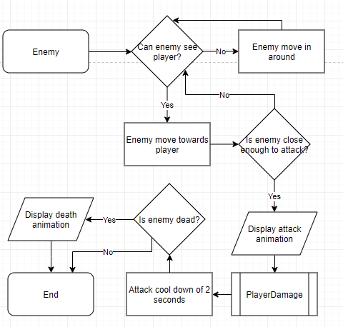

Enemy

IF enemy can see player THEN

Enemy move towards player

IF Enemy is close enough to player THEN

Player health = player health - 1

OUTPUT damage animation

ELSE

Load Game

ENDIF

ELSE

Enemy moves around

Load Game

ENDIF

This runs if there is an enemy on the screen. When this does run it will check if the enemy can see the player and if they can they will move toward the player. When the enemy is close enough they will attack the player and then move to the PlayerDamage algorithm. It then checks if the enemy is dead and plays a death animation if yes.

Event instructions

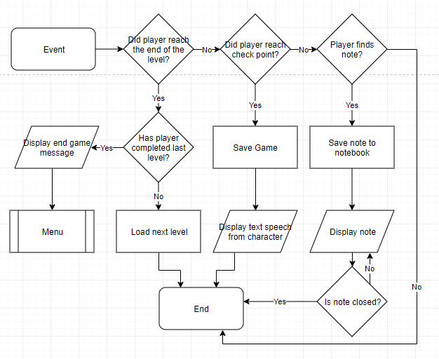

Event

IF player reached end of level THEN

IF level = last level THEN

OUTPUT End game message

Load Menu

ELSE

Load next level

ENDIF

ELIF Player reaches checkpoint THEN

Update game save

OUTPUT character text speech

ELIF Player finds note THEN

Save note

OUTPUT Note

Close note

ENDIF

This is an algorithm that checks to see whether the player has triggered an event and then completes the event. This involves saving the game, saving and opening notes and switching levels.

Pause menu

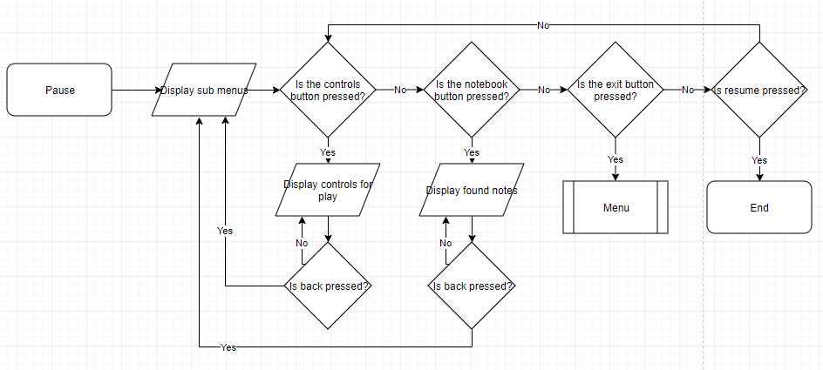

Pause

Load Menu

LOOP

IF notes button is pressed THEN

Open notebook

LOOP

IF cross is pressed THEN

OUTPUT Close notebook

ELSE

Continue to display notebook

ENDIF

ENDLOOP

ELIF Controls is pressed THEN

OUTPUT Open control image overlay

LOOP

IF cross is pressed THEN

OUTPUT Close control image overlay

ELSE

Continue to display image overlay

ENDIF

ENDLOOP

ELIF Quit game pressed THEN

Load menu

ELIF Resume button pressed THEN

Load Menu

ENDIF

ENDLOOP

This comes up if the player presses escape. This brings the player to a menu which appears like the main menu page but it doesn’t include the option to play the game, instead they get back to the game by pressing ESC again.

Player’s health

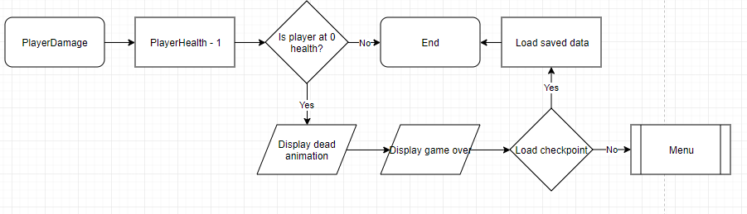

This allows the player to lose health as the enemy attacks them. It checks whether the player is dead and then allows them to reload the game from a checkpoint or quit to the main menu.

Test table

|  |  |  |  |  |  |
| --- | --- | --- | --- | --- | --- |
|  | What's being tested | Input/Data used | Expected output | Reason | S.C. |
| 1. | Username | An acceptable username | N/A | Because I want the user to be able to login | 32 |
| 2. | Play game | Play button | Load main game | So the game works | 12 |
| 3. | Close game | Close button | Close program | So the user can stop playing | 14 |
| 4. | Control menu | Controls button | Display controls | So the user can control the player | 12 |
| 5. | Game save search | Save file | Load save | So the user can continue where they left off | 32 |
| 6. | Player health | Player health = 5 | N/A | So the player can take damage | 5 |
| 7. | Enemy health | Enemy health = set | N/A | So the enemies can take damage | 4 |
| 8. | Player attack | LMB | Damage enemy | So the player can deal damage | 9 |
| 9. | Enemy attack | Enemy close to player | Damage player | So the enemies can deal damage | 30 |
| 10. | Player movement | WASD | Move player | So the player can move | 2 |
| 11. | Load next level | Player reaches end of level | Load next level | So the user can continue playing | 33 |
| 12. | Text dialogue for characters | Player reaches checkpoint | Output text | So the user can follow the story | 27 |
| 13. | Save game at checkpoint | Player reaches checkpoint | Save game | So the user can come back when they die | 27 |
| 14. | Save note | Pickup note | Save note | So the user can look back at the notes they have | 22 |
| 15. | Player die | Player health = 0 | Display death screen | So the player can die | 25 |
| 16. | Enemy movement | Enemy can see player | Move enemy | So the enemies can move | 29 |
| 17. | Enemy die | Enemy health = 0 | Display death animation | So the enemies can die | 34 |
| 18. | Game can end | Levels remaining = 0 | Output victory message | So the player can have a goal | 35 |
| 19. | Move from room to room | Walk to next room | Load next room | So the user can continue through the game | 19 |

Variable table

|  |  |  |
| --- | --- | --- |
| Variable | Data type | Description |
| Player Health | Integer | This is how much damage the player can take |
| Player Attack | Integer | This is how much damage the player can deal |
| Enemy Health | Integer | This is how much damage the enemy can take |
| Enemy Attack | Integer | This is how much damage the enemy can deal |
| Speed | Float | How fast the player can move |
| Attacking | Bool | Checks to see if the player is attacking |
| Enemy Speed | Float | How fast the enemies can move |
| Enemy Attacking | Bool | Checks to see if the enemy is attacking |
| Hit range | Float | How far the player has to be to hit the enemy |
| Game start | Bool | Checks if the game has started |
| Menu active | Bool | Checks if the menu is active |
| Weapon | Integer | Switches between selected, numbered weapon |
| Player Rigidbody | Rigidbody | It represents the players rigidbody |
| Enemy Rigidbody | Rigidbody | It represents the enemies rigidbody |
| Player facing left | Bool | Checks to see if the enemy is facing left |
| Player facing right | Bool | Checks to see if the enemy is facing right |
| Play button | Button | Once pressed it will play the game |
| Quit button | Button | Once pressed it will close the game |
| Controls button | Button | Once pressed it will display the controls |
| Notes button | Button | Once pressed it will display the notes |
| Colour | Integer | Switches between player characters colour |
| Player alive | Bool | Checks to see if the players alive |

Post development comments

Whilst making my game I have discovered that I have created new variables and also not used others. Because of this I have made a table to show all of the changes to the variable table, explaining why something was used or removed.

New Variables

|  |  |  |
| --- | --- | --- |
| Variable | Data type | Description |
| Note text | Text | This is the text which will be on the note |
| Words | String | This is where the text will get its words from |
| Note number | Integer | Each note will have a number assigned to it |
| Camera size | Float | Sets the camera size per room |

Removed Variables

|  |  |  |
| --- | --- | --- |
| Variable | Data type | Removed reason |
| Colour | Integer | I didn’t create a way for the player to change their characters colour |
| Weapon | Integer | I didn’t include multiple weapons in my game |

Hierarchy Table

I have made hierarchy tables to show how different subclasses inherit from its parent class. I have done this for both enemies and weapons as I believe that this will allow me to produce my game at a faster rate, whilst improving the overall quality of it.

Different types of enemies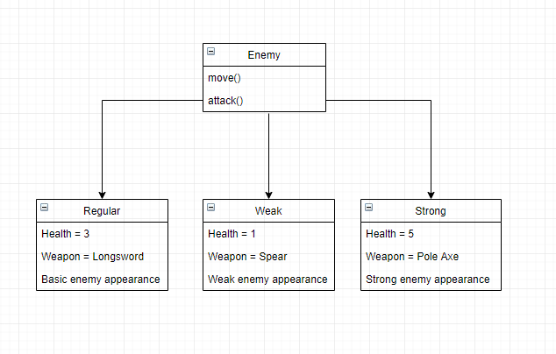

This shows how all enemies will have similar moves but will vary in health and weapons they have. All of the enemies also have a different appearance meaning the player can distinguish between them.

Different types of weapons

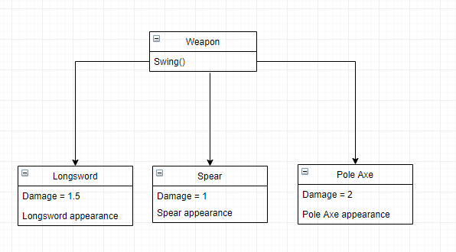

This shows how all the weapons will have a similar functionality but deal different amounts of damage and look different from each other. Each weapon will be assigned to a different enemy, with the possibility of the player being able to use different weapons.

Design Ideas

Character Design Ideas

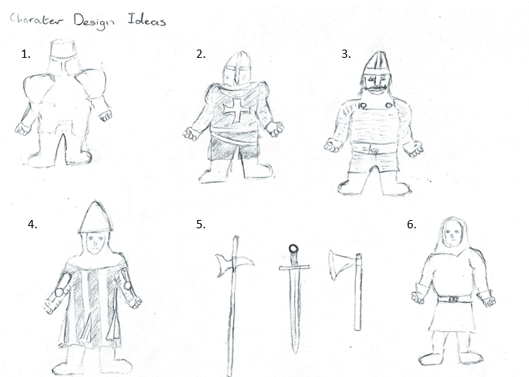

I have decided to draw some of the concept character designs for my game, having a number of different looks and shapes. I will then be able to show these to my client and ask them which they like the most and what part of the game should they be used as (e.g. Player, enemy, npc). I have also drawn a number of weapons which can be given to the player and the enemies, I will also get feedback on them from my client.

What I currently invision with my designs are that number 1 will be the player character, making the player feel like their character is strong. I then believe number 3 should be the regular strength enemy equipped with the sword, number 4 should be the weak enemy equipped with the spear and number 2 as the strong enemy equipped with the axe. The idea for character number 6 was to add a bystander/peasant who the player is unable to interact with and will act as a background filler, this will make the player feel like this is a more immersive world.

Main Menu

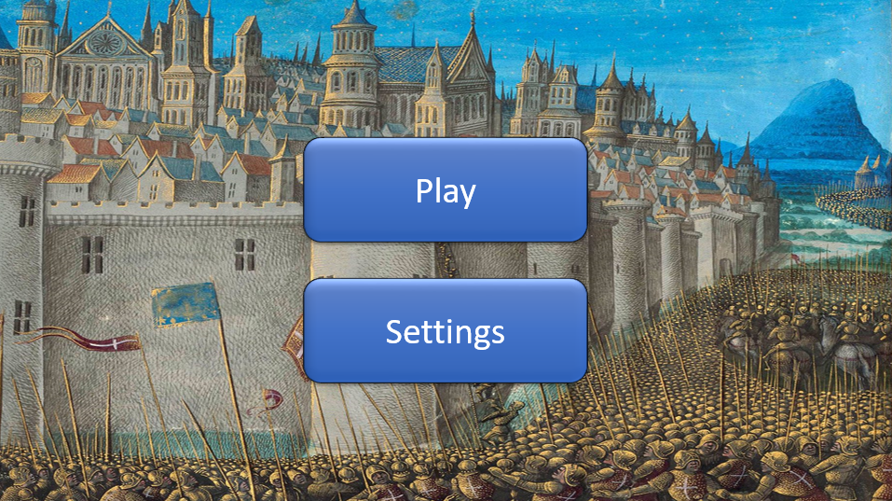

This is a main menu concept page I have created to get an idea of what it will look like when I actually make my game. I have added a play button which will lead the player into the game from where they can pick up from where they left off. The settings button will show the player the controls for the game and also allow them to fullscreen it, allowing them to see the game clearer. I have used a crusades painting as my background to make my game feel more professional and appealing to look at.

Maps

I have made some maps to give me an idea of where everything goes and how difficult each level will be. I put enemies in most rooms giving the player a challenge. I tried to make it slowly get harder as the player progresses through each room, meaning they are always needing to improve their ability to fight. I included a boss at the end of each level as a final challenge for the player. I intend for the boss to have more health and deal more damage meaning the player will likely die when they first come across a boss, giving them a sense of achievement when they kill it.

Map 1

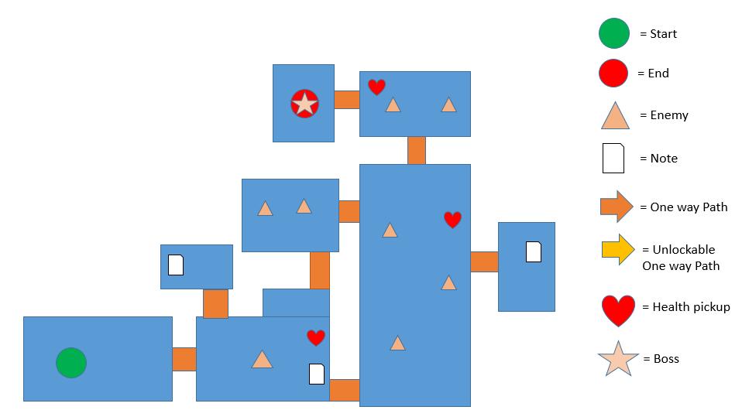

The first map is easier than the other two to allow the player to get an idea of how the game works and to let them learn how to play. I have also included less enemies to make the game easier for the player, however, I will be able to change the amount of enemies if I find out that the level is too easy. I have put a number of notes in my game as well to allow the option for a person to read about the history of the time, this is linked with what my client wanted me to add to my game.

Map 2

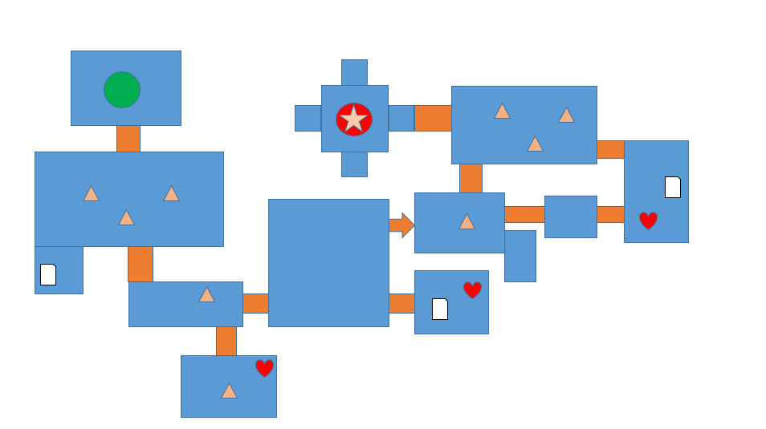

This is my second map, it has more enemies and a larger map. This is a standard map which would be the majority of the maps if I had more levels in the game. This is the first true level for the game as the player has now been introduced to the main concepts. This level introduces the concept of a one way path that doesn’t allow the player to return back from whence they came.

Map 3

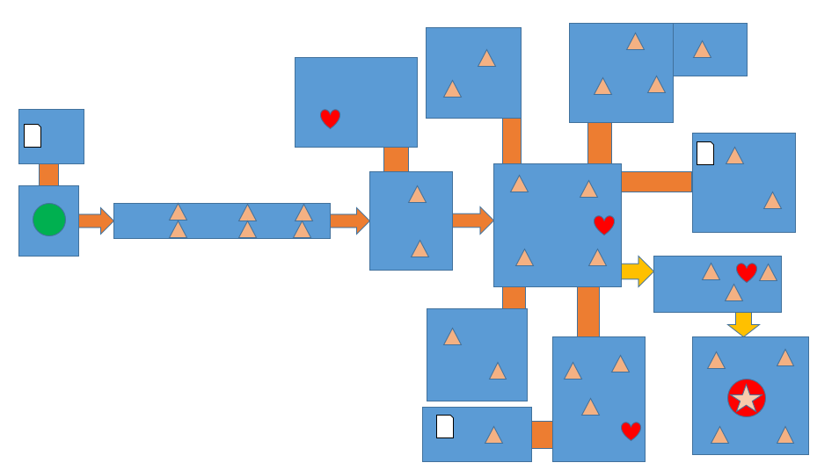

This is my third and final map. This map is designed to be the most difficult, with more enemies and more paths for the player to take, making it last longer and test the player’s full ability. This level also introduces the unlockable one way door which means the player needs to kill all the enemies is the area to proceed.

Client’s response

I showed all of my design ideas to my client and then asked what they thought about them.

Character Design

* “I really like the cartoony look of the characters, with them also being factually accurate”
* “The variety of characters keeps the player on their feet, showing them something they will recognise from studying and knowing the enemies skills”
* “I like that the characters are suitable for the students age range”
* “The characters are simple and easy to interpret which makes the game more fun”

Main menu

* “I like the clear layout of the menu”
* “I think the buttons could blend with the background more or have a nice look applied to them”
* “The background fits the time very well, giving the user a clear understanding of what they are playing”
* I think the buttons could also change position to look more professional

Maps

* “These maps offer a challenge to my students whilst teaching them along the way”
* “They should include educational elements, for example the towns and castles must look somewhat accurate”
* “The maps shouldn’t be too big as I don’t want my students to get bored due to little variety”

Conclusion

I can conclude that my games design meets my client’s needs, with them having liked most of my work with just a few things that need to change, including:

* Main menu button colour
* Main menu button position

With these changes my game should fully meet the requirements and should hopefully satisfy my client. Once I complete these changes I will ask my client again what they think to see if there is more I have to change.

Main menu (Improved)

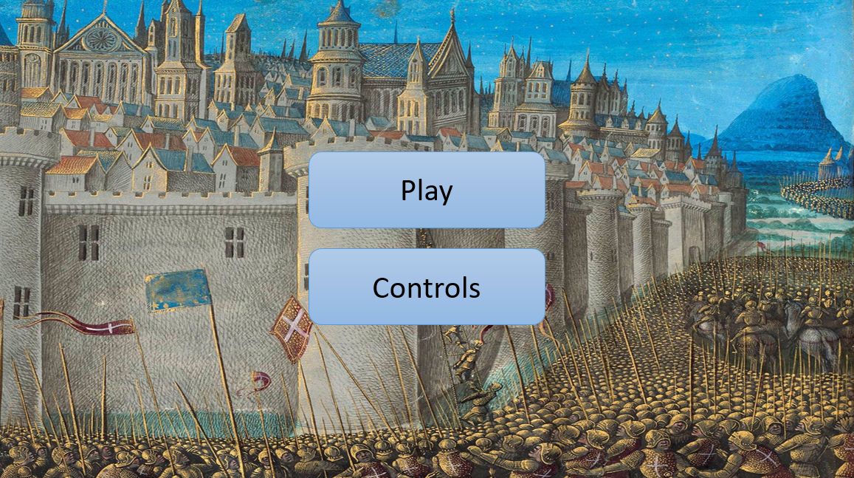

I have improved my main menu by making the buttons a lighter blue and making the buttons a bit smaller and closer together. This makes my menu look more professional and makes it more appealing for the user to look at. I have also changed the button settings to read controls as controls was the only thing within settings, reducing a menu the user has to go through.

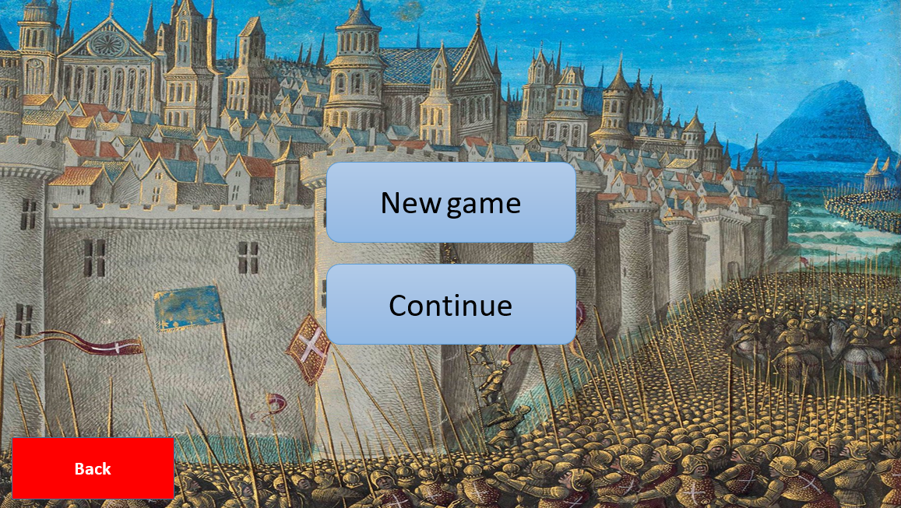

This is what the menu will look like once the user has clicked on the play button, giving them two options, new game or continue. This allows players who have come back to the game to pick up where they left off without confusion. I have added a back button which will allow the user to go back to the main menu where they will then be able to pick from play or controls again.

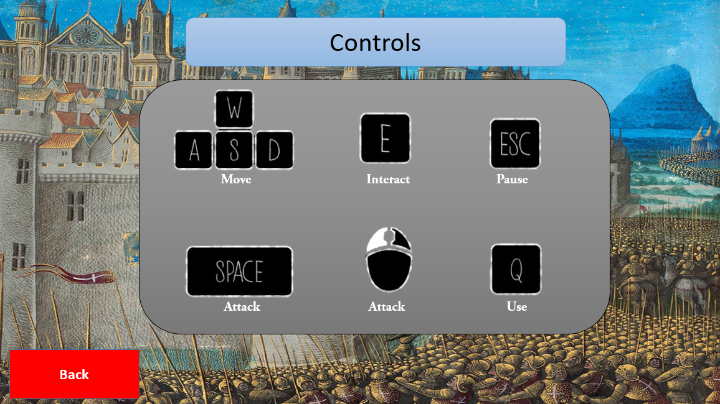

I have made the controls menu, with it having everything the user will need to know to play the game. There are two buttons which do attack, with this being the spacebar and LMB, I have done this to give the user choice on how they would like to play the game. The pause button will take the user to a menu similar to the main menu however, it won't involve the play button, instead having a resume button.

Client’s Response 2

After making my changes I showed my designs to my client to see what they thought.

* “I like the new menu design with it being simpler and softer”
* “The controls menu looks good. It makes it clear the person player what to do”
* “The second layer to play is nice as it makes it clear to the player how to continue their already started game”

Conclusion

I can tell that my client likes my menu page more than they did and they will be happy with it put into the final game.

Back-End Database

When I produce my game I will include a back-end database which will hold all of the personal usernames each player of my game will have. With these I will be able to allow the player to sign in and pick up where they left off in my game. This will all be accessible to the player through a menu which looks attractive and is much more simple for the player to use. As my game will only have a simple database it shouldn’t take too long for me to learn how to make one and it should take too long to produce it.

To produce this database I had to do research into how databases work and how I would be able to link one to my game. I have learned that I will need to use an external program outside of unity to create a backend database, this will require me to learn how to use this program. While researching databases I also discovered that I will have to open and close it whilst the player is acquiring their save to make sure the game is running as smoothly as possible. I must also be able to write to this database as when new players want to make an account I will have to add them to the list.

**Development**

Now that I have finished planning and designing my game, I will now start producing my game in unity over the next few months. By using unity it should allow me to create my project efficiently and also allow me to meet all the requirements that I have set out for my game.

I will show my progress throughout the development of my game by including screenshots and a detailed analysis of each one, making it clearer what I am doing, what’s going wrong and what I plan to do next.

Before I start to make my game I need to plan out what I’m going to work on and in what order. This should hopefully speed up the rate at which I create my game and also improve the quality of it, in the end making an all round better experience for the player.

Plan

1. Create a temporary object to imitate the player character, until I create a suitable alternative for it
2. Create a room which will be duplicated for each room, having a simple design until updated with a better design later
3. Figure out player movement, allowing the player to press wasd to have the players position change
4. Make the player unable to leave the room, unless walking down a path
5. Have the camera fixed to the room until the player leaves it, switching the camera to the other
6. Create a temporary object to imitate the enemy character, until I create a suitable alternative for it
7. Make the enemy character move towards the player, so they are close enough to attack
8. Give the player health
9. Let the enemy damage the player when in range
10. Let the player die
11. Give the enemy health
12. Let the player attack the enemy when in range, having it deal damage
13. Make the player’s attack cause knockback on the enemy
14. Let the enemy die
15. Spawn enemies as player enters room
16. Make a whole level
17. Make notes which the player can use to learn
18. Make a boss for the level
19. Create a pause menu
20. Create a main menu
21. Create a login system
22. Add customisation
23. Add the visuals to my game

This plan will bring structure to my game and make it easier to make and I have split it up into small sections which will be quicker for me to complete. I will try and produce my game in this order as I think it is the most efficient, but if I have to diverge from this plan I will make a note of it, explain why I did this and what has changed in the plan if anything.

Making the game

Setup

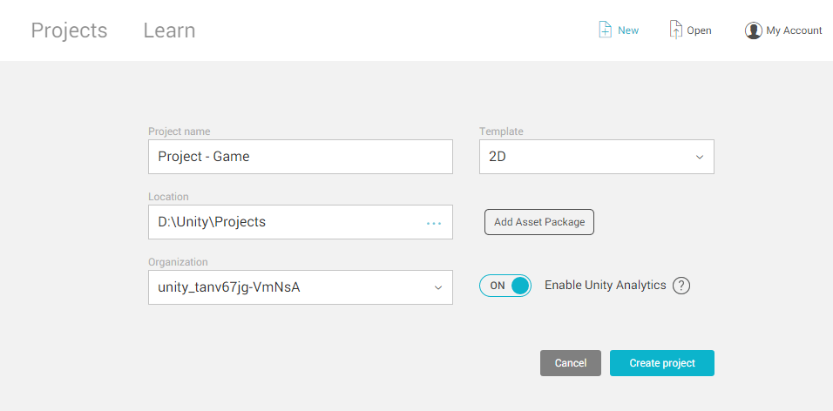

I have started by making a new project in unity, naming it ‘Project - Game’, which is appropriately named meaning I won’t lose it and mistake it for something else. I have made sure that the template is 2D as my game doesn’t involve any 3D elements and made sure to save the game in a location that I will be able to find it.

I will also make a backup of my game every now and then so I don’t lose all my work if a save is lost or corrupt.

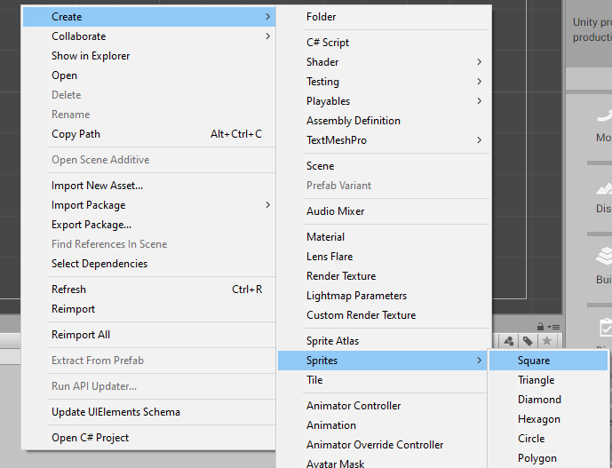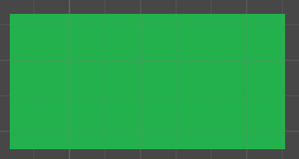

After making my project I have learned how to make a square, which I will use to create a room which the player will be able to walk around in. This square can then be duplicated once shaped into a room, meaning I will be able to create as many rooms as I want. Meaning I won’t have to re add the script each time, which I will make later.

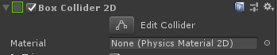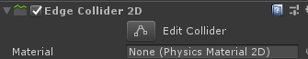

I have tried to add a barrier to the edge of the room meaning the player won’t be able to walk out of the room. I started by adding a box collider however then I learned that you can’t create a hole in a box collider. I then added an edge collider which allows me to choose where the barrier is, allowing for holes to be put into place. This unfortunately means I have to change the edge collider each time I make a new room as the path to the room will be in different locations each time.

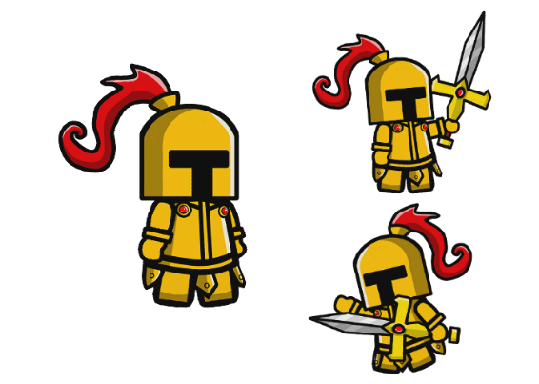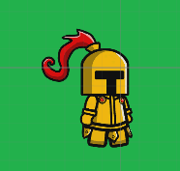

I have now found an image to use as the player character for the time being, with it also including an attacking animation if I want to test animation. I turned the image into a sprite and dragged it into the unity project, making sure to scale it correctly.



From my research on unity before starting this project, I have learnt that it is important to give the player a tag called ‘Player’ and put them on a different layer, which I also named ‘Player’. This will allow me to search for objects with the tag ‘Player’, not confusing them with other objects, e.g. Enemies.

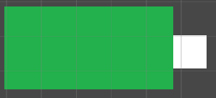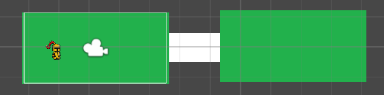

After that I’ve made an additional square which will act as a path to another room. This then led me to copy and paste the existing room, just having to change the edge collider on the new one. This has also helped me realise that I will need two colliders on the rooms, as one will act as the barrier and the other as a trigger.

Player Movement

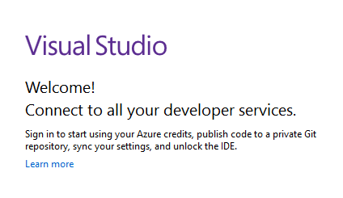

To start coding I opened up visual studios and signed in, checking with other students to make sure I have set it up correctly.

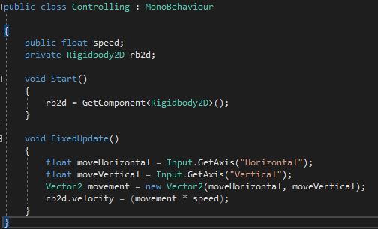

Once I found out I did it correctly I started to look into how to make a player move around. I discovered that you must first get a sprite’s rigidbody to use it, having to assign a name to it. I used the name rb2d to represent it, using the code in the first picture to do it.

To make the player move, I got the players vector and allowed for an input to transform the players position. I then got this and multiplied it by a number called speed, which I will be able to set once in the game and possibly change mid game.

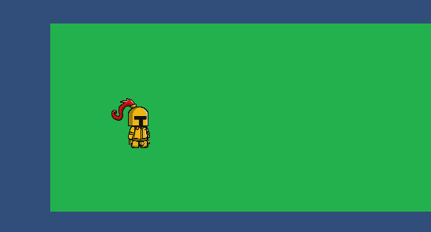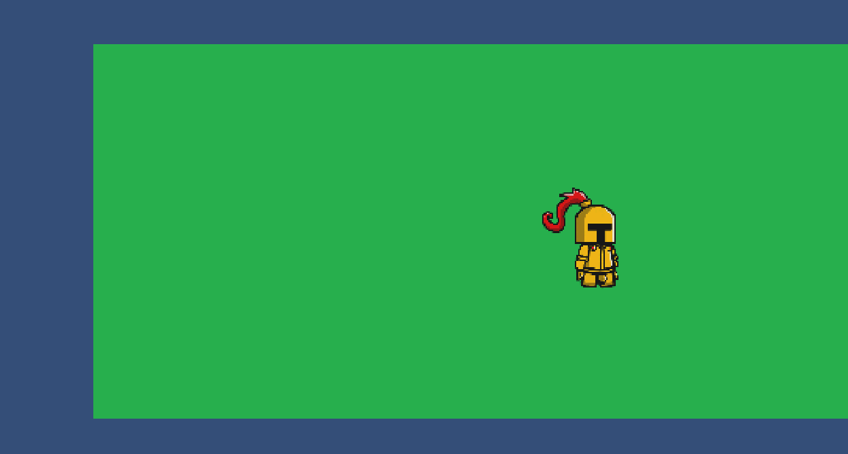

When I entered the game I tried to move around the player and it worked very well, with the sprite moving around by press either W, A, S or D. The player is also able to move diagonally which I wasn’t sure would work, but pressing both W and A will move you to the top left.

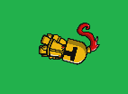



Whilst testing the players movement I found that if the player hit the wall in the right way, it would cause them to start to rotate. To figure out what was wrong I used the internet to help me. I found out that you can lock the X and Y, and also able to lock the Z axis. Locking the Z axis freezes the players rotation meaning when they hit walls they don’t turn.

Rooms

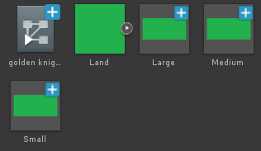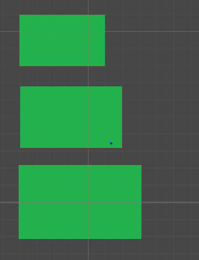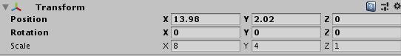

After making the player able to move I looked into making rooms of different sizes. What I did was get the existing room I had and changed its dimensions, saving it as a seperate object. This took me a few tries as I wanted to make the rooms to the same ratio but forgot that you could change the size on the objects in transform.

Camera

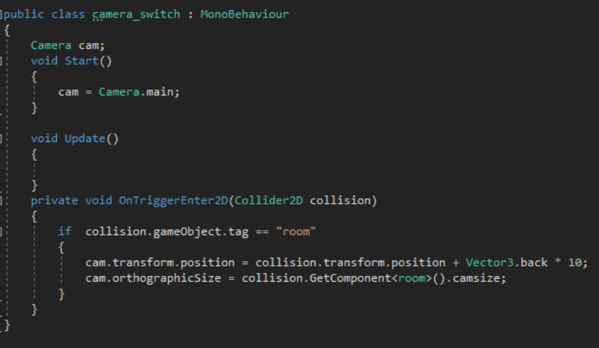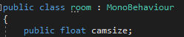

To make the camera switch when the player entered the room I was going to have to assign the camera size for the different room sizes. I made a float named camsize which I can then use to choose the size once in game.

In this code I have made it so when the player collides with an object with the tag room the camera would change position to be over the room. It will then resize the camera depending on the camsize variable in the room script.

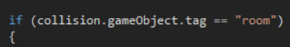

When coding this I had an error which was meaning the game wouldn’t compile properly, meaning I wouldn’t be able to test if the code worked. Whilst looking into it I discovered that I had forgotten that to put the brackets around the if statement, meaning the code couldn’t compile.

Tiles

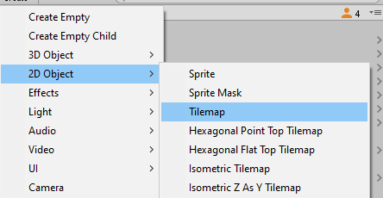

Whilst creating the barriers for the room I decided to see if there was an easier and more efficient way of making a barrier around the room. Will doing that I discovered tilemaps, which will allow me to both create a barrier around a room, but also decorate the edge of the map. To create a tilemap I had to go to 2D objects and create a new tilemap.

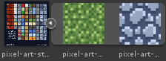

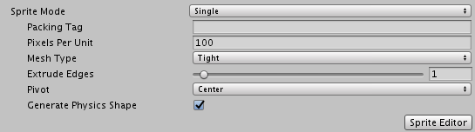

Next I found an image of different tile textures which I would be able to use in my game. I had to take out the images from the picture so I used the sprite editor, running into the problem of the sprite mode being single instead of multiple, meaning I wasn’t able to take out more than one image.

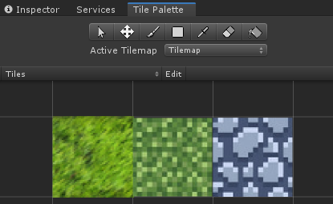

Once I had my images made I dragged them into the tile palette which gives you your selection to use to draw them on the tilemap.

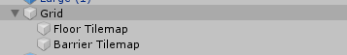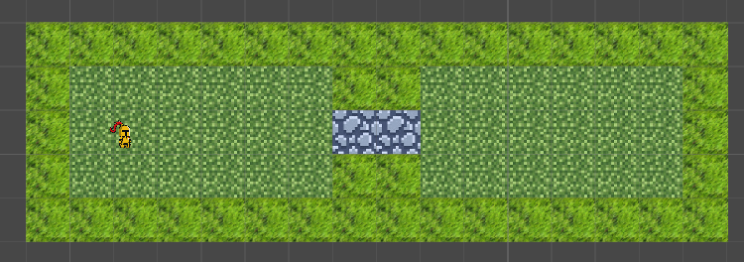

Whilst creating the tilemap I had the idea of making all the art elements for the map with tiles, making it easier than creating textures for my game. With making textures like this I realised that I would also have to make a second tilemap so I could apply a barrier to one of them and make the other one possible to walk over. I also made sure the tiles were the right size so the player would be able to fit through the walkway.

Enemy

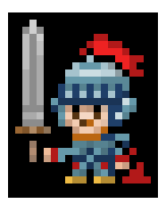

After Creating the barrier I have found a placeholder knight sprite to act as the main enemy within my game. Now that I have an enemy I will be able to create combat within my game and develop a health system. Once I have reached the end of the coding in my game I will look to replace this image with one of my own creation.



As with the player, I have also given the enemy a separate tag and layer which will allow me to search for all enemies in my code. This will be even more beneficial than the ‘Player’ tag as there could be many enemies in one room, whereas there will only ever be one player.

Enemy Movement

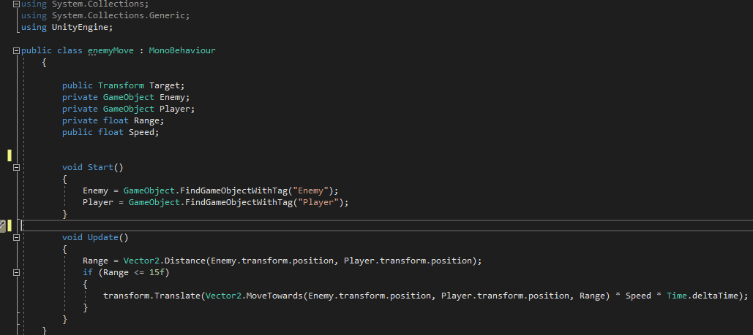

I have started by looking at how to make the enemy move towards the player. I started by looking at what I would need to find in my game, with objects with the Enemy and Player tag being important.



I then looked to find how far away the enemy is from the player and if they’re within range of them. By looking at this it will allow me to tell the enemy to make that number smaller. This should hopefully make the enemy move.



Finally I set a range that the player must be within for the enemy to start following it and then told the enemy to change its position when within that range. To complete this I had to learn more about transforming positions and using Time.deltaTime, which is the time between every frame.

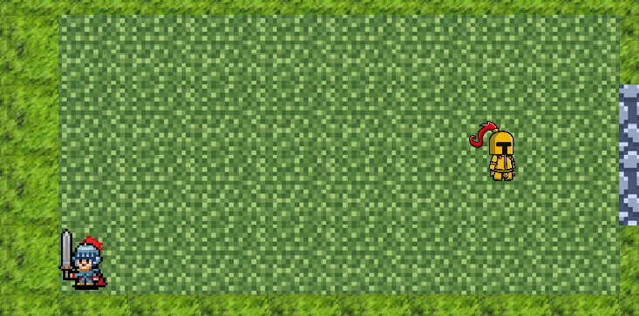

Once I added the code to the enemy it started to move past the player and into the corner of the room. I’m not sure what caused the problem, however I will reread my code to check for errors and typos.

After looking into it for about an hour I wasn’t able to find a solution to the problem so I have decided that I should start again with enemy movement, finding a new way of making the enemy move towards the player.

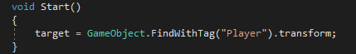

I have started again but have only found the Player tag not including the Enemy tag as each enemy is going to have this script applied to them so it’s not needed.

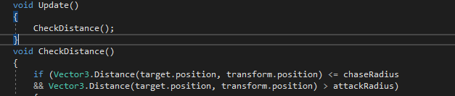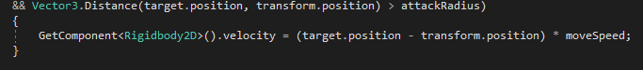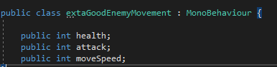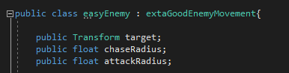

I then produced a function which will check the distance the enemy is from the player and move them towards the player if they are in range. To do this I have to get the rigidbody of the enemy to transform them towards the player.

I then defined the variables for the enemy allowing me to set the values once in unity. I have put some of these in a separate script, with the plan being to have different scripts for different enemies, having them all inherit from one main script.

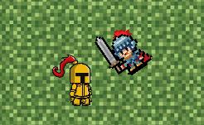

I have run the code and it worked. The enemy has moved towards the player, meeting them when the player moves. However, the enemy rotates towards the player which isn’t what I wanted. I try some things and see if I can make the enemy move without rotating its body.

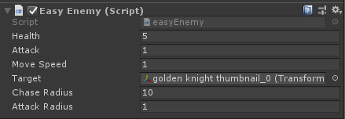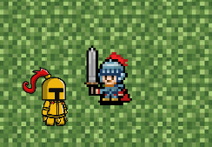

I discovered that having the enemy’s target set to the player was causing it to rotate and removing it made it stop. Once it was removed the enemy continued to follow the player just without rotation.

Knockback

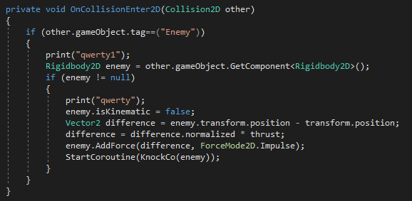

Now that the enemy walks towards the player, I think it is important that the enemy isn’t able to walk into the player blocking them from moving whilst testing. If it was like this it would make it much harder to see if features are working correctly.

I have written some code, that will get the enemies rigidbody when something with the tag ‘Enemy’ bumps into the player.





I have then gone and set the enemy to not be kinematic, meaning I will be able to fully control the enemies position. After setting this I added a force to the enemy which should cause the enemy to be thrown back when they collide with the player. I have also added a variable called ‘thrust’ which I will be able to use to set the power of the knockback.

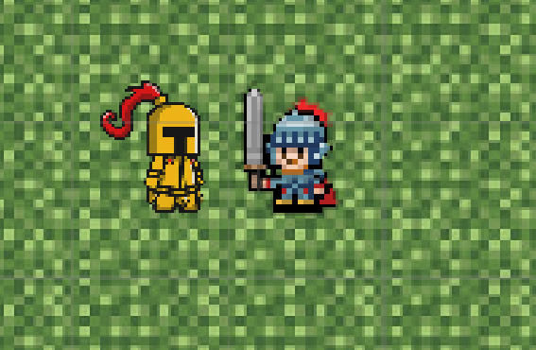

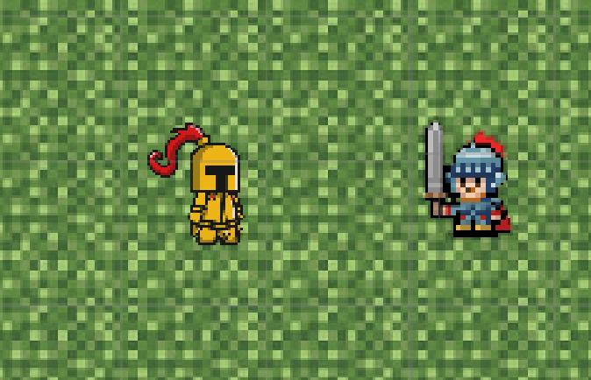

After testing my knockback I received no errors, however it didn’t seem to be working. I went back to the code and tried to rewrite some parts of the code to see if I had tried to create something that wouldn’t work within a 2D game. Whilst looking into this I remembered that I had a thrust variable which hadn’t been set. I changed that thrust from 0 to 10000 and the enemy started to get thrown back.

Now I will have to try and make this run when only when the player presses an attack button.

Attacking

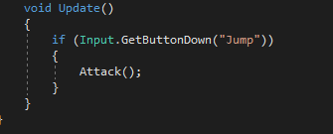

Now that the enemy is affected by knockback, it should be made that the player can attack the enemy. I started this by going into the player script and creating something so when the player presses the spacebar, it will run the attack.

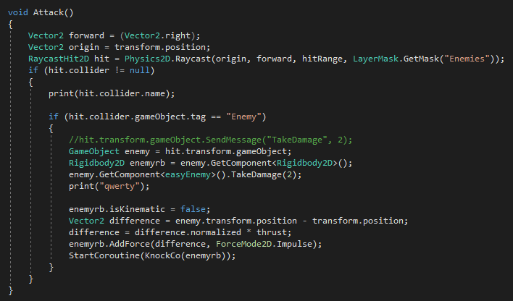

I started the attack function by setting a forward vector for the player, making sure they’re not attacking in any direction. Next I found the current position, which I will then be using to develop a raycast for the combat.

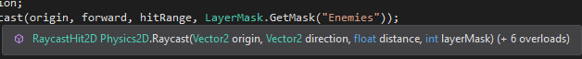

To make a raycast I hovered my cursor over the word to look at the requirements. I need to use the origin (which I have), a direction (which I also have), the distance and a layerMask.

I currently don’t have a distance and a layerMask, meaning I need to look into these and see





After some research I discovered that I just need to set an integer that will act as the range at which the player is able to attack the enemy. I have set this to 1 tile as I want the combat to be somewhat realistic.

I also discovered that a LayerMask is for a certain layer of objects. Luckily I had already made a layer called ‘Enemies’ meaning all I had to do was type in to get the layer and it should work.



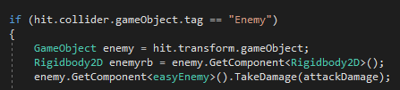

Once I had done this I made it so if the player was colliding with an object with the tag ‘Enemy’ when they attacked then the enemies rigidbody would be taken to use later on the knockback and then run a function which would deal damage to the enemy.

I have set the damage that  the player does to a variable which I will be able to change in unity if it is too much or too little.

I made sure to then attach the attack to the end of the attack, meaning the knockback will only be activated when the player attacks the enemy.

Before I will be able to test if the attack works I will have to develop the enemies health so the ‘TakeDamage’ function runs.

Enemy Health

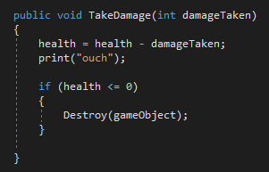

I have now gone into the enemy script and created a function matching the one I called within the Player attack function. In this function I have made use of the health variable and had it go down with the damage the player deals to them.

I have also printed ‘ouch’ to notify me if the enemy is actually taking damage or if I have an error.



I added an if statement which will look to see if the enemies health reaches or goes below 0 and then destroys them if so.

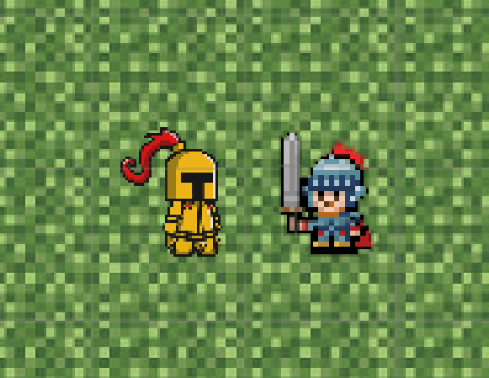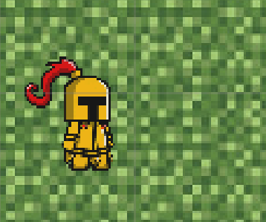

After testing this it worked perfectly, with the enemy having been set 5 health, taking the player 3 hits to kill them.

Now that this is complete, the next step on my plan is to give the enemy the option to attack the player. This shouldn’t be too hard as it will be a lot of the same code that I used for the player’s attacking function.

Enemy attacking

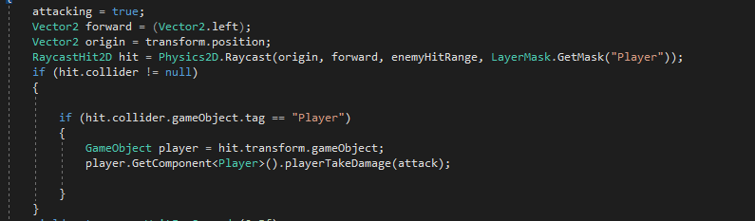

After making the player attack it is much easier to create an enemy attack, simply having to copy the players attack and change a few elements.

One of the main elements I changed was that a ‘PlayerTakeDamage’ script will now run as I will be dealing with the players health instead of the enemies.

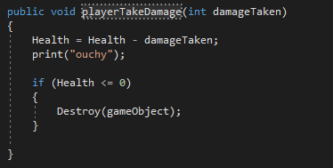



I then took the enemy health function and turned it into a player health function by changing only the name of it.

I made a variable which is similar to the players hit range, just acting as the enemies instead.

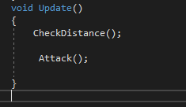

I also had to run this attack constantly to see if the enemy was colliding with the player, as I’m not waiting for a button input from the enemy to attack.

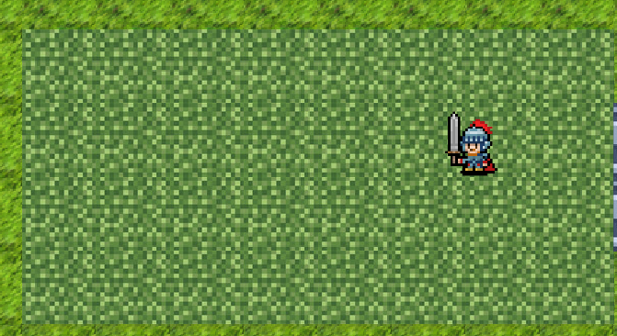

After launching the game, it started with the player being there for a single frame before disappearing. However after looking at the console I noticed that ‘ouchy’ had been printed a few times. This led me to the conclusion that the enemy was dealing damage to the player but not whilst touching them.

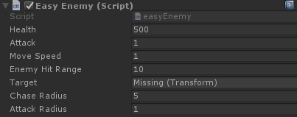

After looking in unity at the enemy script I found out that I had set the enemies hit range to 10 instead of 1, meaning they could attack the player from across the map.



After changing that the enemy no longer killed the player from across the map, but they still instantly killed the player when they touched them.

Looking at the console I realised that the enemy had attacked the player 5 times but there was no gap between how often they were able to attack. This led to the enemy instantly killing the player.

To fix this problem I will look into how to create time delays between how often code can run and if there is anything that I will need to change about my code.

Attack time delays

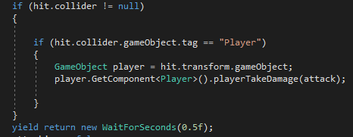

I found out that you can write ‘WaitForSeconds(x)’ to create a countdown in your code to stop it from continuing until it’s complete.

I placed this at the end of the attack function within the enemy script, letting the enemy only attack every half of a second.

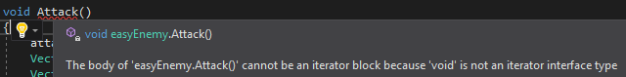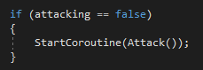

After adding the time wait I received a compiler error, stating that ‘void is not an iterator interface type’. After googling my error I have discovered that to use a time wait you have to turn your function into a coroutine.

To turn a function into a coroutine you have to change ‘void’ to ‘IEnumerator’. After doing this you also have to call it differently, changing ‘Attack;’ to ‘StartCoroutine(Attack());’.



Once I ran the program the enemy approached the player and I continued to run into the same problem as before. The enemy is attacking the player but the time wait isn’t working.



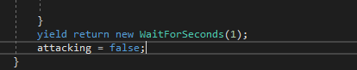

After talking to some of my peers I learned that the coroutines were stacking up and didn’t have to wait for one attack to be done before doing another.

I have got past this problem by having a bool which will state whether or not the enemy is attacking. This means it won’t run unless the coroutine has been fully complete.

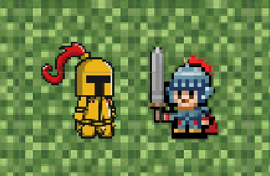

I tested this again, with it this time working. The enemy was dealing damage to the player every half a second, with the player being destroyed after their health reached 0.

Attacking direction

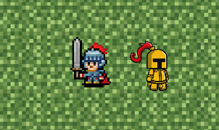

Whilst testing my game I noticed that the player is unable to deal damage to the enemy if they are on the right hand side of them. This of course is a problem with my code and something I will look to fix immediately.

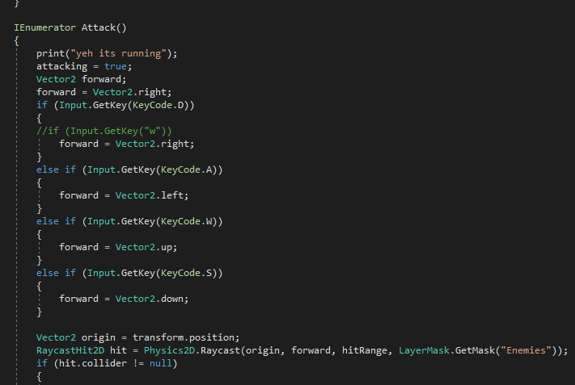

Looking back at my code I noticed that forward had only been set to the players right. I realised I had to make it so forward would change on which way the player had last moved.

To do this I made it so when W, A, S or D is pressed it will get that direction and turn it into ‘forward’.

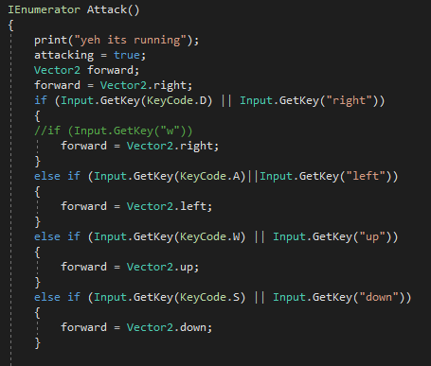

I tested to see if the attack worked in different directions and it did but whilst testing my game I asked someone else to give it a try. When the person started to play my game I noticed they were using the arrow keys meaning that the directions wouldn’t work.

This led me to go back and add the arrow keys too as an alternative to change the forward direction, incase the player prefers to use them to WASD.

Flipping the player

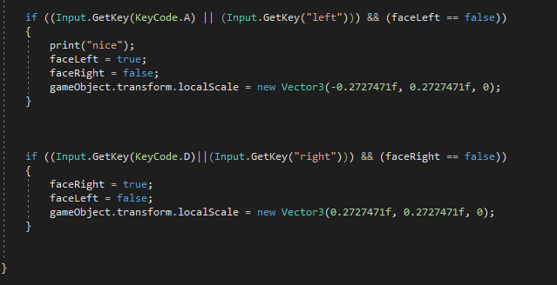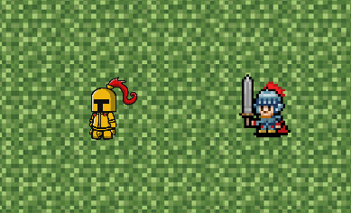

When the person who was testing my combat was playing my game, they mentioned that the player should flip to look the other way or it would be confusing to know if you were dealing damage to the enemy.

I have done this by looking at if the player has pressed the button to move the player left or right. After I know which way they are moving I can then flip the player by changing their scale, making the x value negative when the player moves to the left.

Spawning enemies

Now that the main functionality of my game has been added I need to add other features to flesh out the game.

After checking the plan I must now make it so enemies spawn when the player enters a room instead of having them all on the map at the start. This is so all the enemies don’t walk to the player at the beginning of the game, making it too hard for the player.

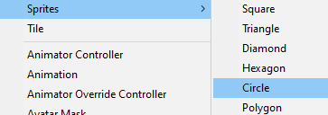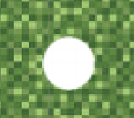

I’ve started by creating a circle sprite to act as a spawn point for the enemies.



I have given the spawn point a tag called ‘EnemySpawn’, this will allow me to find all the spawn points at once.

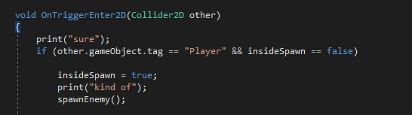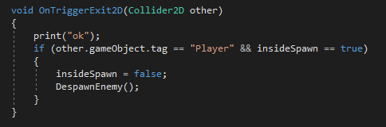

I have written this function inside the room script that will look for when the player collides with a room and run a function called ‘spawnEnemy’.

I then created a similar function for when the player leaves a room, having it despawn the enemies in that room, making sure they don’t move over to the other room.

Now I will have to create two functions which will spawn and despawn enemies.

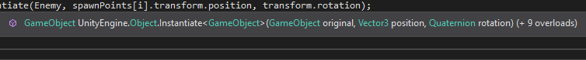

To spawn the enemies I have found out that you can instantiate objects. To do this I need to list the game object, the position and the rotation. The game object I want to use is the enemy and the position and rotation will just be the same as the spawn points.

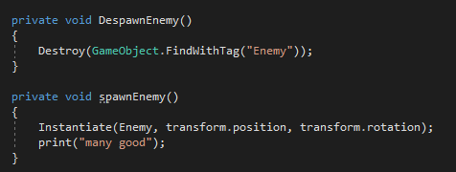

I have produced a spawn function, which should instantiate an enemy on top of it. I have also made a function that will find a gameobject with the tag ‘Enemy’ and destroy it.

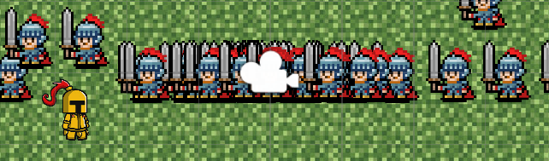

Once I launched my game hundreds of enemies started to spawn in and cause unity to crash. I’m not too sure what caused this problem but I think that it’s a problem similar to the player being instantly killed by the enemy, with code overlapping.

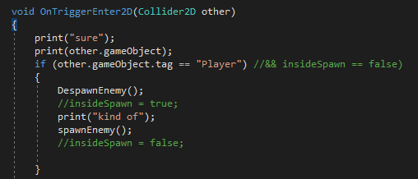

I discovered that having an insideSpawn was causing the code to run more often than it should’ve been, having it not just run once when colliding with the room. I also put the despawn and spawn together when a player enters a room. This will allow for all existing enemies to be removed and new ones to be added with the same trigger.

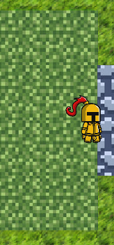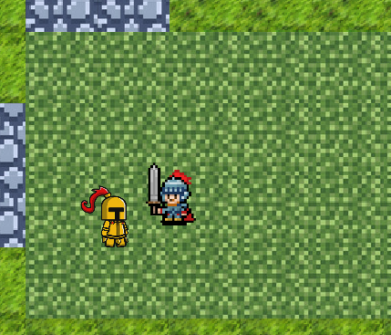

The next issue I noticed with when the player enters the room, the enemy isn’t actually spawning on the spawn point. The enemy is instead spawning in the center of the room and only spawning one when I put down two spawn points.

To find a fix for this I will look at what actually makes the enemy spawn and see where it finds its location to put the enemy.

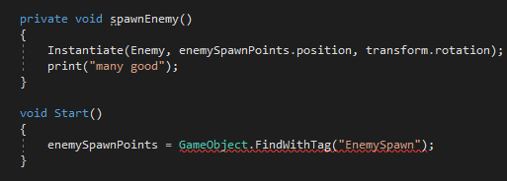

I reread the instantiation and realised that I was spawning the enemy at ‘transform.position’ but this script is in the room script, which means the rooms centre has been acting as the spawn location for the enemy. I changed the spawn location to the name of the spawn point which should hopefully look to spawn the enemies on them.

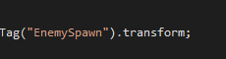

I realised that you aren’t able to just put in the name of a spawn point as it means nothing to the program and also it would only end up using one of the locations, this is why I created ‘enemySpawnPoints’ which should act as a term to describe all spawn locations.

I received an error when I typed this line of code, however I learned that I had forgotten to say that this is a transformation.

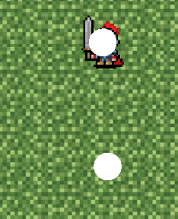

When I ran the program I found that only one of the enemies were spawning in on the spawn points. I think that this is being caused by only one of the spawn points being  found or me only asking to spawn an enemy once. If I can’t find a solution to this I will ask some of my peers if they have had a similar problem with their game.

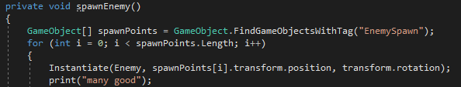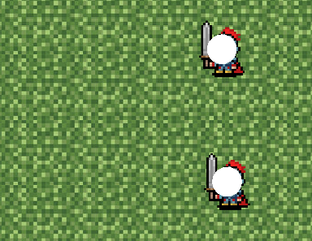

After asking some peers I discovered that I had only been searching for one game object with the tag ‘EnemySpawn’, ignoring all the other existing ones. I have attempted to fix this issue by creating an array of all objects with the tag ‘EnemySpawn’, allowing me to create a loop that will spawn an enemy one by one on each spawn point.

This was a success and made the enemies spawn the location. However, it turned out that this new code was spawning an enemy on every spawn point and not just the ones in that room.

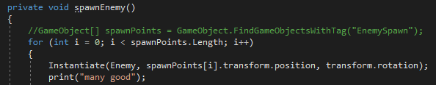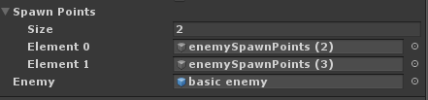

I have gone about fixing this issue by instead of creating an array of all the spawn points I created an array which is set within unity. This allows me to select the size of it and which spawn points I want to be activated when the player walking into the room. I am also able to select what type of enemy I want to be set to these spawn points, meaning I could make it so different types of enemies spawn in different rooms.

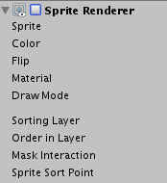



Now that I had added the spawn points and made them work I wanted to make the spawn points invisible, so the player wouldn’t be able to see the spawn locations of the enemies. I was going to do this by simply disabling the sprite renderer for it but then I thought about if the player went back to an old room, ending up spawning more enemies in that room.

To remove this I decided that I should destroy the spawn point once it spawns an enemy. This stops the position from spawning enemies more than once and also hides it from the player.

Map Creation

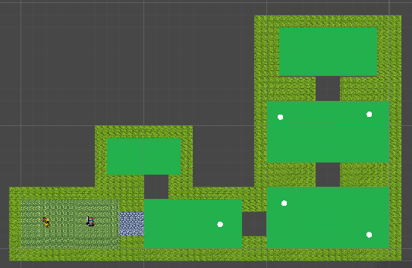

Looking at the plan the next thing on the list was to create an entire map. I went about doing this by laying rooms out with a certain tile amount of spaces and then filling in the gaps with a tile that matches the location. I have continued to use the current textures as they serve their purpose and don’t look too bad.

I also made the tiles smaller, allowing me to fit more tiles in a room than before. This makes the game’s textures look cleaner and less pixelated, as well as giving me more freedom to place them.

Once I had done that I added a few enemy spawn points around the map, not forgetting to assign each spawn point to the room it is in.

Notes

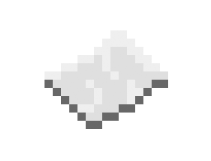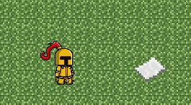

To create a note system within my game I must first find a note to use. After looking across the internet the image above is the best ‘note’ I could find to act as mine. I have turned this image into a sprite in my game, placing it in the game.

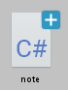

To make this note system I have had to create a new script for it. This is due to the complexity of the notes and how they don’t relate much to any existing aspect of my game.

In my notes I will have to make it so when the player approaches them that they are able to press a button to bring it up on screen, then saving it to a note section on the pause screen.

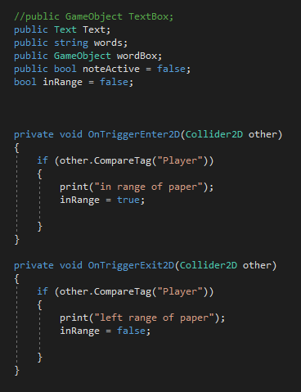



I have started by creating a bool which will look to see if the player is in range of the note to pick it up. I have set it to be false when the program launches as the player won’t be on top of a note when the game starts.

I have written a function that will run when an object with the tag ‘Player’ enters the notes collider, setting the bool to be true. I also wrote a function that will look for when the player leaves the collider, setting the bool to false.

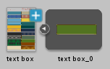

After programming the code to tell whether or not the player is in range of the note I have gone and found an image of different text box styles, selecting my prefered one from them. This text box should appear to the player and show them the note, disappearing once they’ve read it.

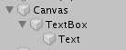

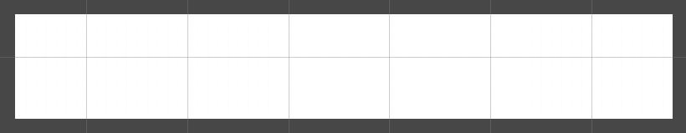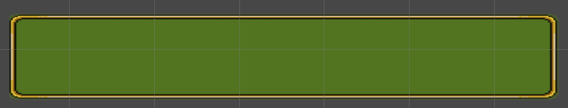

To create an effect like this I have found out that you are able to create a ‘canvas’, which acts as the user interface. Within the canvas you are able to create images which are able to have their textures changed once placed. Then within the image, text can be placed, being displayed when the image is activated.

I have put the canvas image to look like the text box texture I had found earlier, having it change from a white box to the image I want.



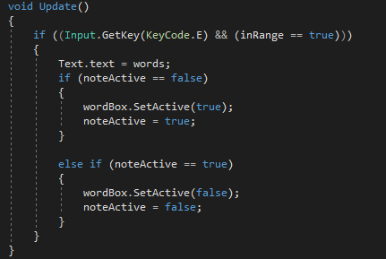

To make this text box appear when the player activates the the note I have looked for when the player presses the ‘E’ key and requires them to be in range of the it. If both of these things are true then I have made it so it sets whatever text I want to display will be the same as the text I write into unity.

I then set it so if the text box wasn’t activated to then make it active and the opposite if it is activated.

I will now test to see if what I have written works correctly and if I need to change anything.

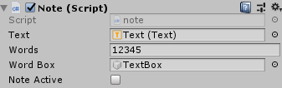

Before I am able to continue I must remember to attach the note script to the note object, as well as enter the game objects and the words I want to be used in this script.

For now I have used ‘12345’ to test the text as it is simple and long enough to give me an idea of how it works.

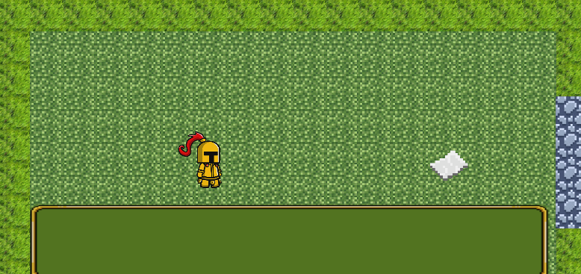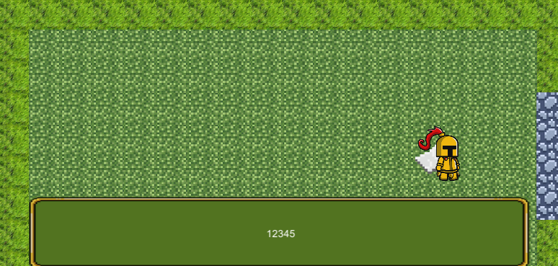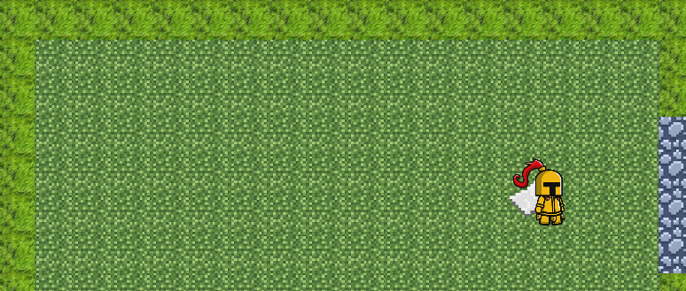

Once I entered the game I found that the text box was already activated without any text in it. I’m not too sure why this would be happening as the code is set up to only activate it once the player has walked over to the note and pressed E on it.

I walked the player, with this error still being present, over to the note and pressed E on it, finding that the text would then appear. I then pressed E a second time and found that the entire text box disappeared.



Looking into the problem I ended up finding that I had to disable the text box in unity before running the game. This was easily done by simply turning off the box with the tick box next to the objects name.

I will now learn from this and try to remember with all UI elements that if I want them to show up once something is pressed, I must make sure to disable them before launching my game.

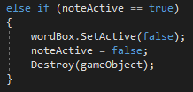

I also thought it would be important to simulate the process of picking up a note by having it disappear once the player stops reading it. They will be able to read it in the note section of the menu.

Back-end note system

When coming up with ideas on how to display the content of these notes, I came up with the idea of having all the notes stored in a text file which I could then use to call each of them, one by one. This will make it easier when I have to show these notes in a menu, being able to call each line of this file instead of having to take it out of unity.

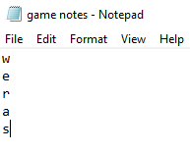

To start making this back-end system for my notes I created a text file, writing a different letter on each line to simulate a note.

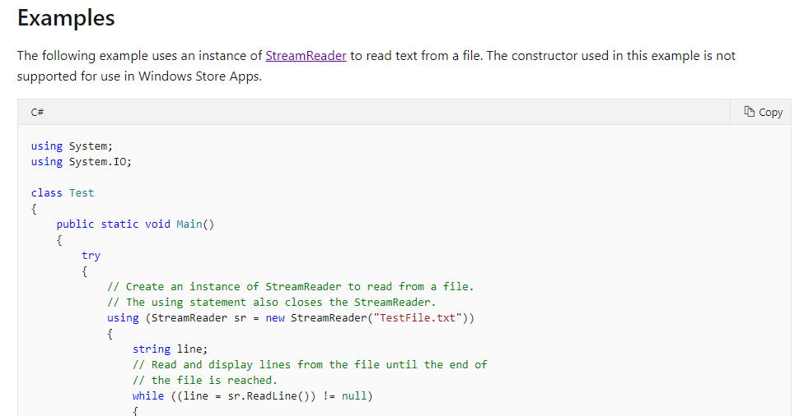

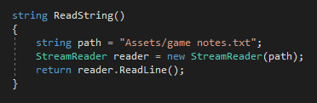

To read from a text file I had learnt that you needed to use a streamreader. However as I wasn’t too sure on how to use them and what commands I would be able to use, I turned to google. I found the web page: ‘https://docs.microsoft.com/en-us/dotnet/api/system.io.streamreader?view=netframework-4.8’, which I was able to use to learn the basics of stream readers. It taught me that you list a file location and tell the streamreader to read from that location.

I have done this by making a streamreader called ‘reader’ to look at the lines in the file, located in ‘path’.

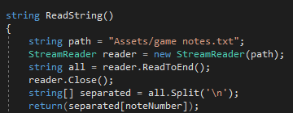

After looking further into the streamreaders, I discovered that ‘.ReadLine’ only reads the first line of the file, where as I want it to read the entire file. To fix this I changed it to ‘.ReadToEnd’, with this command reading everything in the file. Once I have read the file I learned that you can then close the reader as it's not needed anymore.

I then created an array of all the different notes in my file, splitting them up by line. I have done this by using ‘all.Split’ and then using ‘\n’, which represents a new line.

I have heard from my peers that they have had trouble using ‘\n’, telling me that it doesn’t normally work. I will continue to use this until I run into an error or find that my code isn’t working.



Now that the lines were split up into an array, I have made it so this string will return the line which matches with a ‘noteNumber’, which will be set for each note.



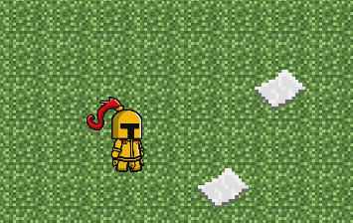

I have assigned a note number to two notes testing to see whether or not it would work with multiple notes. This should allow me to not only see if the streamreader has worked but also to see if the file was split up correctly using ‘\n’.

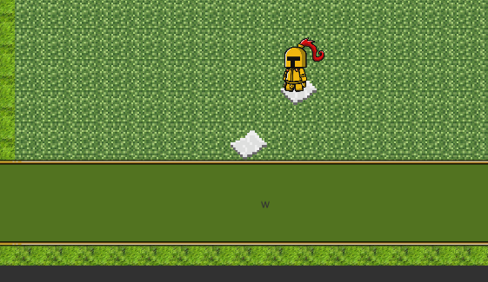

I tried to interact with the note and found that it worked very well and I was able to get the text to appear on the first note. After interacting with the second one I also found that it work as intended and the letter ‘e’ appeared.

Now that I have created a set of working notes, I must now look to find a way to make it so the notes are acknowledged as being collected. To do this I will write on the end of the line a certain

character which will represent whether all not the player has found the note.

To write to the file I will have to do more research into ‘StreamWriter’, finding out what I need to use to make change and reset.

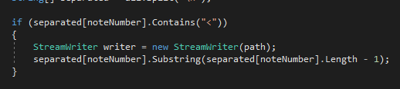

After researching the stream writer I have been able to write a line of code which should remove the ‘<’ symbol from the end of a line. I have decided to use the ‘<’ symbol to signify a note not not being collected by the player, having it deleted when they pick it up.

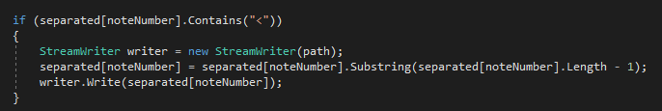

After removing the ‘<’ from the end of the line I have to also rewrite it to the file. One way in which you can rewrite a file , which I have used, is by using ‘.write’. Using this should replace the line in the file which I have changed to take the ‘<’ symbol of the end.

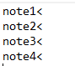

To make testing easier I have changed my file to have lines named so they clearly represent each note. To also test the removal of the symbol I have added a symbol to the end of each of the lines, making it easier to test to see if it works.

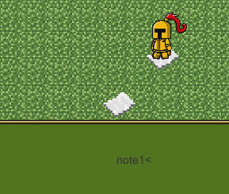

After testing the notes I discovered that the line wasn’t being updated like it was supposed to be doing.

I believe that this problem is being caused by forgetting to write a line of code that is important for StreamWriters.

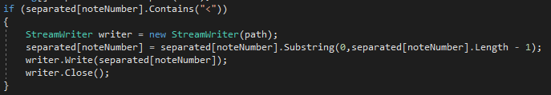

I found that I had forgotten to close the writer before running the code, meaning the file didn’t save. I fixed this by using the line ‘.close();’, which closes the writer.

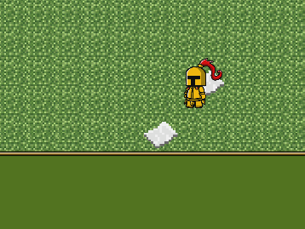

After testing the notes again I found that the problem wasn’t fixed but I had found another error. This time the text is not displaying for the second note. I think that there could be an error with deleting characters from the file. To test this I will try to delete an additional character to see if it will change anything.

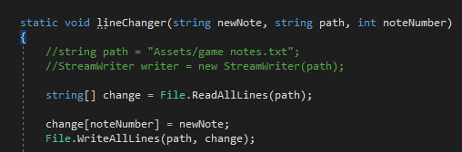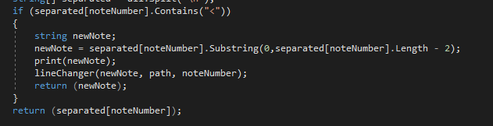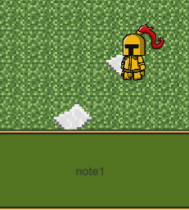

Whilst trying to fix my problem I found out that I had been trying to write to the file incorrectly, adding a line to the bottom of the file instead of replacing the existing one.

To fix this problem I have made a function called ‘lineChanger’ that is made to read the lines in the file and then replace that line with the previously edited line.

I have also changed how many characters I am taking away from the line, discovering that taking away one character removes an invisible space and not the first character.

Testing this I have found that the notes are now working, with the player being able to read them with no errors.

I will now look to create a way that will reset the notes when the player launches the game.



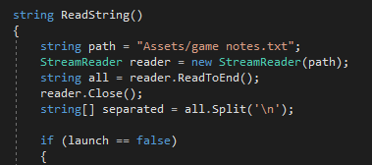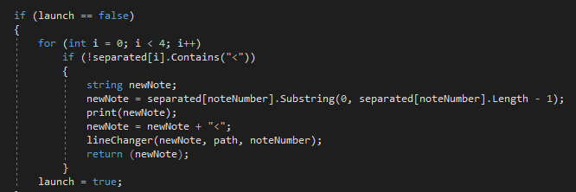

To make it so the game resets the notes when the player presses new game I have had to check which lines in the file are missing a ‘<’ symbol and then add one back to the line. I have put this within the reading notes function so I don’t have to create a new stream reader.

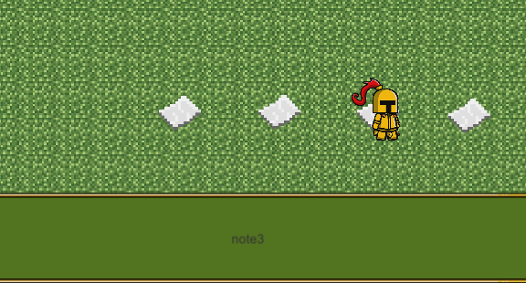

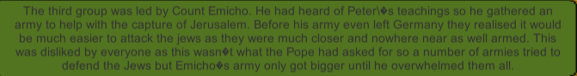

I have tested the note reset by picking up every note and then quitting and going back into the game. The results of my test show that the reset system is a success and will work everytime.

I have also added true notes to my game. I have done this by simply putting my research into the notes to save time.

If I have any spare time I will go back and improve on the qualities of these notes.

Barriers

I have had some peers test my game and have found that some of them decide to run away from the enemies back into other rooms, causing the enemy to despawn and them not having to fight them. To get past this issue I have come up with the idea from the video game I researched ‘The Legend of Zelda’ having barriers blocking rooms, meaning you have to kill every enemy in the room to proceed.

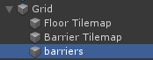

To make these barriers I have started by making a new tilemap inside the grid which I have called barriers. I will paint all of the barrier blocks onto this and should be able to turn it on and off depending on how many enemies are left in the room.

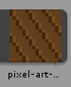

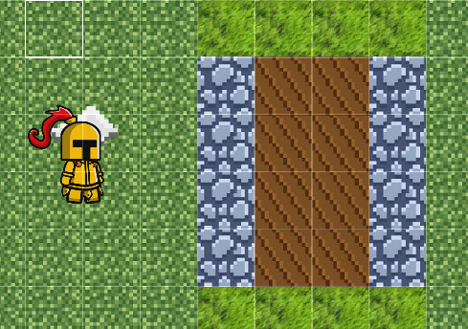

I have looked online and have found a texture which I believe would make a good barrier design. Once I had this texture I added it to the tile palette and drew on barriers on the path to make them block the player, not forgetting to add a box collider to them.

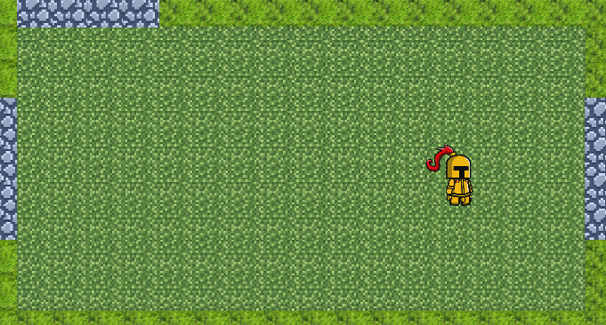

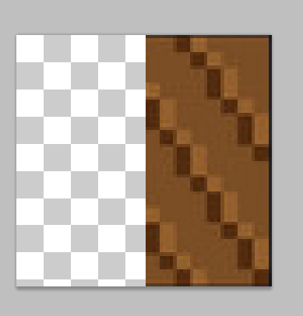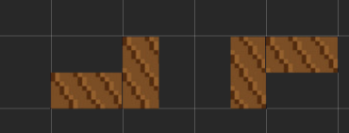

When I loaded up the game I discovered that the barriers weren’t in the players view range, meaning the player wouldn’t know whether or not the barrier was still there.

To get past this problem a peer suggested that I create a half barrier which will not block the path but will bring the barrier into the player’s view range.

To make this I opened up photoshop and took one of the barrier pieces, chopping it in half, making sure to match the end of the textures to the main barrier pieces.

After making one half barrier I realised I was going to need many half barriers for every side of the path, depending on which way the path went.

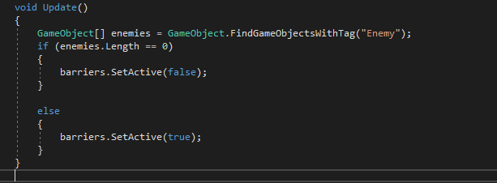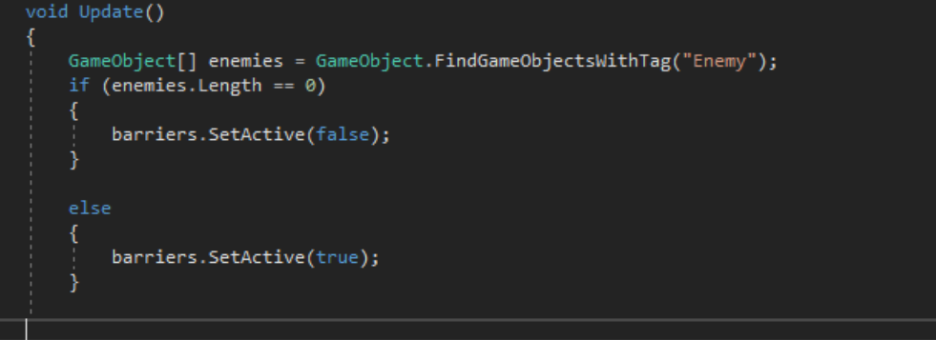

To program in the barriers to disappear I made an array which will find how many enemies there are on the map. Once this number reaches 0 the barriers are set to false and the player will be able to walk into the next room.

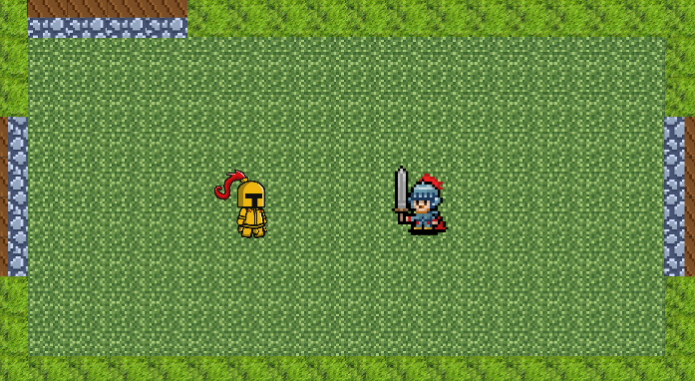

When trying to test this I discovered that I had received a compiler error. After going back and looking at the code I found that I had forgotten to add a bracket to the end of update causing it to not load properly.

After I fixed this error and tested my game I found that it worked very well, with the barriers disappearing once the player killed the enemies in the room.

Hearts

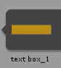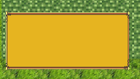

I have decided that to let the player keep up to date on their health that I should have a heart system, displaying the current hit points remaining for the player.

I have found this sprite online of a heart which I will look to use as hearts inside of my game.

I also reused the box sprites I found for the text box, creating a box for the hearts to go within, making them clearer to see.



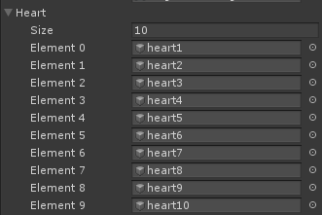

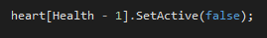

To make the hearts match the player’s health I have written a line of code that will get the player’s health and deactivate a heart once the player loses it. I have had to make an array of hearts for this to work, assigning each heart to a value and matching the health value to it. As arrays start at 0 this is why I have had to minus one from the health value to match with the array.

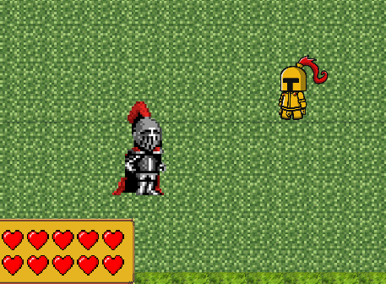

To make these hearts clear for the player I have laid them out on top of each other in standard video game style. This should hopefully give normal people an easy way to understand their health and for people who play video games regularly to have a familiar experience.

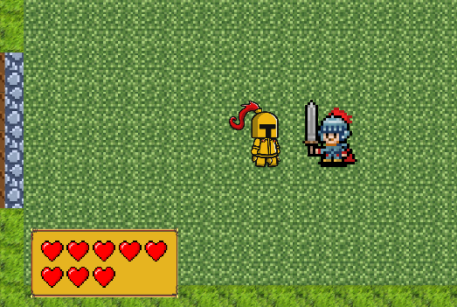

I have now tested the heart system in my game finding that it works well, with the enemy dealing one damage and the player losing one heart at a time.

Boss

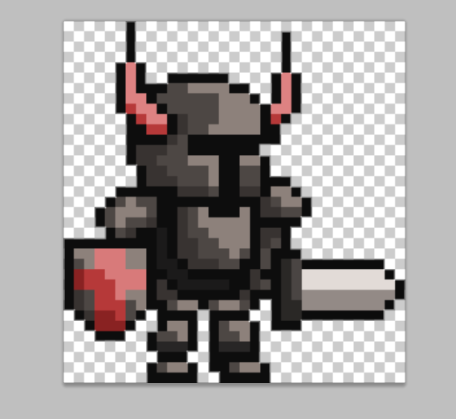

To develop a boss for my game I have looked at different sprites to use them as place holders. I have found the image above, putting it in photoshop and removing its background.

To make this boss enemy I won’t have to change much of my current code as I have already developed an enemy script so all I will have to do is write one or two new functions to make the enemy work.

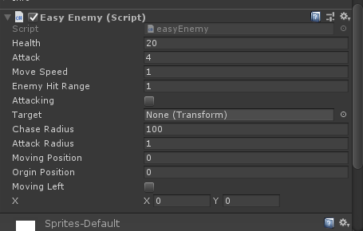

After looking into it I have found out that I already had all the code I needed for the boss, just having to change the existing scripts variables. I gave the boss 20 health and 4 attack to increase the difficulty for the player.

As I was working on the boss I realised that an enemy chase radius wasn’t needed as the rooms are too small anyway to make it reasonable. I have therefore set the chase radius to 100 tiles for each enemy meaning the player will always be chased by the enemies in the room.

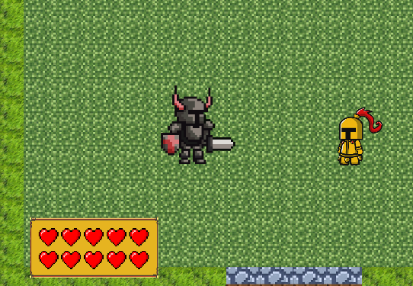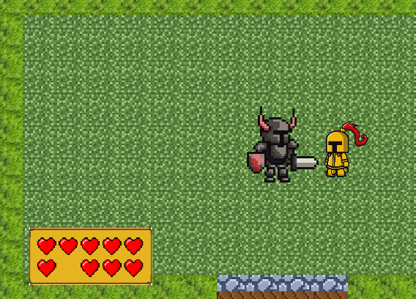

Now that I have implemented a boss I have tested to see if it works. Whilst testing I have discovered the hearts aren’t disappearing as I wanted them to, having only the amount of damage heart turn off instead of all the ones above.

To fix this problem I will try to make a loop that will go through and deactivate all the hearts above the player’s health.

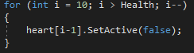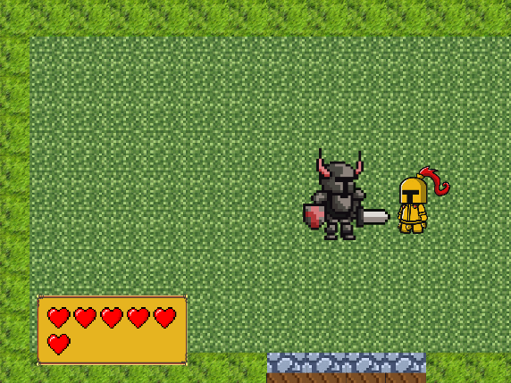

I have created a FOR loop that will go through and turn off the player’s hearts depending on how much health they have. This is better than my other code as it will deactivate all the hearts above the player’s health as well, meaning I don’t end up with only one heart disappearing at a time.

To make sure this worked I went back into my unity game and moved the player in front of the boss. To my surprise I found that the heart system worked and went down four hearts at a time.

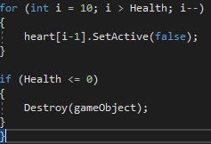

I have now tested it again to see if there are any more problems with the boss and have found that when the boss approaches the player and attacks them, the player will reach 0 hearts but not die.

I believe this problem may be caused by the enemy dealing 4 damage instead of 1, having the player skip past 0 health and go to a negative value. This is fine for the health function, however the displayed hearts in the corner don’t have a value which is negative causing it to create an error.

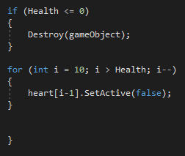

I have fixed this problem by moving the code to change the hearts after the destruction of the player, meaning the player will die before the code tries to make the hearts go below 0.

After changing this I found that I ran into no errors when testing the boss fight.

Pause menu

To make a pause menu for my game I have to have menus within my menu, allowing the player to select the section they want.

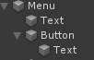

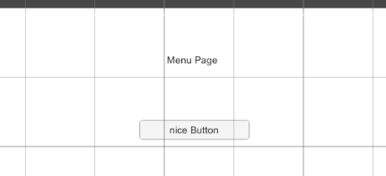

To start making my menu I have made a basic menu page using a canvas image, a text box and a button. I have made these through the object creation, making sure to put them all inside of a background image, meaning I will be able to turn on and off the menu as I like. Setting up these basics will allow me to build off them when I start to develop it more.

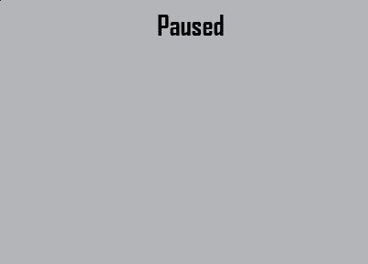

To make my menu look better I have made a basic design for the pause menu within photoshop. I will be able to apply this image as the texture for the background image in unity, meaning I won’t have to remake the background image.

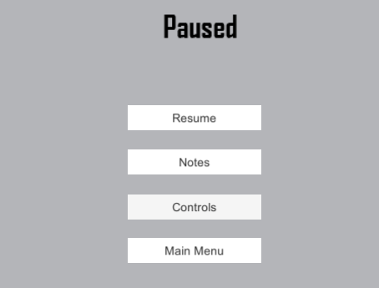

Once I put the image in unity I added some buttons to the menu, having them read different titles for the submenu they will open. I included the menu notes, allowing the player to check all the notes they’ve collected, along with a controls and menu button.

To produce code for my menu page I believe it will be similar to the notes, with me turning on and off the element depending on whether or not a button is pressed. However, unlike the notes, the menu has many subsections which I will have to be controlling depending on which button is pressed.

Buttons

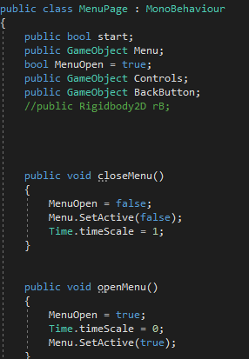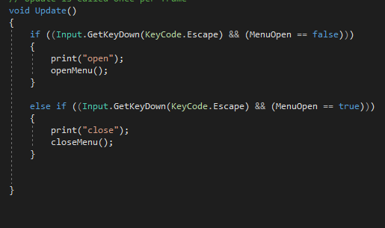

I have discovered that buttons in unity can have a function assigned to them and run it when pressed. This means I will create a number of functions which will launch each element of my menu, one for turning it on and one for turning it off.

I have already made an open menu and a close menu function that will open or close the pause menu when run, having this run when the escape key is pressed. This also pauses the game having the time scale set to 0 when the menu opens.

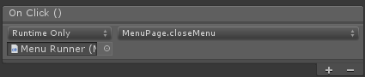

I then assigned the close menu script to the resume button, letting the player get back into the game once they have paused. This is also set so it will only run once when pressed, allowing the player to get back into the game and then pause it once escape is pressed again.

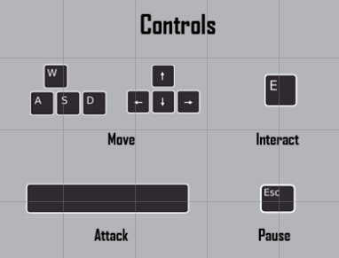

In photoshop I designed a controls page which will give the player an idea on how to play the game. To make this image I got an image of a keyboard and took out the keys from it, turning them into individual images.

This menu should hopefully remove player confusion as it teaches them all the controls and how to recheck them if they get stuck.

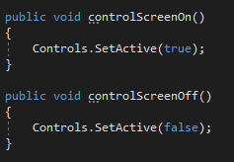

To turn on and off the control menu I have created two new functions.

Back button

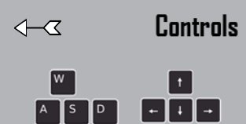

To make my menu pages easy to navigate I have found an arrow sprite which I have decided to use as a back arrow for them. This arrow also fits with my medieval theme, making my game have a more professional feel to it.

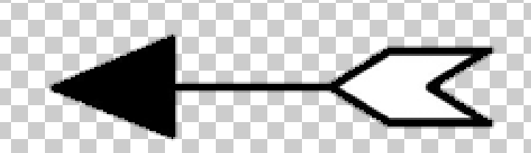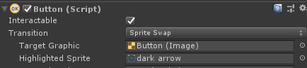

While looking into making this arrow function as a back button, I found out that you are able to swap a sprite out for another one in a few circumstances. The one that most interested me was the sprite would be swapped if the user hovered their mouse over the button.

This gave me the idea to make a fully black arrow that would change colour depending on if the player put their cursor on it. This would also help the user know that the button is function and their game isn’t frozen.

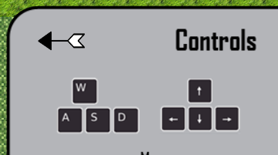

After implementing this I asked a peer on what they thought of the arrow and if the colour change improved it. Their answer was “The arrow is very on theme and the colour change increases the overall professionalism of the game.

Notes page

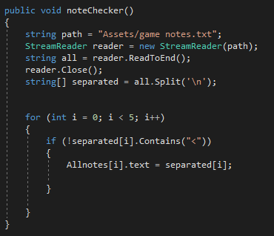

To make the note screen I have realised I don’t have to write much new code, with my notes already doing most of the work. The main difference between my notes and the note screen is that I have made an array of notes within the note screen and setting each one to turn on with new notes as they are discovered.

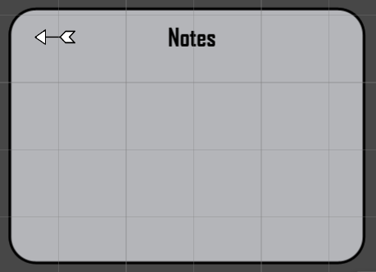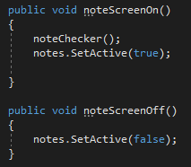

I have now created a notes page which the player will be able to use to read the notes that they have picked up. This will allow them to revisit their notes and should continue to hold the notes until the player starts a new game.

This page like the others has a function which activates and deactivates it.

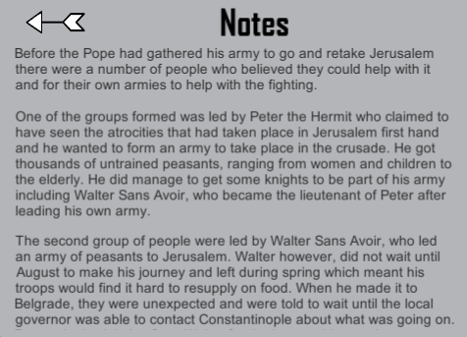

I have tested to see if the notes stack up when they are picked up and it works. However, all the notes don’t fit on the screen at once meaning I will have to make a way of scrolling through them once collected.

Main menu

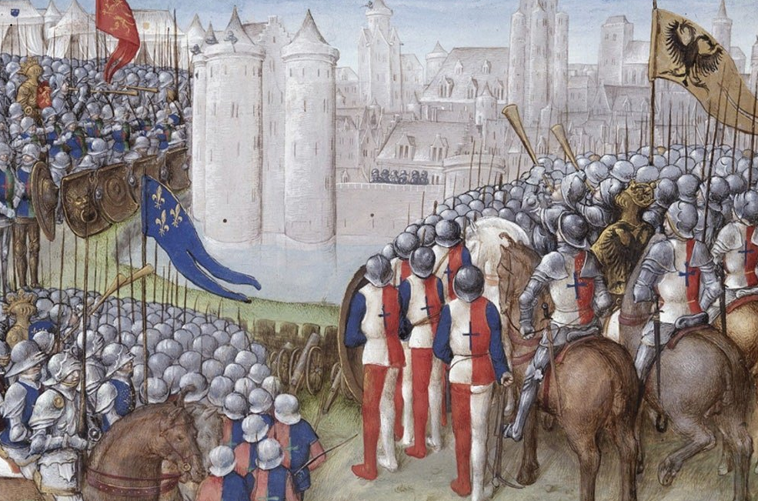

To start making a menu page I have found a background image of art during the crusades to give my game a more medieval feel.

To make my menu I will have to make a different scene that I will launch whenever the player presses ‘main menu’. This will also be the first screen the player sees when the launch my game, giving them different options on what to do before starting.

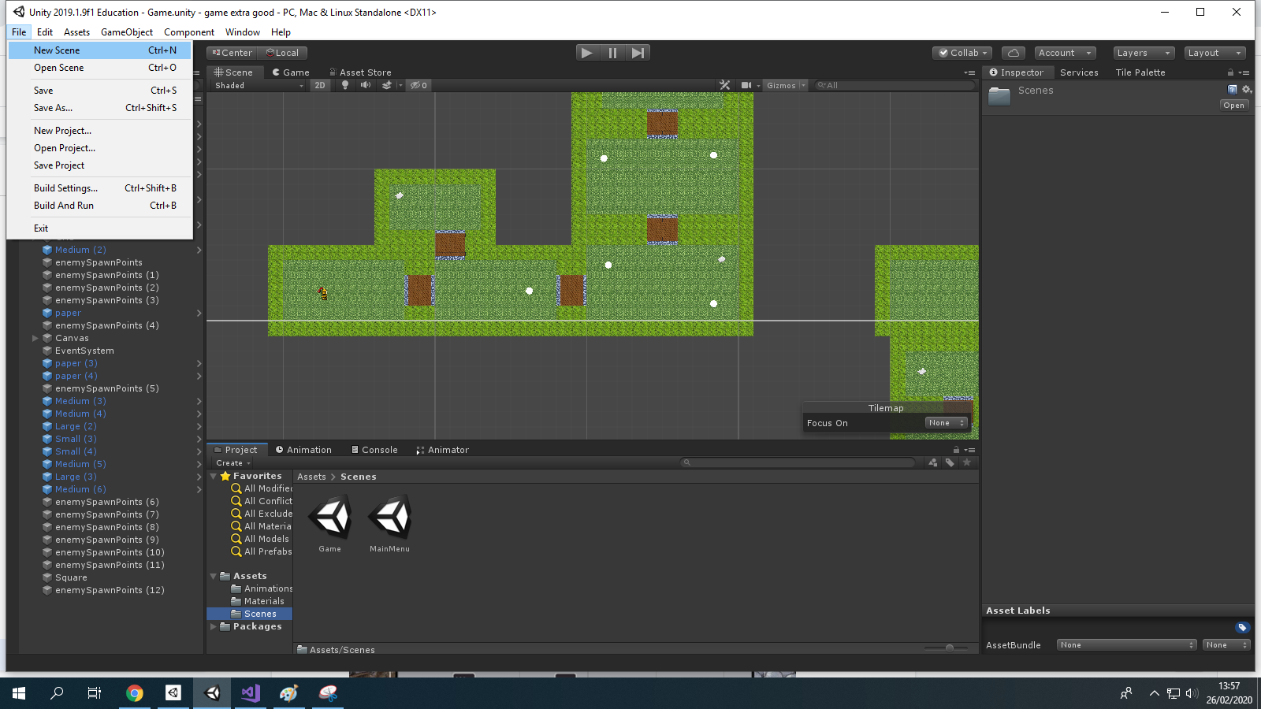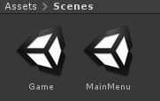

To make a new scene I have gone into ‘File, new scene’, letting me switch between my existing game and a new, empty scene that I will use as my main menu.

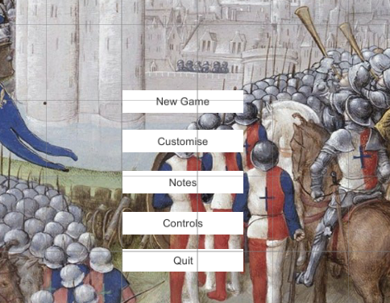

I have got the image I found earlier and put it as a background image to my main menu, placing a number of buttons on top of it. The controls and notes section of my game will be the same as in the pause menu meaning I won’t have to write as much code for it.

The New Game button will load the main game scene, however I will have to figure out how to load a scene before I do this.

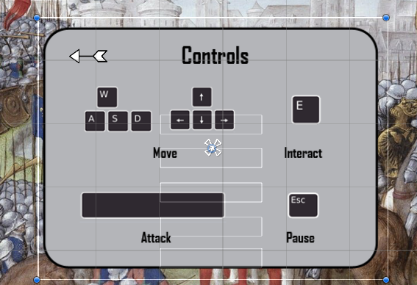

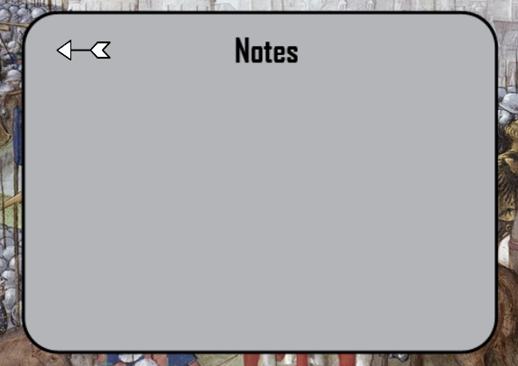

Adding the two pages that already existed wasn’t difficult, simply dragging what I have already made into the new scene.

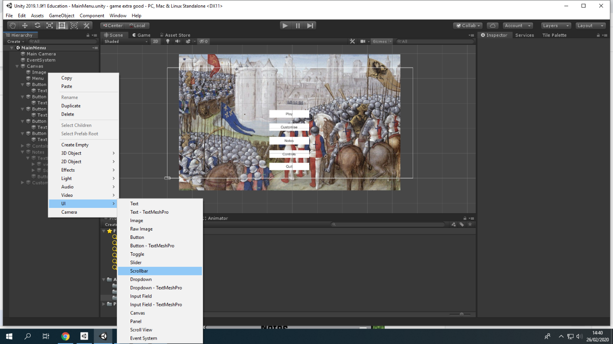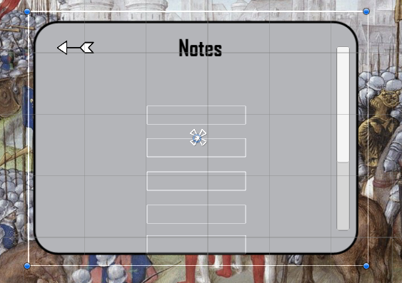

To make a scroll bar I discovered that you can just go to create UI and select a pre made scroll bar which has a few elements part of it. Once I made the scroll bar I placed it in the notes menu

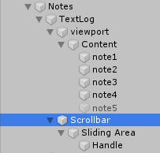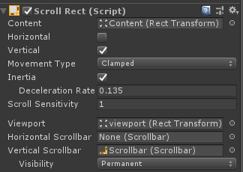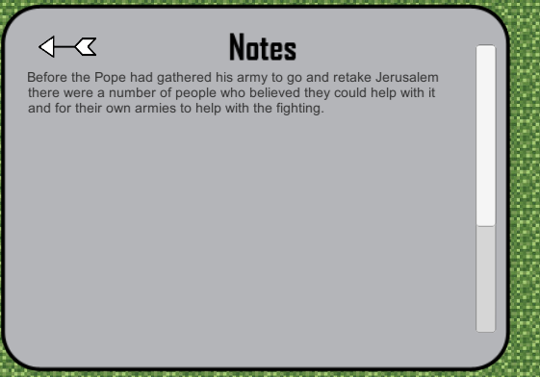

Within these scroll bar elements there is a viewing port which is used to display the text which is scrolled through. This has led me to put the notes in the viewport, meaning the notes should work with the scroll bar.

I have made sure to set all the scroll bar settings to match my design idea, having it go vertically and have a scroll sensitivity of 1.

Customisation

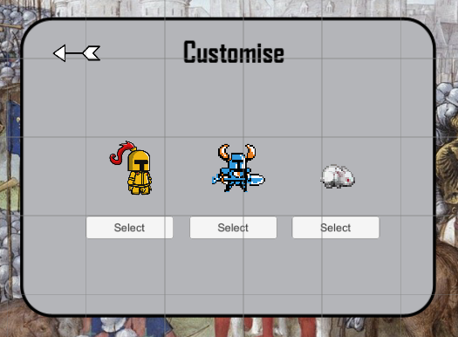

Starting to make a customisation section for my game has led me to realise that this part of my game isn’t too important for the crusades, with most soldiers looking the same.

Due to this I have decided to make the customisation element a side feature that I will be able to use to encourage younger students to play my game. This should in turn allow them to start to learn about the history of the crusades early, setting them up for the further years.

As this feature is for younger children I have found more child friendly characters, with there being a blue knight and a rabbit.

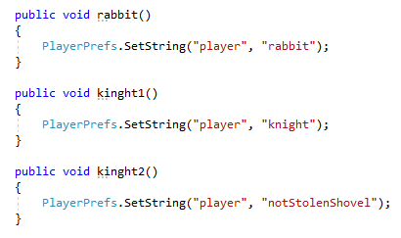

To switch the characters sprite I have decided to use animation as I believe it will give a more professional feel to my game. Using the animator will also allow me to add a walking animation to my characters, making the player feel like their character is stepping instead of gliding.

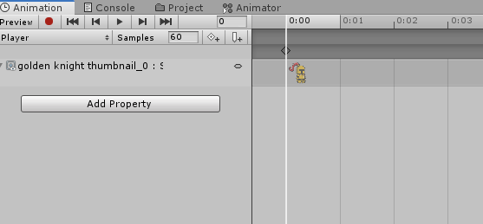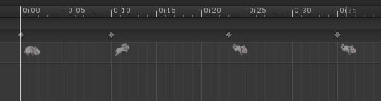

To make animation work I have gone into the animator and have created a different animation for each sprite. These animations will be swapped out depending on which character the player chooses at the start of my game.

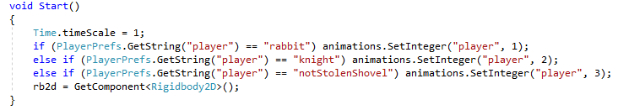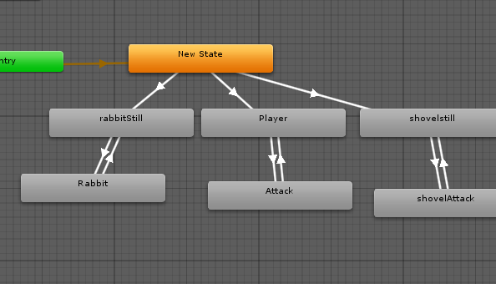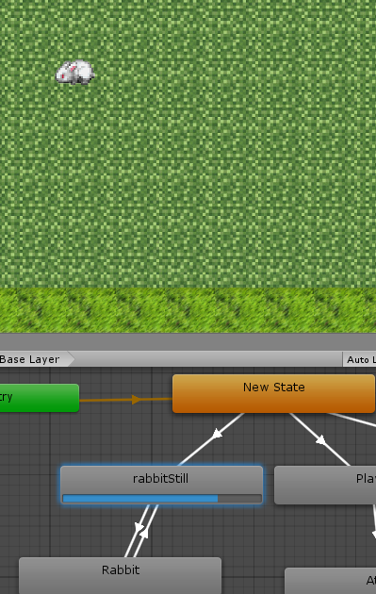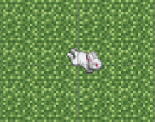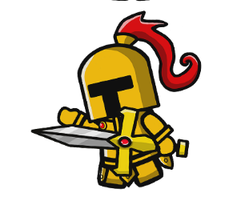

I have written a function that will convert the players animation depending on which button they pressed at the start of the game. This works by looking at the player and changing which animation is currently active.

Within the animator you are able to layout how the animation flows and when to switch. I have made the knight have an attacking animation but only included a moving animation for the rabbit as I didn’t have a different sprite for the other characters.

Second level

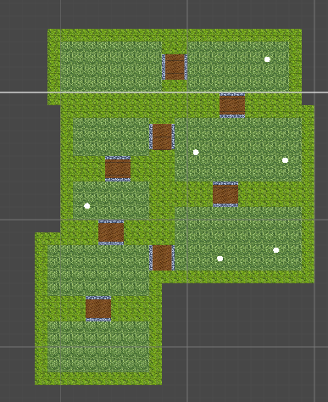

I decided to make a second level for my game as it wouldn’t be too hard to make. This second level will not only lengthen my game but also give the player a sense of progression.

To make the second level I have placed down a few rooms and spawn points, coving them in tiles.

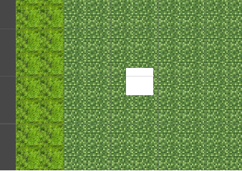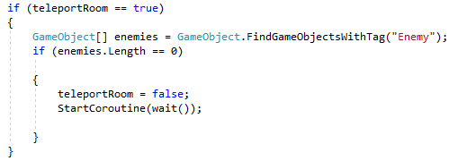

To move the player over to the new map I have made a teleport object. This object doesn’t need a texture as I will turn off the sprite renderer, making sure the player doesn’t see it.

I have written a function that will check to see if the player is in the final room of the level and if there are any enemies left alive in it.

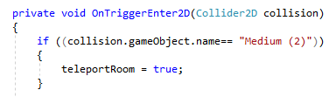

To check whether the player is in the room I have looked to see if they have walked into the object, which I have done by using an on trigger enter. Once the player walks into the room I have set a bool ‘teleportRoom’ to true, which has to be true to teleport the player.

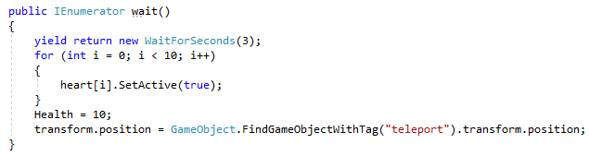

After the player has been teleported I have set it so the players health is reset. I do this by going through each heart and reactivating them one by one.

To make the player’s position change I find the gameobject and its position and make the player’s position the same.

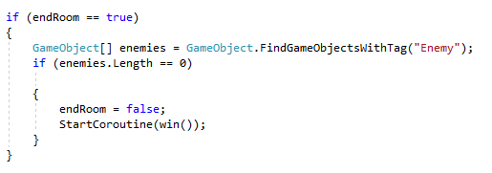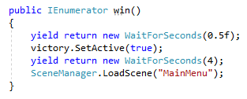

To make my game have an ending I have made it so when the player kills the enemy in the last room of the second level, it will run a function that displays an image informing the player that they have won. After that it will load the player back to the main menu page allowing them to start the game again.

Final boss

Now that I have finished making the second level I need to produce a final boss for the player to fight. This should be just as simple as adding the other boss to the game, only having to find a new sprite for the enemy.

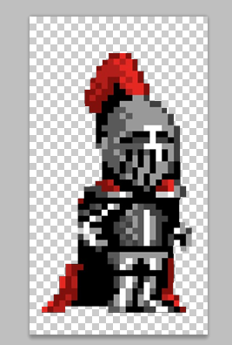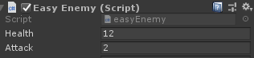

I have found another enemy sprite to use as the final boss. This image could be replaced by my own enemy design at some point. I will do this if I have time left over to do this. Also, I have attached the enemy script to the new sprite, having this enemy deal 2 damage to the player but having 12 health.

Screens

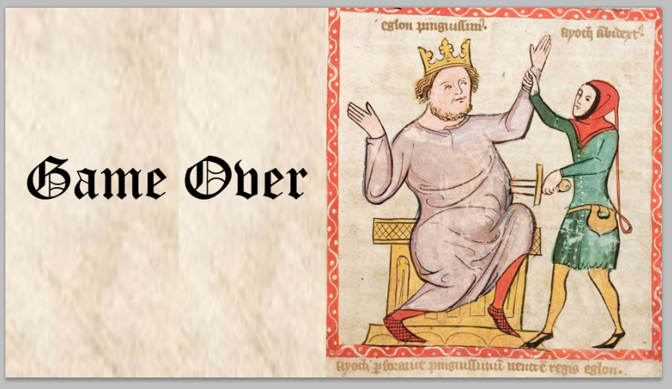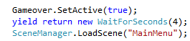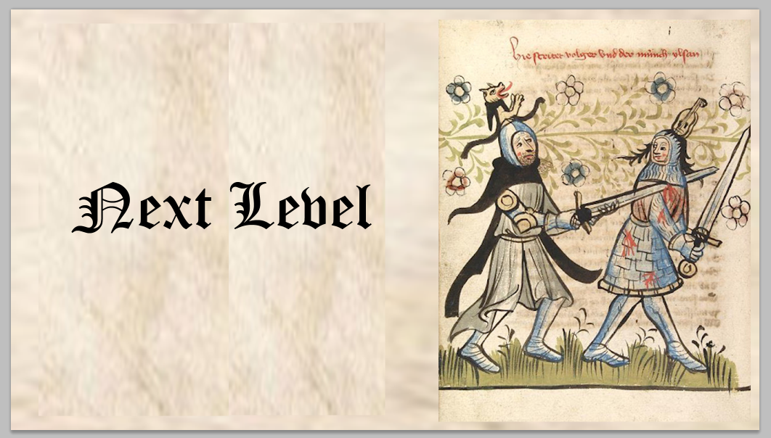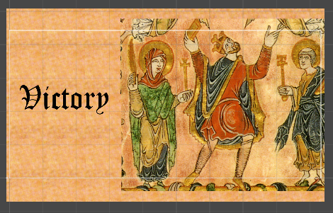

As a final part of my game I have made the screens that will go into my game when an event happens. To make these screens more historically related I have used old medieval art which is also funny, giving my target audience another way to not feel like they’re being educated.

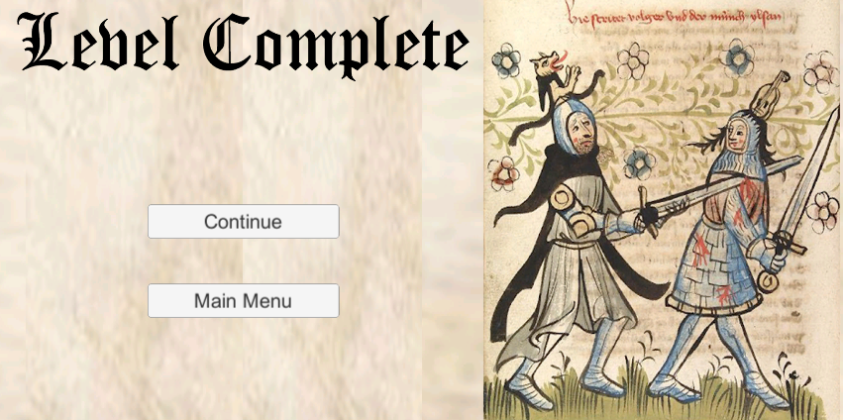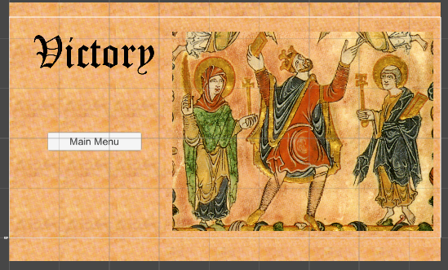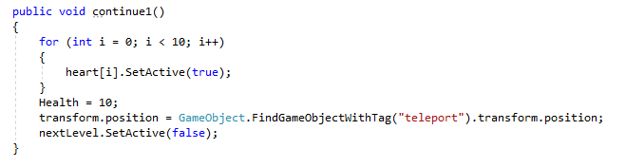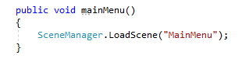

Now that I had applied the screens I felt like they could go by too fast. To avoid this issue I have added buttons to the screens so the player is able to go to the main menu when they want. I have also put a continue button on the next level screen which allows the player to decide whether they want to stop playing there or continue the game.

Conclusion

Now that my game is fully developed I will be able to go on and test my game, making sure each part of it is up to a high standard with my client.

In my development I have realised that I have not commented on each function within my code. Whilst I have been commenting on it within the report I believe it is important that the code is also annotated for anyone else who may want to read through the code and have a shorter, more simple explanation for each function. This is why I will go back and annotate all of my code to make sure it is suitable for someone who has never read my report to understand it.

**Testing and Evaluation**

In this part of my report I will be looking to see what I have achieved and what I wasn’t able to achieve within the development of my game. I will compare each section of my success criteria with actual elements of my game to see if there are any parts of it which I changed or improved on.

I will additionally fully explain why I was unable to meet any success criteria I didn’t complete, also giving a possible way that I would be able to include it and how long it would take.

Client Testing

To test my developed game I have asked my client to play through it a few times to get their opinion on it. Along with that I will ask them to give me an overall review of what I have produced and what they believe my game could use if I had more time to produce it.

The first thing my client did when they launched the game was reach to press the play button before looking at any of the other options on the menu. I questioned them about this to find out they hadn’t believed that they would be as important as the main game and they felt like they would be able to figure out the controls themself.

Once my client was in the game they immediately reached for the WASD keys to move the player around and walked into the first room. As soon as they saw the enemy appear they tried to turn back, running into the barrier. This furthers the importance of the barriers as it has stopped the player from getting the enemy stuck or just despawning the enemy, making **the barriers a success**.

When my client went to attack the enemy they realised they didn’t know what control to press, leading them to pause the game and open up the pause menu. After checking the control screen they were able to fight the enemy without any problems, making my **control menu a success**.

Once they had killed the enemy they moved to the room with the note. They had remembered from earlier that the control to pick up notes was E, making them not have to pause the game again. My client read through the entire note, and then closed it to continue on. I mentioned to my client that they could reread the note in the pause menu whenever they wanted, remarking that this is a **good feature**.

Once they had reached the final room of the level they instantly knew that they were fighting some kind of boss due to the difference in sprite and size. My client played much more protectively this time around, moving in and out quickly to attack. They eventually won the fight and being presented with the level complete screen. My client said that they thought that the **first level was too short** for them, suggesting I work on making the fights longer or making a bigger map. However, having the option to stop or continue the game impressed my client with them saying that it is important for students to want to learn and with them clicking continue, it subconsciously makes them keener to learn.

With my client on the second level they felt a lot more confident. They went into the first few rooms expecting to find it easier, however with the increase in enemies it became too much. My client ended up dying and being taken back to the main menu screen.

Clients overall opinion

After my client finished playing through my game three times they were very impressed with what I had created and believed it would definitely help their students learn a few new things about the crusades.

Positive feedback:

* “The game functions very well”
* “The notes have accurate information on them”
* “The combat is simple enough, making it available to more of my students to play”
* “I like how the screens include art of the time, making it more memorable to my students”

Negative feedback:

* “The levels feel too short”
* “The characters in the game are not too fitting of the times, with the colours and look of the armour being different”
* “The game should include a heavier element of education, such as a story”

Levels being too short

This was an element of my game I had been looking to develop more and more as time went on. I have realised that my game is much shorter than I originally intended it to be, with it being possible to complete it within a few minutes.

Fix: To make the levels longer in my game I would look to increase the number of rooms in the levels and also make the enemies tougher to kill. Along with this I would have more collectables that the player could look around for and pick up.

Inaccurate designs

The character and enemy designs for my game were not originally meant to be the final designs, with me planning to create my own in photoshop, however due to time constrictions I was unable to get this done. My original designs were much more fitting of the time and had been liked by my client.

Fix: If I had more time I would look to turn my designs into actual sprites which could be used in game. This would then give the game a much more crusader feel to it and have it further educate the students that are playing it.

More education

When I started to plan my game I believed it would be possible to plan out an entire storyline for it, however as I have discovered I was too ambitious and should’ve looked for another method education. Although the notes exist within my game which add a layer of education, a proper storyline would give the player a chance to watch the event of the crusades actually happen.

Fix: To create more education in my game I would have small bits of dialog between real historical figures to give the player an idea of what it was like. Additionally I could look to make images to go along side the text to help make them more interesting to bored students.

Student Testing

To make sure my game was suitable for my target age range of 14-18 I have had three students play through my game and give me feedback on what they did and didn’t like in my game.

I have written questions which I asked the students after they played my game to see if any of them feel the same way about certain parts or if they give a response I wasn’t expecting.

Question list

1. Did you like my game and why?
2. Have you played a similar game before and if so how does it compare?
3. Did you complete my game?
4. How difficult did you find it?
5. Did you learn anything new?
6. Would you play it again?
7. Is there anything I could improve on?

|  |  |  |  |
| --- | --- | --- | --- |
| Questions | Student 1 (14 years old) | Student 2 (16 years old) | Student 3 (18 years old) |
| 1. | I really enjoyed your game as it was easy to follow and play. | I liked the game because it taught me new things about the crusades. | I liked your game as it reminds me of the games I like to play. |
| 2. | I don’t normally play games so I haven’t ever played a game like this before. | I have played games like this before, however they’re normally a much more fleshed out version of what you have made. | I have played a game similar to this before. The main difference between your game and the games I have played is it doesn’t include as much of a sense of progression. |
| 3. | I didn’t manage to finish the game, dying on the first boss fight. | I did manage to complete the game, also collecting all of the notes. | No I didn’t finish the game. I died on the final boss fight. |
| 4. | I found the basic enemies easy to kill but found the boss a big leap from the others. | I found the game fairly difficult to complete, with the bosses being much stronger than I expected and harder than in other games I’ve played. | The game was a decent difficulty, with most of the enemies providing a challenge to me. |
| 5. | I only read two of the notes, but of those I did I learned about the beginning of the crusades. | Whilst playing the game I learnt more about the crusades, being interested by each note I picked up. | I learned a lot whilst playing the game, finding out about the history and the people of the crusades. |
| 6. | Yes | Yes I would | Yes |
| 7. | I think that the game should have a title which I can use to talk about the game. | I think you should make the game longer and have a wider variety of enemies. | I believe that your game could be longer and could involve a crusade related story. |

With the information I have gathered here I have been able to see what students in my target age think of my game and what they believe I could do to improve on it.

I have found that all the students liked my game and said they would all come back and play it again. This tells me that my game is able to engage someone enough to the point at which they want to continue to play more. This is an important feature for my game as it will be used by many history students, needing to keep them engaged by it.

I have also discovered that all of the students learnt something whilst playing my game. This is very important as this is the main premise of the game, looking to educate students. However, I learnt from student 1 that if you are unable to find the notes or ignore them then you won’t get the same effect as someone who has found them all.

The difficulty of my game was a surprise to all the students, with them expecting it to be a much easier experience. Student 2 told me that the game doesn’t have a similar difficulty to it which games of the same genre normally have.

Improvements

This has given me a number of ideas for improvements to make to my game if I had more time.

* Add a title to my game
* Make my game longer
* Include more enemies
* Include a story
* Make game match difficulty of games from same genre

Conclusion

After asking these students questions, I have learnt that my game has met a lot of the requirements I originally set out to achieve and has also not been as successful in places that I would’ve hoped. With this information I have found out, I would be able to use it to further my game, making it a much more enjoyable and educational experience.

Test Table Revisit

|  |  |  |  |  |  |  |
| --- | --- | --- | --- | --- | --- | --- |
|  | What's being tested | How I tested it | Input/Data used | Expected output | Actual output | Improvements/Changes |
| 1. | Username | I was unable to test this due to not making a login system | An acceptable username | N/A | N/A | I didn’t end up making a login system for my game as I wouldn’t have enough time to make my game long enough to make it useful |
| 2. | Play game | I went to the main menu and pressed the play game button | Play button | Load main game | The game loaded as I had originally expected | My test was a success |
| 3. | Close game | I went to the main menu and pressed the quit game button | Close button | Close program | The game closed as I had originally expected | My test was a success |
| 4. | Control menu | I went to the main menu and pressed the control menu | Controls button | Display controls | When I pressed the control button it brings up the control menu | My test was a success |
| 5. | Game save search | I wasn’t able to test this as I haven’t made a way to save my game | Save file | Load save | N/A | If I was able to lengthen my game I would look into adding a game save feature |
| 6. | Player health | I have put the player in the game and have looked at their health points | Player health = 5 | N/A | N/A | My test was a success |
| 7. | Enemy health | I have gone into the game to see if the enemies have health | Enemy health = set | N/A | N/A | My test was a success |
| 8. | Player attack | I have tried to attack in many positions and in each room | LMB | Damage enemy | When I pressed the spacebar the player attacked the enemy. | My test was a success |
| 9. | Enemy attack | I have had the player stand still and leave them to be attacked by the enemy | Enemy close to player | Damage player | After leaving the player stand still the enemy moved over and attacked the player, damaging them | My test was a success |
| 10. | Player movement | I have inputted each directions possible to move the player, testing each one | WASD | Move player | After pressing the WASD keys the player moved around the screen | My test was a success |
| 11. | Load next level | I have completed the first level to see if the next one loads | Player reaches end of level | Load next level | The player is put in to the next level to continue playing | My test was a success |
| 12. | Text dialogue for characters | I have not been able to test this as characters don’t have dialogue in my game | Player reaches checkpoint | Output text | N/A | To make this a feature in my game I could use basic images and give them speech bubbles |
| 13. | Save game at checkpoint | I can’t test checkpoints as I didn’t implements them | Player reaches checkpoint | Save game | N/A | If I was able to lengthen my game I would look into adding a game save feature |
| 14. | Save note | I have tested this by picking up a note and then going back to the main menu | Pickup note | Save note | Once the player picks up a note it is put into the notes menu | My test was a success |
| 15. | Player die | I have left the player in a room with enemies to see if they deal enough damage to kill them | Player health = 0 | Display death screen | Once the player dies there is a message on screen informing them they’ve got a game over | My test was a success |
| 16. | Enemy movement | I have walked into a room with an enemy to see if they approach the player | Enemy can see player | Move enemy | After walking into the room the enemies all walk towards the player | My test was a success |
| 17. | Enemy die | To test this I have fought the enemy to see if they can die | Enemy health = 0 | Display death animation | Attacking the enemy caused it to die and disappear | My test was a success |
| 18. | Game can end | I have looked at all the possible ways to end the game, e.g. Death, beating the game, quitting the game | Levels remaining = 0 | Output victory message | After going through and testing all the ways the game can end all three ways, outputting a message explaining what's happened | My test was a success |
| 19. | Move from room to room | To test this I went from one room, walking through the door, to see if I would appear in the next room | Walk to next room | Load next room | When the player walks into a new room the camera moves over with them | My test was a success |

After running through my test table I have discovered that I have achieved a lot of what I set out to achieve but also fell flat at some key parts of the game which could’ve really added to it.

The main feature that wasn’t included which many of the tests focused around was the login system. This part of my game would’ve had the player be taken to a log in or sign up page where they would have to make a unique username and write a password which met a certain criteria. After they did this it would’ve saved their login details to an external file where they would keep track of what position the player was at in the game and which collectables they had found whilst playing.

The main reason why I didn’t include this feature in my game was the fact that my game doesn’t have many collectables and isn’t long enough for multiple game sessions. To have a save game facility it is important that a player will find it useful and not a meaningless step for their short playtime because if they don’t then they mean stop playing soon than anticipated. Along with this reason I also didn’t include this feature as I was running out of time when programming my game and would’ve had to sacrifice a key element of the game to include saves instead. I believe that not including a saving game system was the right idea but it would definitely be an important feature to add if I went back and increased the overall length of my game.

Success Criteria Revisit

|  |  |  |  |  |
| --- | --- | --- | --- | --- |
| No. | Success Criteria | Did I achieve it | What made it be successful/not successful | Improvements for this section |
| 1. | Have a player character | Yes | I was able to create a character which was made clear to the player that this represented them. | N/A |
| 2. | Have inputs to move the character (WASD) | Yes | The player is able to use both WASD and the arrow keys to transform the players position, moving them in all directions. | To further improve the movement for the player I would look into making it so the player could bind their own controls to each key within the game, meeting their prefered layout. |
| 3. | Have enemies | Yes | I have made a few types of enemies that the player is able to fight, with killing them being the main goal of the game. | To improve on this I could include a wider variety of enemies |
| 4. | Have a set number of hit points for enemy | Yes | Each enemy has a certain amount of hit points depending on what type it is. | N/A |
| 5. | Have a set number of hit points for the player character | Yes | I have been able to set the players health, evening going as far to display it in the corner of the screen. | N/A |
| 6. | Include a weapon which the player can use | Yes/No | This weapon is built into the player sprite, with the player's body acting as the attack sprite. | To improve on this I would create actual weapons the player can find or select from, each having their own unique design and feel. |
| 7. | Have the weapons deal a set amount of damage | No | I have not included different types of weapons, with all the sprites having their weapons built in to them. | To make the weapons deal a set amount of damage I could assign different attacks to each weapon, buffing the player’s damage when using it. |
| 8. | Have consumables that can buff the player | No | I was unable to include consumables due to time constraints, leaving the player with no way to make themselves strong. | To make consumables I could have made a simple sprite that once the player picks it up they receive more health or they’re attack is stronger for a short time. |
| 9. | Allow player to attack the enemy | Yes | The player is able to deal damage to the enemies, with a hit causing the enemies health to go down. | N/A |
| 10. | Have a small tutorial on how to play the game | No | As my game was much shorter than I was expecting I didn’t find a need to add a tutorial as it wouldn’t be of much value to the player. | To improve I could make a small tutorial that could consist of just the controls fading onto the screen, informing the player how to play the game. |
| 11. | Teach at least 80% of students about the crusades and what happened during the time | Yes/No | Although my testing of my game has shown that the people who have played my game enjoyed it and learned new information about the crusades, I believe to get a true answer i would have to have a larger number of students test it. | N/A |
| 12. | Include a menu page | Yes | I have made a menu page that the player is able to access when the press the escape key. | To make this menu page better I could try to include more options for the player, e.g. Display settings, sound settings. |
| 13. | Pause game when menu button is pressed | Yes | I have stopped time once the key to pause the game is pressed. | N/A |
| 14. | Allow player to quit game | Yes | The player is able to press a main menu button as well as a quit button that will either take you to the main screen or completely shut down the game. | I could ask the player if they are sure they want  to quit the game, giving them a chance to stop if it was a mistake. |
| 15. | Allow play to resume game | Yes | There is a  resume function that will start time again once pressed. | N/A |
| 16. | Allow player to select from a number of colours/looks for character | Yes/No | I have included a form of character customisation but not how I was hoping to, with the player only having the option to select from a few premade looks. | Although I have included characters the original plan was to have it so the player would be able to change the colour and change different elements of the base player. If I had more time going back I would look to add this feature as it would give another way to increase replayability. |
| 17. | Have a map for the player to walk around | Yes | I have made it so the player is able to walk around the whole map, going back to old rooms, whilst still making it somewhat linear. | To make the map better I could include a smaller version of it in the top corner of the screen acting as a mini map. |
| 18. | Include a basic story | No | To make a story for my game it would’ve had to of been both longer and have more characters. | Working on a story for my game would take some time, however it would be possible to add one by having a character in each room create a text box on screen, creating a form of narrative. |
| 19. | Load the map as the player moves across the world (move from room to room) | No | Instead of loading the map as the player walks around it I have found it to be much easier to have the rooms preloaded and to just move the camera as the player collides with each new room. | If my game grew to a larger size it might be more efficient to have the rooms saved in separate scenes, loading them as the player walks through them. This would also open the opportunity to have randomised rooms. |
| 20. | Have a top down camera | Yes | I have made my game in a way that the camera is top down and the player is able to walk around the whole room. | If I had more time I could’ve made it so the camera followed the player as they walked up a tall room. |
| 21. | Have real historical figures from history | No | Including real historical figures in my game would require the story element to be implemented. | To make historical figures in my game I would add them in the story, having you fight real people from history. |
| 22. | Allow the player to pick up items | Yes | The player doesn’t have many options however they are able to pick up notes. | N/A |
| 23. | Have the player be able to look at items through menu | Yes | The player is able to read through any notes they pick up in the menu page notes. | N/A |
| 24. | Include readable notes | Yes | I have been able to make notes that include historical information. | If I had more time I would go back and add more to my notes, making them easier to read, encouraging people to read them in more detail. |
| 25. | The player can die | Yes | The player has a set amount of hit points and when that number is reached the player sprite is destroyed. | N/A |
| 26. | Inform the player they’ve died | Yes | Once the player dies a screen appears informing the player that they have died and have got a game over. | I believe that I should add a main menu button to the game over screen, similarly to the next level and the victory screen. |
| 27. | Game is saved when player gets to checkpoint | No | I have not included checkpointing in my game as it would require me to have more time and for the game to be longer. | If I was able to go back and make my game longer I would look at making a checkpoint system, having the players progress stay saved. |
| 28. | Inform player when the game is saved | No | As there are no checkpoints the player doesn’t get told about any kind of game save going on. | To create this I would have an image that would fade in and out saying ‘game saved’. This feature would only be necessary if the save system is added. |
| 28. | Game can be made full screen | No | The game doesn’t include an option to make the window fill the whole screen, although this wouldn’t be too hard to add if I went back. | To make my game full screen it would involve me looking at tutorials on the best ways to do it but I believe it could be added quite easily. |
| 29. | Enemies move towards player | Yes | The enemies take the player character as a target and looks to follow the player until they’re dead. | N/A |
| 30. | Enemies attack player | Yes | The enemy is able to affect the players overall health, being able to take it down to 0, causing the player to die. | N/A |
| 31. | Control menu | Yes | If the player wants to know how to control the game then they can go to the pause menu or main menu and look at a control menu. | N/A |
| 32. | Save players login data in a table | No | The player login system was removed from my game as there wasn’t anything to save aside from the notes, making the game have less replayability if you could load in with all notes. | If I was able to make my game much longer and have more collectables, then I would look into making a system where the player can make a login that can be used to save their progress. |
| 33. | Load next level | Yes | The game has a second level which ‘loads’ when the player completes the first level, teleporting the player over to the next location. | N/A |
| 34. | The enemys can die | Yes | Each enemy in the game has a set number of hit points which when reach 0 cause the enemy sprite to be destroyed. | To improve on the enemy death I would’ve liked to add an enemy death animation, making it clear to the player the enemy hasn’t vanished. |
| 35. | The game can be completed | Yes | To achieve a win in my game you have to defeat the final boss in the second level. | If I had more time I would look to lengthen how long it takes the player to finish my game, upping the difficulty in places. |
| 36. | Make my own sprites | No | To make my own sprites this would’ve required a lot of research into character design and a lot more time than I had remaining. | To improve I would make sprites in photoshop based off my original design ideas for the characters and the weapons. |

Maintenance

If I was able to release my game to the public I would need to constantly be able to make sure my game had all bugs fixed, whilst also being able to keep players entertained.

To make sure my game was ready to launch I would fully check my game for any bugs and any possible ways players could look to break my game. If these were not fixed before the game launched I could end up having unhappy users and may receive complaints based around the game not functioning correctly. My game may even see a drop in the player base if I continued to have bugs, making it lose its main functionality, to teach.

After realising my game I would most likely find that there are a few bugs I had missed when testing. If any bugs were reported I would have to find a way to quickly act on the problem, finding a solution and implementing it as fast as possible. Luckily in today's age there are many different ways to receive feedback from users, with the main one being social media. This would allow me to be kept up to date on any problems users are finding and acknowledge that I’m aware if it and looking for a fix. Another way that I could be informed about errors in my code is through the development of a report error button, this would allow users to stay anonymous whilst still helping me find and fix bugs.

As my game isn’t very large this reduces the amount of maintenance I will have to do on it, as well as reduces the factors I would need to consider when releasing this to the public.

One factor that I wouldn’t need to worry about is the Data Protection Act of 1998 which requires all data to be kept safe and secure. I don’t have to worry about this because I am not collecting any personal data from the players and don’t intend to in the future if the game was developed further.

Although I don’t have to worry about many factors I would have to worry about the Copyright, Designs and Patents Act of 1988. This is due to the sprites within my game being taken from other sources which most likely have a copyright on them. To avoid this issue I would have to look into the sprites I’ve used and create my own for any which are copyrighted.

As my game is for a school environment it is important that I don’t allow students to bully each other online and make others feel bad. I don’t have to worry about this issue much as my game has no online facilities and doesn’t allow for any forms of communication.

Limitations of the system

I believe one of the biggest limitations of my game is that it is missing a historical storyline that would further educate students on the history of the crusades.

My current way of educating students is through a note system that works very well at giving players large amounts of information at a time but don’t force the player to learn. I originally thought this idea was a better way of educating students as it was an optional element for people who already knew about the crusades but as I have come to realise many students get bored very quickly and could find notes tiresome to read.

I feel that adding a storyline would keep all students of all ages engaged in my game, having them feel like they’re part of the crusades themselves. To further this I could even have it so the player is given questions by characters about figures of the time to ‘prove their allegiance’. This would make sure that the player is learning and not ignoring the educational elements they’re being taught.

Another limitation of my game is how short levels are, not giving the player enough content to want to play it again.

My game being only a few minutes long wasn’t originally intended as I had planned for a whole narrative to play out with my game as well. Although this would lengthen the game by a bit it still wouldn’t allow the player to have endless hours of educational fun.

A way to implement this would be to have randomised rooms that the player could visit and have it so the game would only ever end if the player died or found a selection of collectables. This would both lengthen the play time and add an element of replayability in my game, encouraging students to learn more about the crusades.

A different way to lengthen the game would be to make the fighting more difficult, with boss fights having different stages in them. This would support the video game style, with old video games being harder than most new ones, along with providing a harder challenge to the player. My only concern with developing this would be that players would get too hung up on the combat of the game and ignore too much of the history being taught.

Finally I also think that adding a different variety of weapons which the player can unlock over time would help to keep students interested in my game.

Originally my game was meant to feature different weapons that would all inherit from a parent class. This can be seen with my hierarchy weapons table that would’ve had the existence of a longsword, a spear and a pole axe, having them deal different amounts of damage to enemies. As well as this enemies would also have different weapons depending on how hard they were meant to be.

The main reason this feature wasn’t added was due to a lack of sprites for weapons and the tight time constraints that had more focus on more important elements of my project.

Final Evaluation

With the information I have gathered from testing and evaluating my project I have learnt a lot about what is and isn’t vital when creating a game. Although I achieved many of my criteria I have ended up having a fair number of features that I was not able to include due to time constrictions and the limitations of my own skills in programming.

Although I couldn’t make everything, I have produced a game that is fit for its purpose and has received good reviews from everyone that has played it. The inclusion of silly but historical art in my game has improved the reactions  from people, informing me that you don’t need to have huge features and changes made to a game to make it better.

In conclusion my project has been successful as it not only teaches students about the history of the crusades but is able to entertain them enough to want to play through it again, relearning the content whilst doing so.

**Code**

This is all of my code that I have written including all of the variables which I have used to make the game. Whilst going back to take these screenshots I have added comments to each section of code to make it easy to follow and also allow for easy maintenance if I, or anyone else was to ever come back to this project to further its content.

Player Script

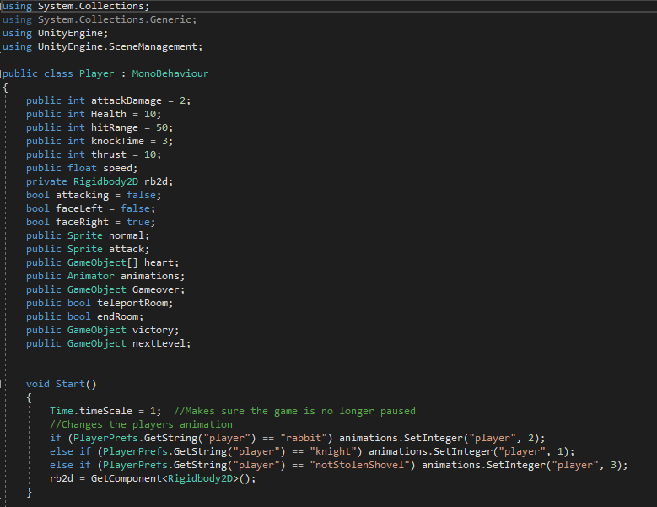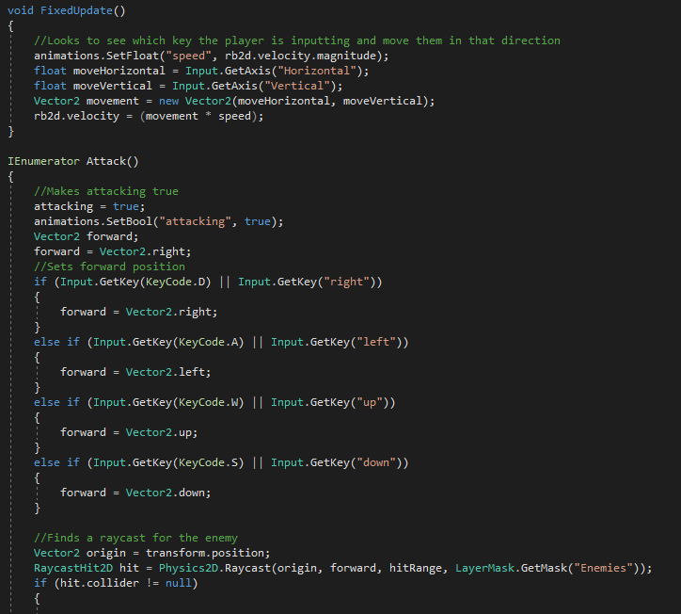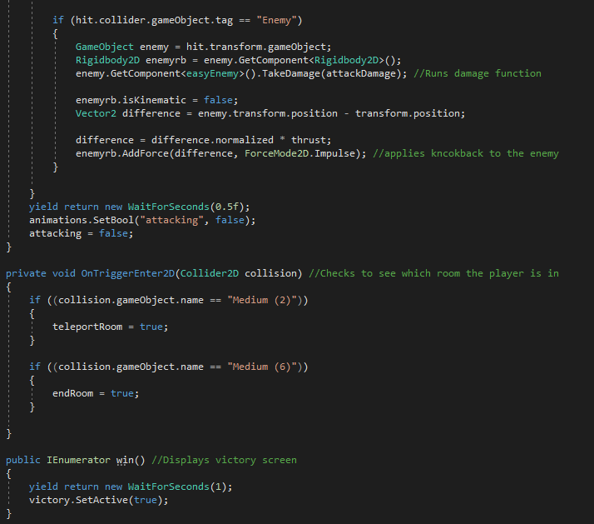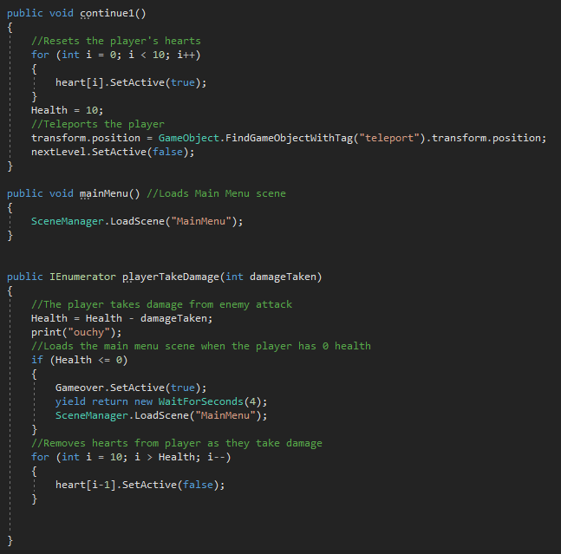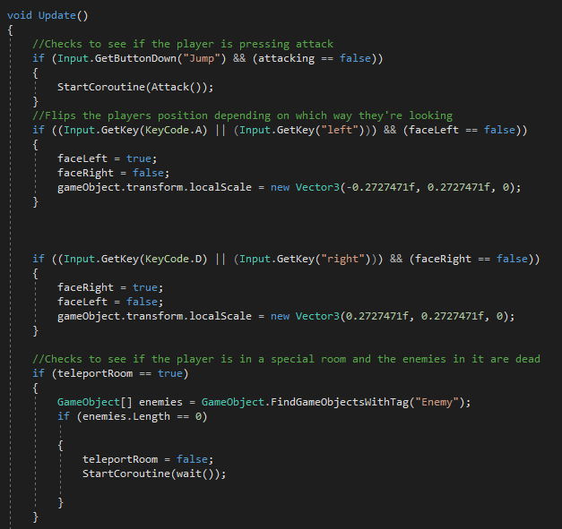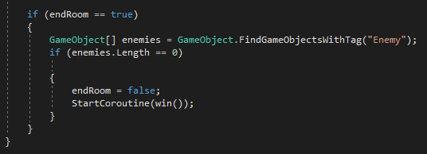

Enemy Script

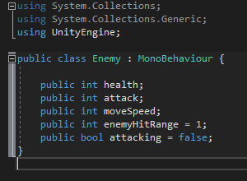

Basic Enemy Script

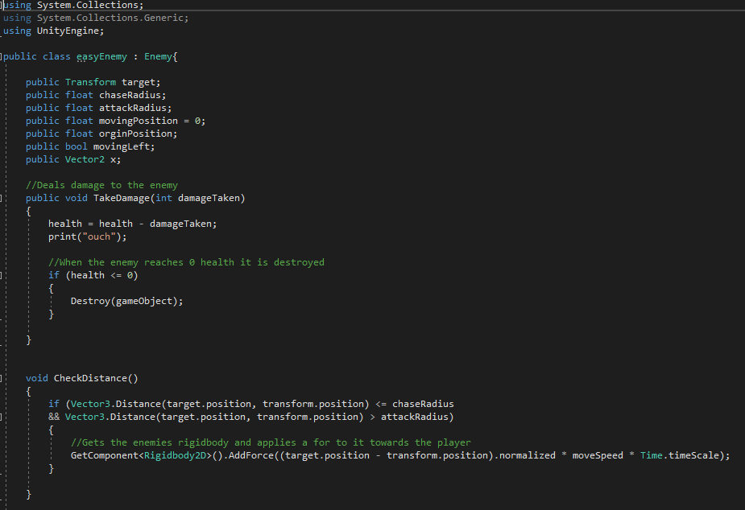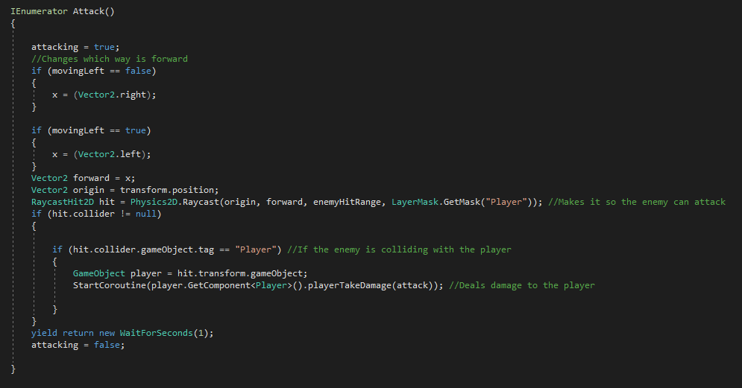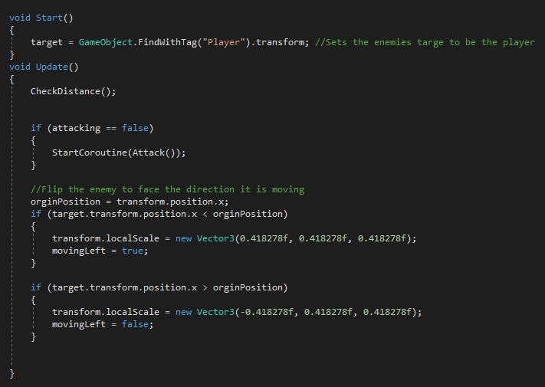

Room Script

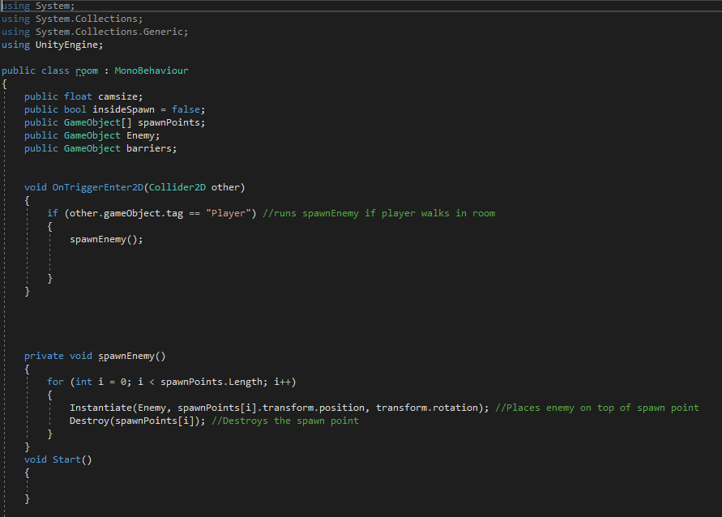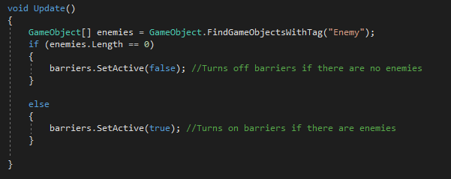

Menu Page Script

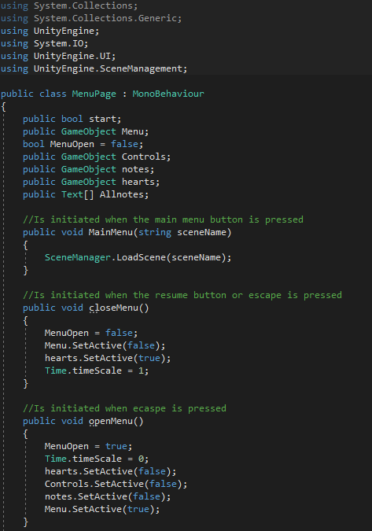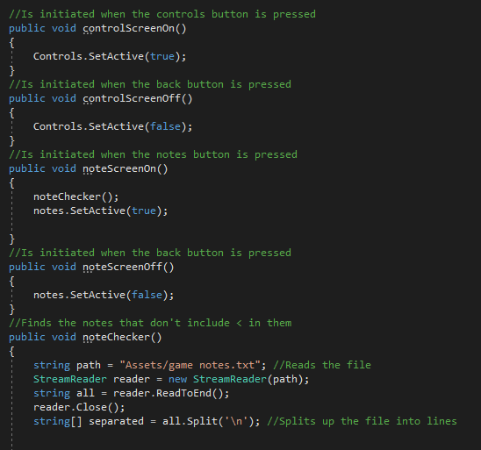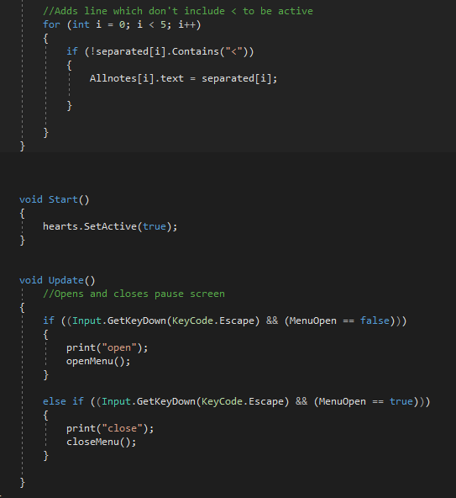

Camera Switch Script

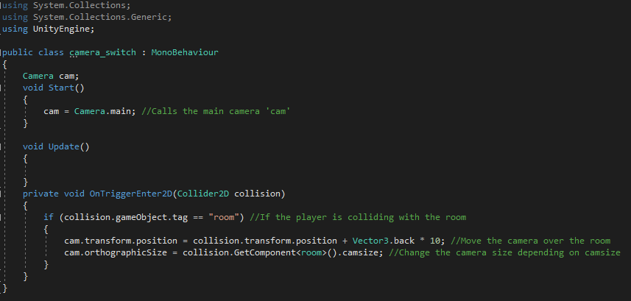

Main Menu Script

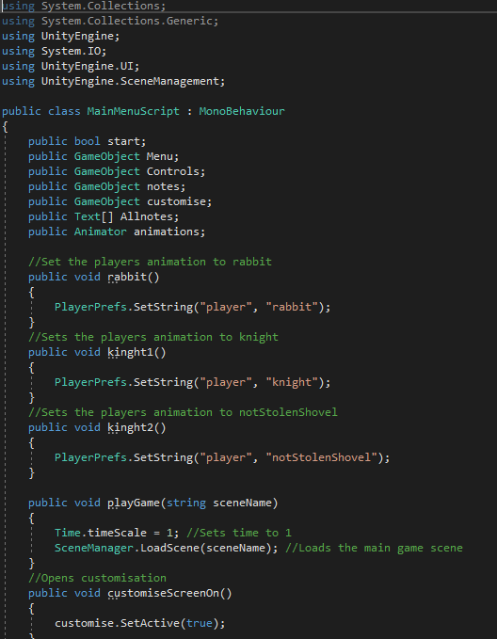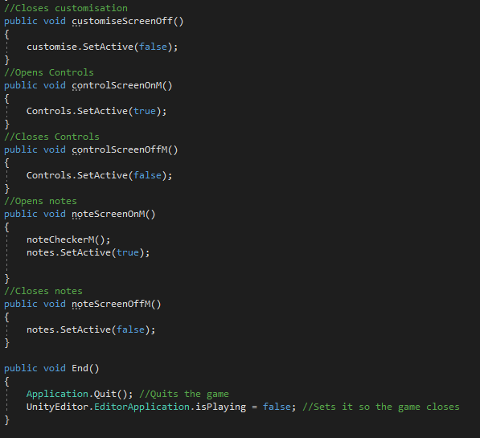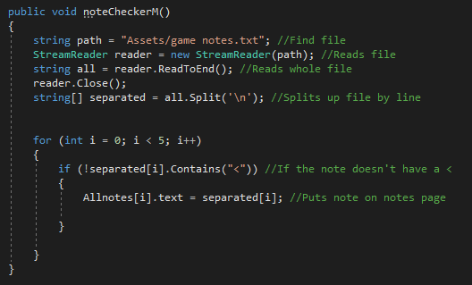

Note Script

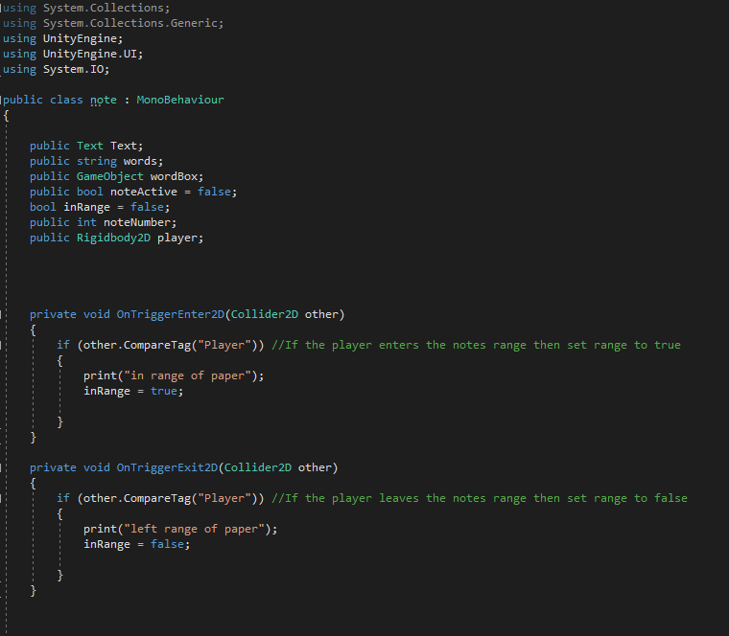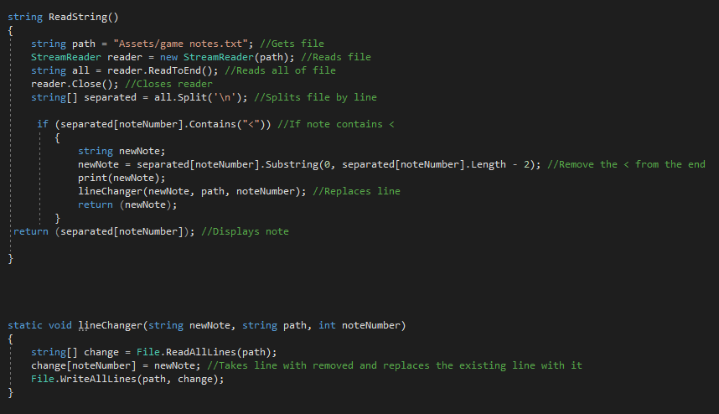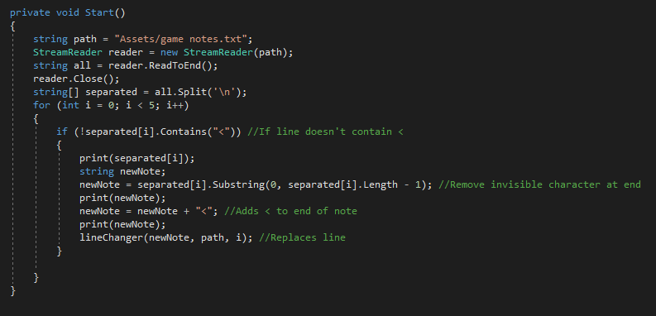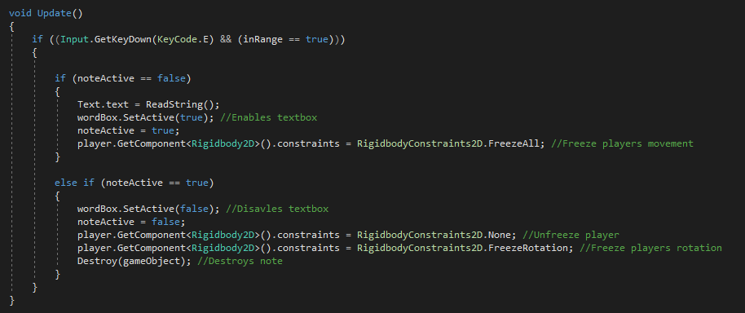

**Bibliography**

<https://youtu.be/A-E8FhN9x4k>

<https://answers.unity.com/questions/1373810/how-to-move-the-character-using-wasd.html>

<https://www.youtube.com/watch?v=F5sMq8PrWuM&list=PL4vbr3u7UKWp0iM1WIfRjCDTI03u43Zfu>

<https://docs.unity3d.com/Manual/class-Tilemap.html>

<https://docs.unity3d.com/ScriptReference/Object.Instantiate.html>

<https://docs.unity3d.com/Manual/UIToolkits.html>

<https://answers.unity.com/questions/570100/using-streamreader.html>

<https://docs.microsoft.com/en-us/dotnet/api/system.io.streamreader?view=netframework-4.8>

<https://answers.unity.com/questions/570100/using-streamreader.html>

<https://docs.unity3d.com/ScriptReference/Transform-position.html>

<https://forum.unity.com/threads/set-value-on-gameobject-transform-position-x-with-c.66768/>

<https://docs.unity3d.com/ScriptReference/Object.Destroy.html>

<https://forum.unity.com/threads/how-would-i-destroy-self-after-collision.353037/>

<https://docs.unity3d.com/ScriptReference/WaitForSeconds.html>

<https://answers.unity.com/questions/379440/a-simple-wait-function-without-coroutine-c.html>

<https://answers.unity.com/questions/1302697/how-to-lock-the-rotation-of-an-object.html>

<https://www.youtube.com/watch?v=hkaysu1Z-N8>

<https://docs.unity3d.com/Manual/animeditor-CreatingANewAnimationClip.html>

<https://answers.unity.com/questions/1369393/how-to-switch-between-scenes.html>